RISE Monthly Meeting
January 31, 2025
Zoom Link:
- Introductions
- Internships Follow Up
- Career Fair Planning
  - Wednesday, March 19 at Wheeling Park High School
  - 8-10 a.m. College students, 10-2 High School Students
  - Watch for more information.
- RISE Logo (see reverse)
- Marketing Committee Volunteers
  - How can we increase participation in RISE events?
- Grant-Writing Updates
- Communicating Contact Information for Businesses and Educational Institutions
  - What would be the best way to provide that listing?
- Upcoming Events
  - Thursday, Feb. 13, 4:00-5:30: RISE UP for Human Resources/Business Services/Technology sector
  - Friday, Feb. 28, 8:30-10:00: RISE Monthly Meet at Wheeling University.
    - Topic: Mentoring, Job Shadowing, Workplace Tours
- Artificial Intelligence Presentations
  - Moonjung Kang: Professor of Graphic Design at West Liberty University
  - Michael Santamaria: Managing Director at Williams Lea
  - Hilary Kinney: Director of Community at Civics Unplugged
- AI Discussion
  - What skills and competencies do you believe will be most critical for the workforce to effectively collaborate with AI technologies?
  - How can educational institutions and businesses work together to close the gap between current workforce capabilities and the demands of AI-driven industries?
  - What ethical considerations should be prioritized when integrating AI into workforce practices, and how can we address them proactively?
  - What strategies can we implement to ensure that AI adoption supports workforce equity and inclusivity, rather than exacerbating disparities?
  - How can we encourage lifelong learning and upskilling to prepare both current employees and future graduates for AI-augmented work environments?

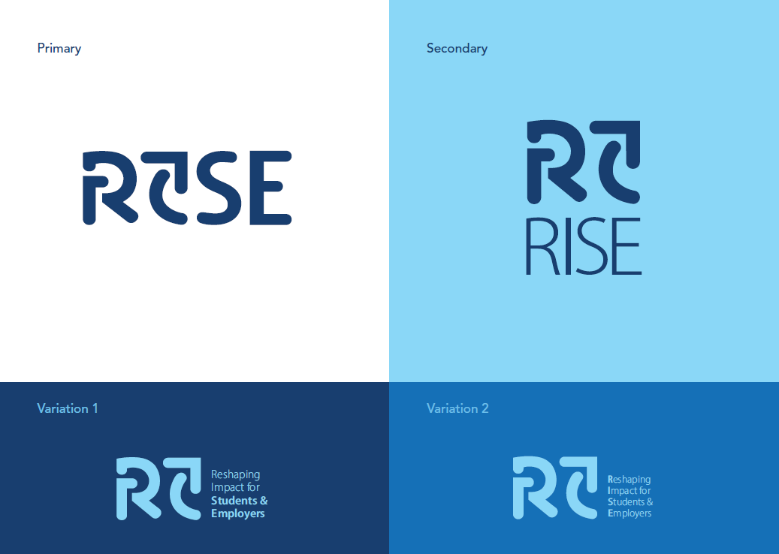Version 1
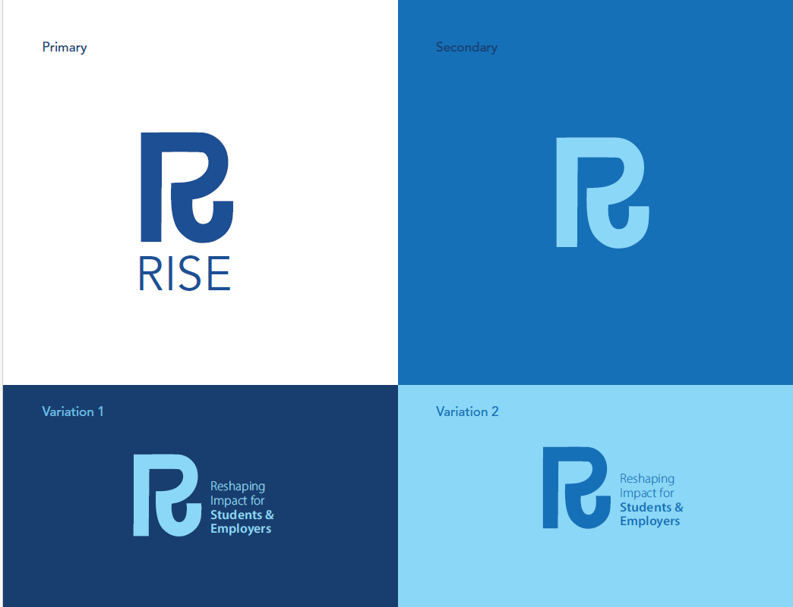Version 2
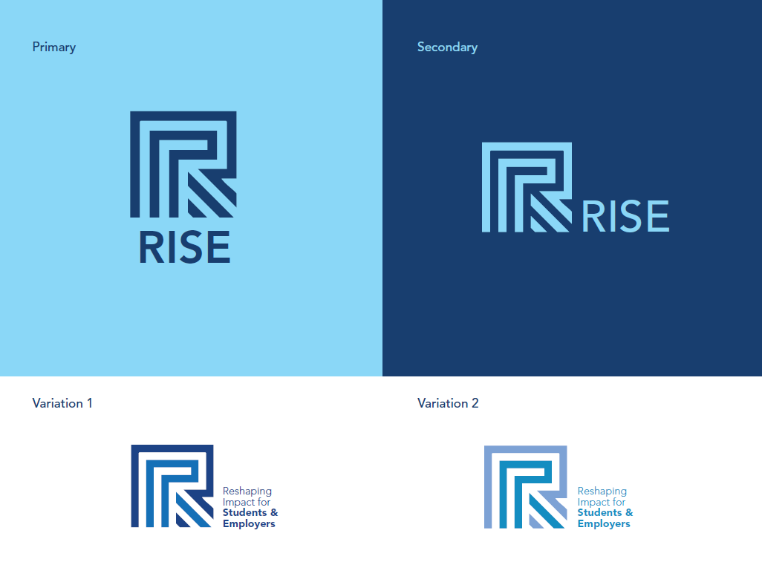Version 3

