Understanding Call Numbers
By: Anna Cipoletti

What is a Call Number?
A call number refers to the location of a book on the shelf. It may be helpful to think of a call number as a book’s address: finding a book on the shelf is comparable to finding a house on a street.
Figure 1: Breaking Down the Call Number
The figure below is the call number for a book of plays by Oscar Wilde. Before we look at a specific example, let’s discuss a few of the elements that make up a call number.
- The classification number: in our library, we catalog our items using the Dewey Decimal Classification (DDC) system. This is the series of numbers in blue within the call number. For a more in-depth explanation of the DDC, please refer to Figure 2 below.
- The first letter of the author’s last name: in this case, it is “W” for “Wilde”.
- The Cutter number: Cutter numbers are named for Charles Ammi Cutter and are a useful way for librarians to alphabetize books by author’s last name. For the patron, however, these numbers aren’t as important as the Dewey Decimal numbers.
- First letter of the title: in this example, it is “p” for plays. Note: articles, such as “A”, “An”, or “The” are skipped when an item is cataloged. For instance, Oscar Wilde’s The Importance of Being Earnest would have “i” for “Importance” in the call number.
Example: Call number for Plays by Oscar Wilde:
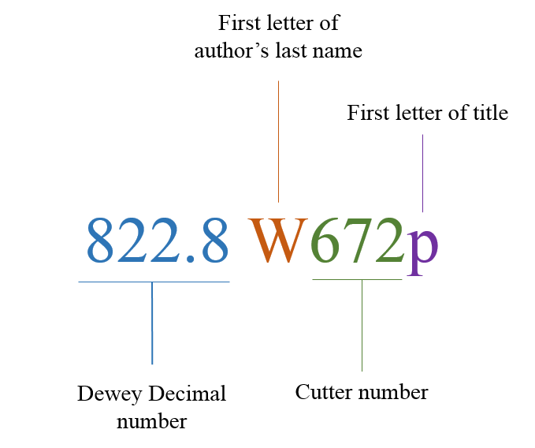
Figure 2: Understanding the Dewey Decimal Classification (DDC) system
The DDC, created by librarian Melvil Dewey in 1876, catalogs items by sorting them into ten main classes or areas of study. The classes are as follows:
000 | Computer science, information & general works
100 | Philosophy & psychology
200 | Religion
300 | Social sciences
400 | Language
500 | Science
600 | Technology
700 | Arts & recreation
800 | Literature
900 | History & geography

From there, each main class is broken down into ten more subclasses. For instance, the 800 class (literature), has the following ten subclasses:
800 | Literature, rhetoric & criticism
810 | American literature in English
820 | English & Old English literatures
830 | German & related literatures
840 | French & related literatures
850 | Italian, Romanian & related literatures
860 | Spanish & Portuguese literatures
870 | Latin & Italic literatures
880 | Classical & modern Greek literatures
890 | Other literatures

Each subclass can then be broken down into ten more subclasses, but it is not necessary for the purposes of this tutorial to keep going. To continue with the address analogy, think of each class as a neighborhood, the subclasses as streets, and the entire call number as a house. In this example, we could say Oscar Wilde’s book of plays resides in the “800” neighborhood on street “20”, and it lives in the second house on the street (because the call number is 822).

Sources:
“Dewey Decimal Classification.” Encyclopedia Britannica, 19 Feb. 2016, https://www.britannica.com/science/Dewey-Decimal-Classification
“Dewey Decimal Classification summaries.” OCLC, n.d., http://www.oclc.org/en/dewey/features/summaries.html

