How to Find a Book
By: Anna Cipoletti

- Go to the library’s page on the university’s website
- Under “SEARCH BOOKS”, enter a title, name, or keyword to begin your search
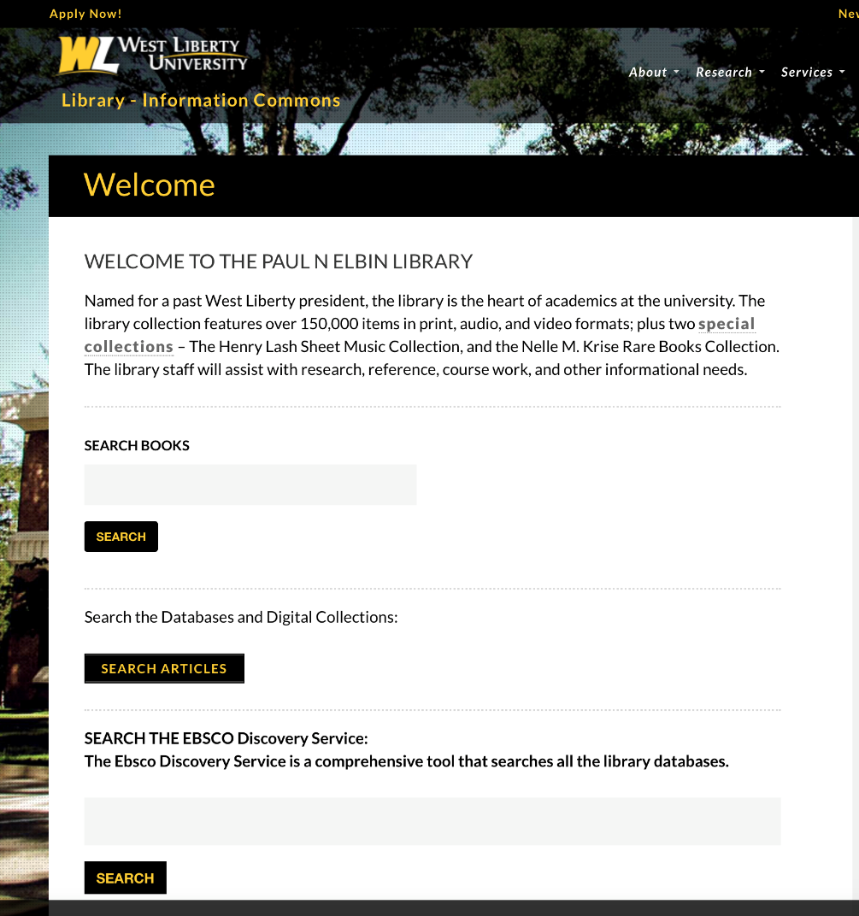
- Once you enter a search, your page will look like this:
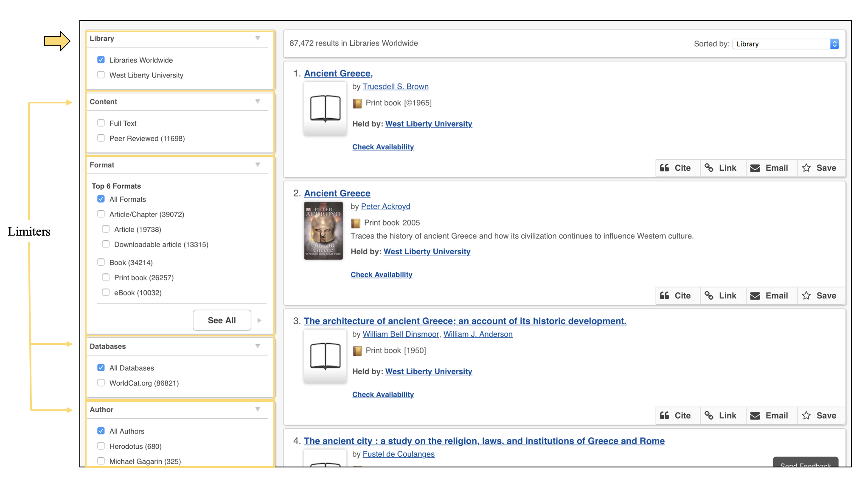
- Select “West Liberty University” under Library: this will search ONLY the items in our collection (to search multiple libraries’ holdings, check out this tutorial).
Note: If your results are too broad, try adding some limiters, located on the left side of the page (click here for more information about limiters)
I Found the Item I Want—Now What?

Finding Your Book in the Stacks
- Under the item’s information, select “Check Availability”. This will tell you whether or not the item is available and where it can be found.
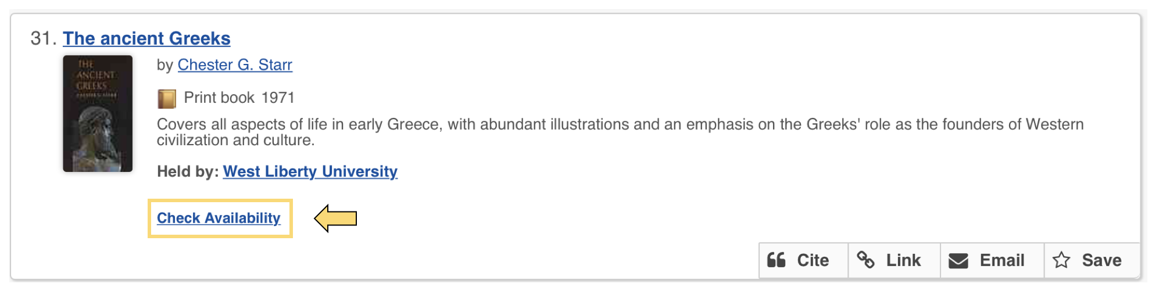

- Once you click “Check Availability”, the hyperlink should change and look like the screenshot below:
Note: If you do not know how to locate a book using a call number, visit our tutorial on the library’s website OR ask a librarian at the reference desk to help you

How Do I Decide What Limiters to Use?
Limiters can be a great help when finding the right material, but you need to consider what you are looking for.
Examples of limiters:
Library
- Libraries Worldwide will give you more options, and if the West Liberty library does not have the item you want, you can request it through interlibrary lending
- If you want the item immediately, limiting your search to the West Liberty University would be a good idea, BUT it means you may not find what you really want
Format
- Select a format that best suits your needs. Formats include tradition print books, e-books, microform, and books in Braille or large print.
Database
- The default selection is “All Databases”, which will search everything database collection the library has access to.
- Selecting WorldCat.org searches all the holdings in the world, as the name implies, and anything not in our collection can be requested through interlibrary lending. This will return more results but the items may not be instantly accessible.
Author
- The default setting is “All Authors”, but if you are looking for a particular title select the appropriate author to narrow your results.
Year
- Selecting by year can be very helpful depending on what you are looking for. If you are looking for a field that tends to change rapidly and in which information is often updated (e.g., the sciences), try selecting “Last 5 Years”, “Last 10 Years”, and so on. If you are looking for Victorian literature, for instance, you may want to enter a custom year range.
Language
- The default setting for the search is “All Languages”, so you may want to narrow it down to the applicable language (English, German, French, etc.) to improve the accuracy and accessibility of your results.
Topic
- This options will vary depending on your search, but you have the option to search “All Topics”, a particular area of study (such as “Language, Linguistics & Literature”), or a combination of several areas of study.

