KRONOS QUESTIONS:
- How and where do I access the system?
Go to www.wvsao.gov, log onto myApps and click on the orange KRONOS icon.
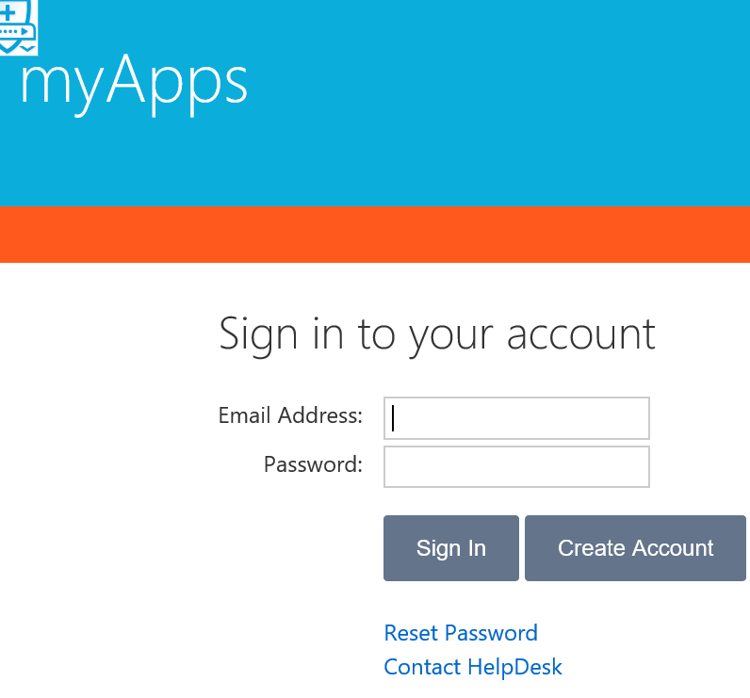

- How do I request time off?
See pages 9-12

- How do I cancel my time off?
See page 12

- Where do I find my accrual balances?
See page 6

- Who do I call if I have a question about my timecard?
Payroll Department: Stephanie Mills x8115

- How do I approve my timecard?
See pages 13-14

- How often do I have to approve my timecard and what do I do if there is an error?
See page 13

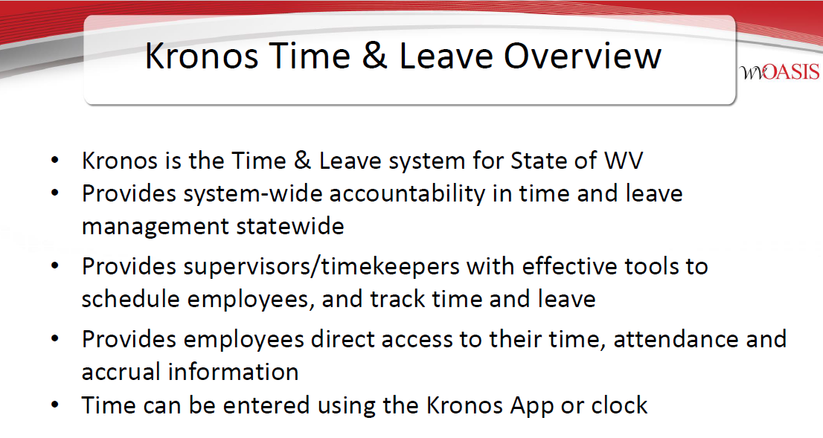
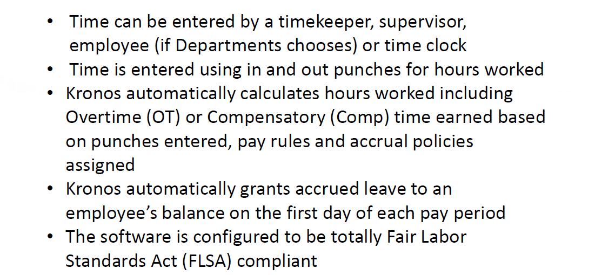

West Liberty University no longer tracks Compensatory (COMP) time on KRONOS.

Supervisor or Timekeeper Tasks
On a daily basis, the supervisor/timekeeper performs the following tasks:
- Check for missing punches and other exceptions.
- Handle unexpected leave and missed time.
- Enter non-worked time for employees.
- Approve time off requests.
- Monitor overtime.
On a pay-period or as needed basis, the supervisor/timekeeper performs the following tasks:
- Review timecards for completeness and approval.
- Approve timecards for payroll processing.
- Supervisors and timekeepers can submit a leave request on behalf of an employee, or an employee may contact the Payroll Administrator directly to request leave.

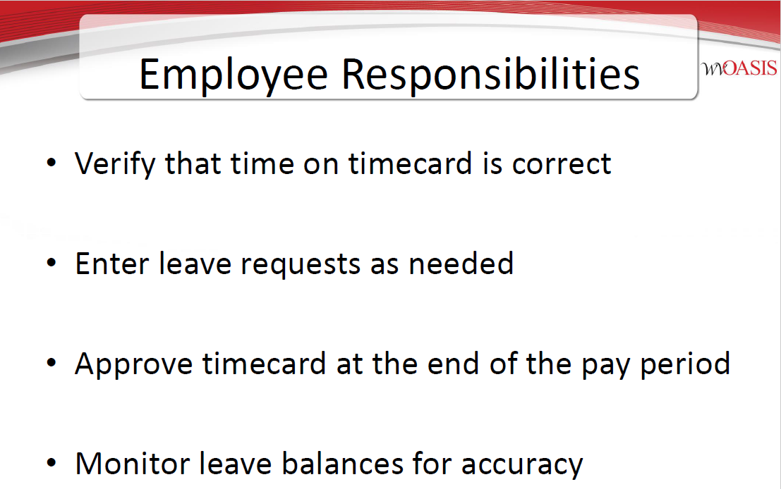

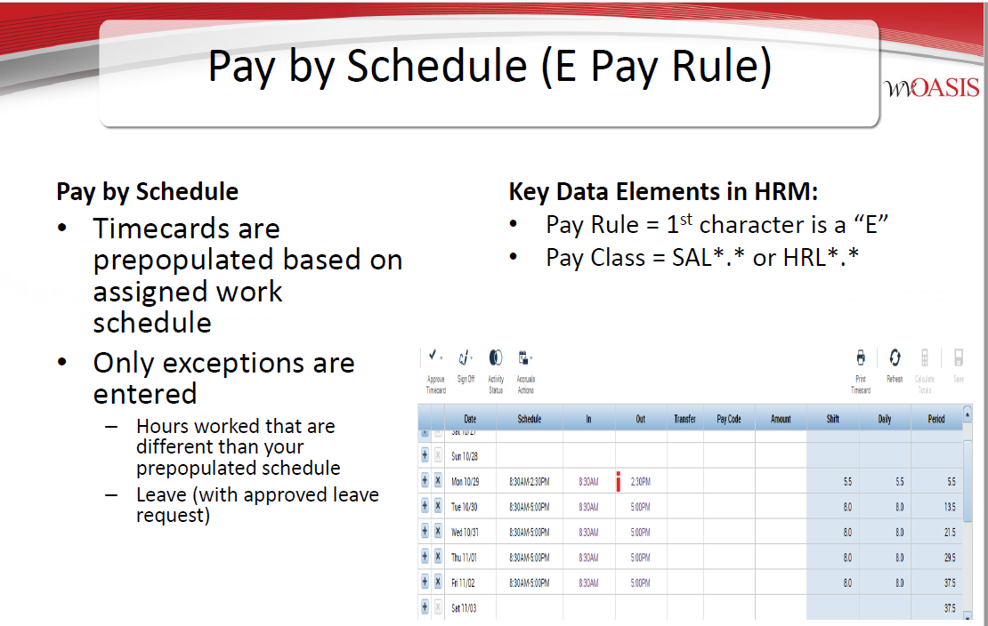
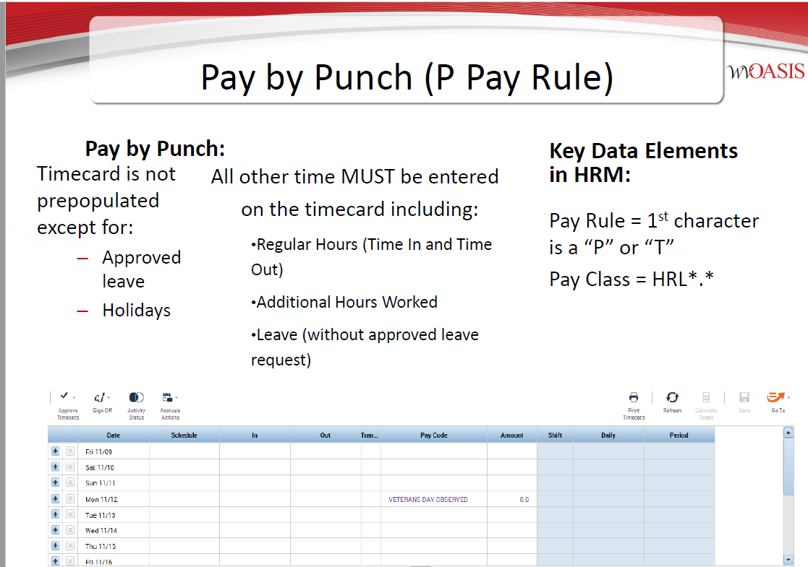

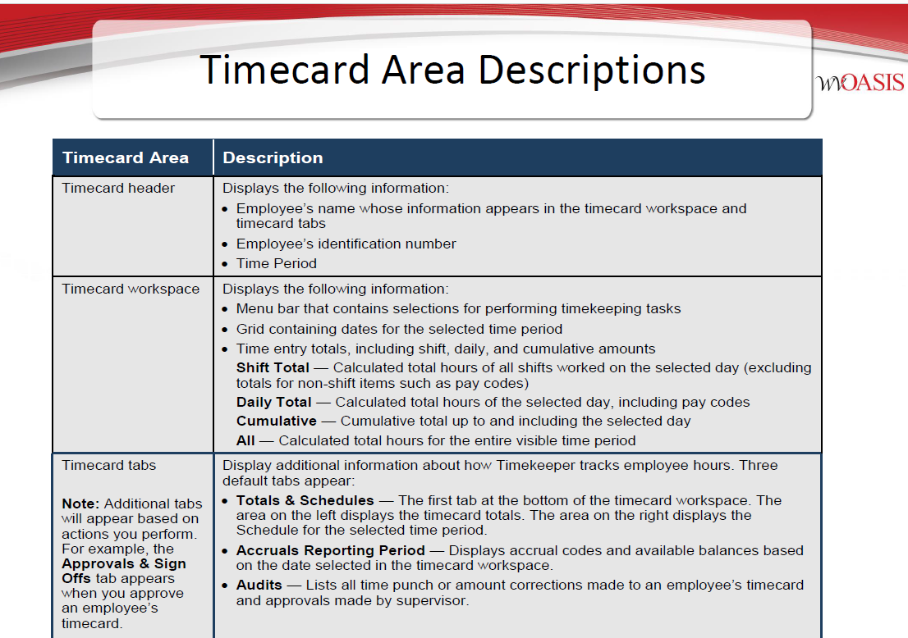

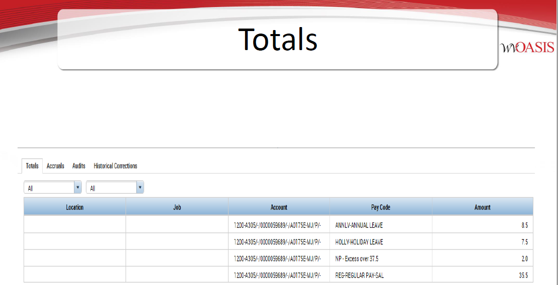
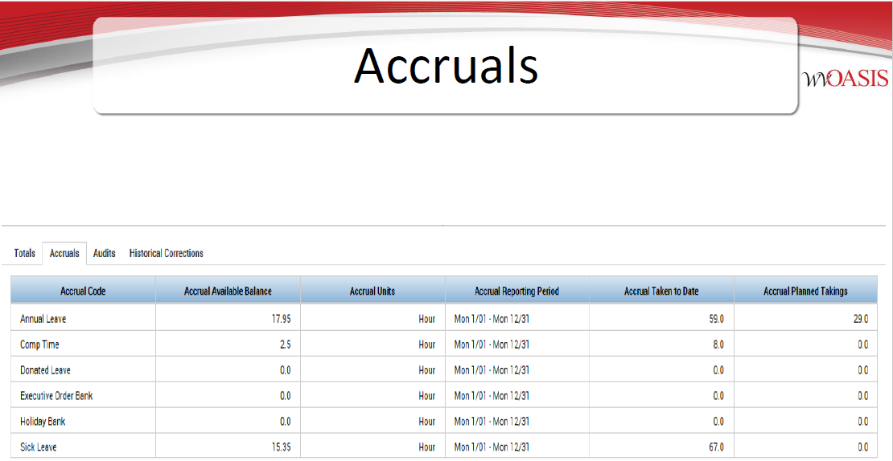

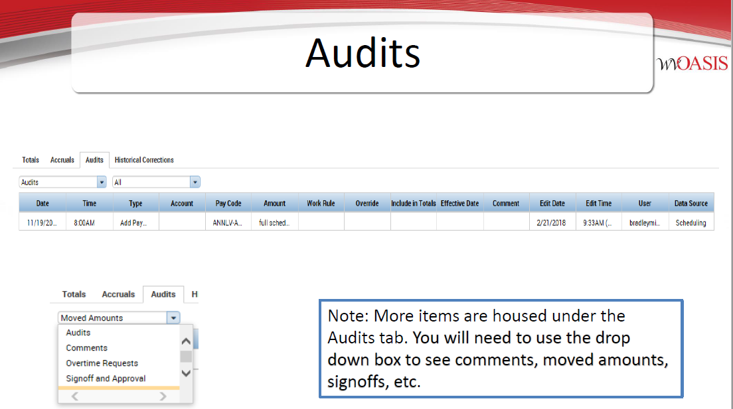

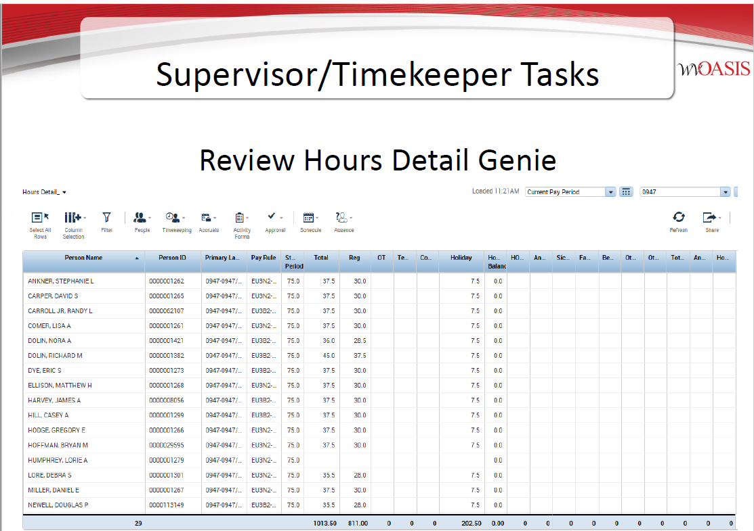

Supervisors/Timekeepers are responsible to ensure the correct amount of hours are in an employee’s timecard.
For example: A 1 FTE employees will have 75 hours in their timecard for the pay period which will consist of worked hours, annual/sick leave or holiday hours.
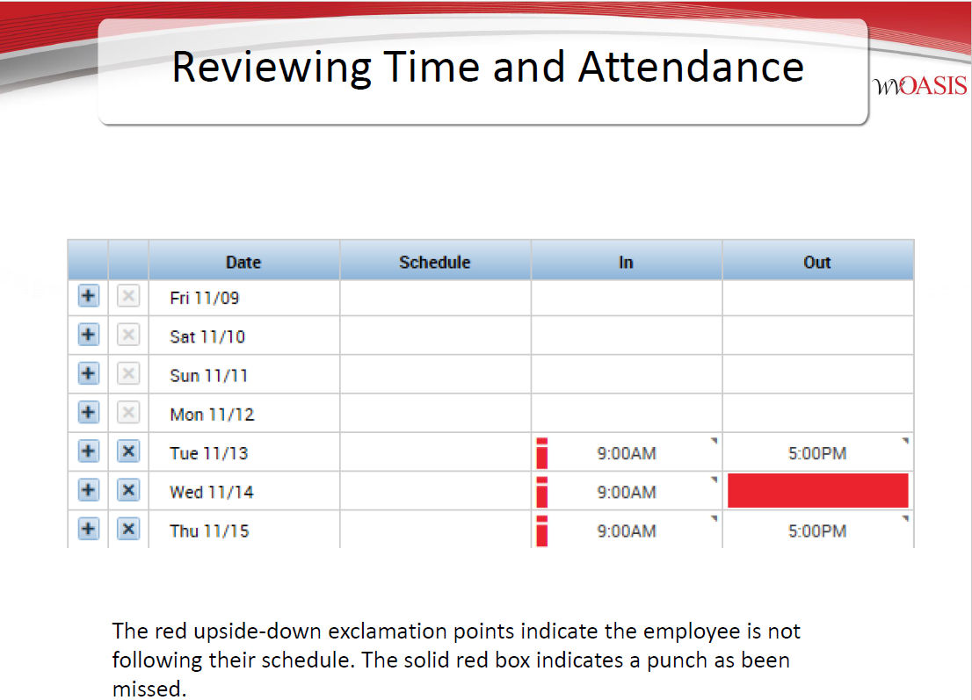

Also, a manual entry can be made by the supervisor/timekeeper directly to the timecard by clicking on “Pay Code” column then using the drop down menu select the leave type and enter the hours in the “Amount” column.

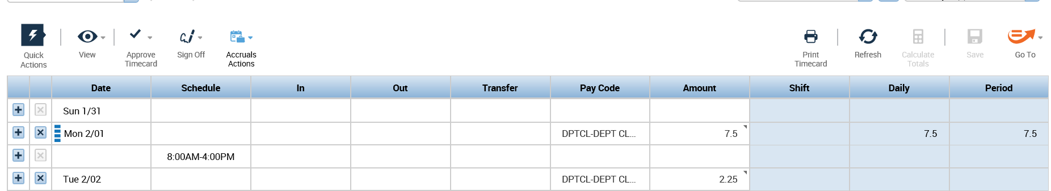

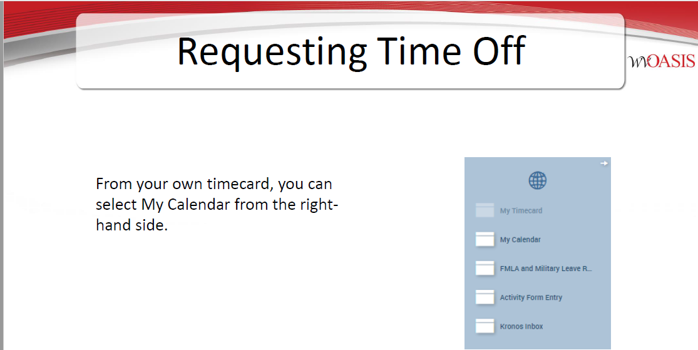

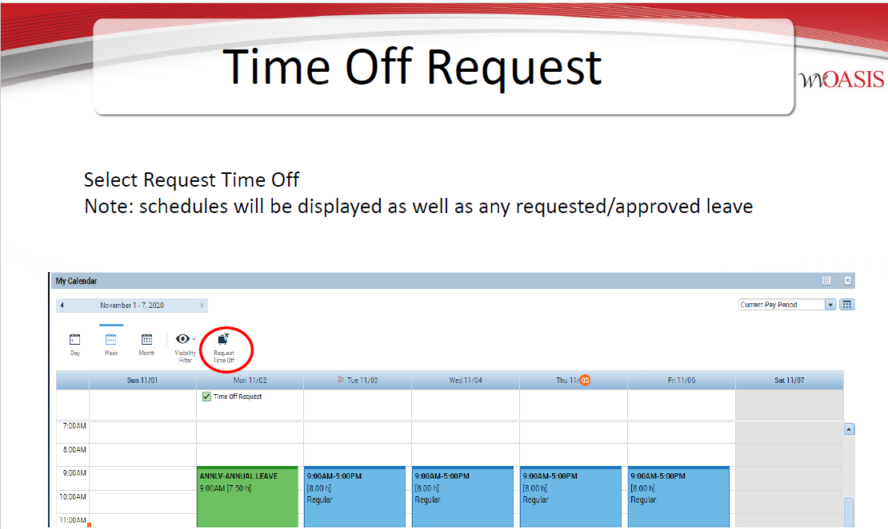
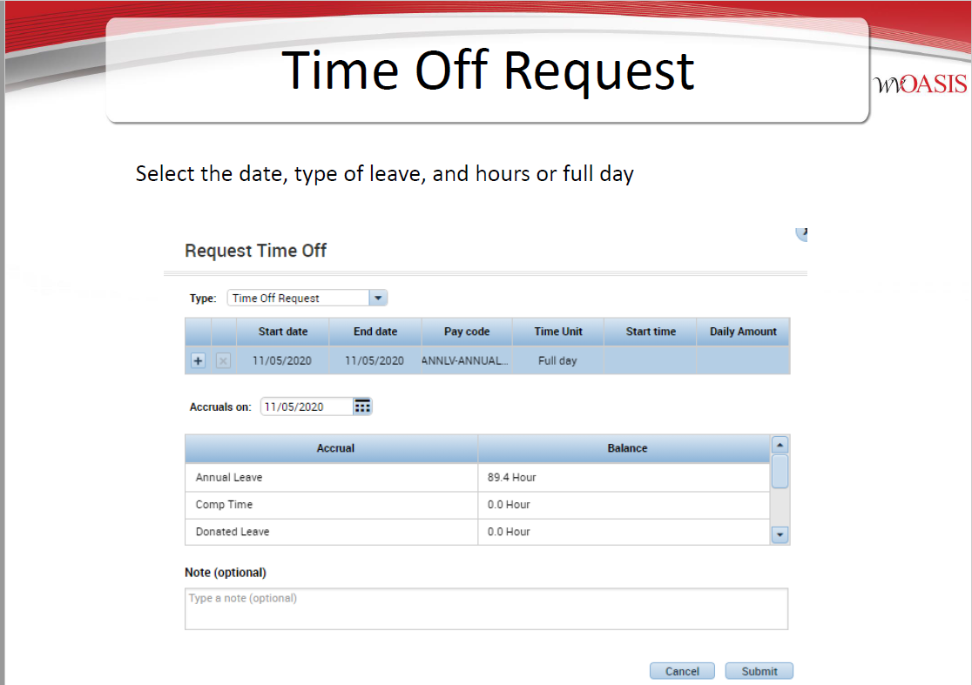
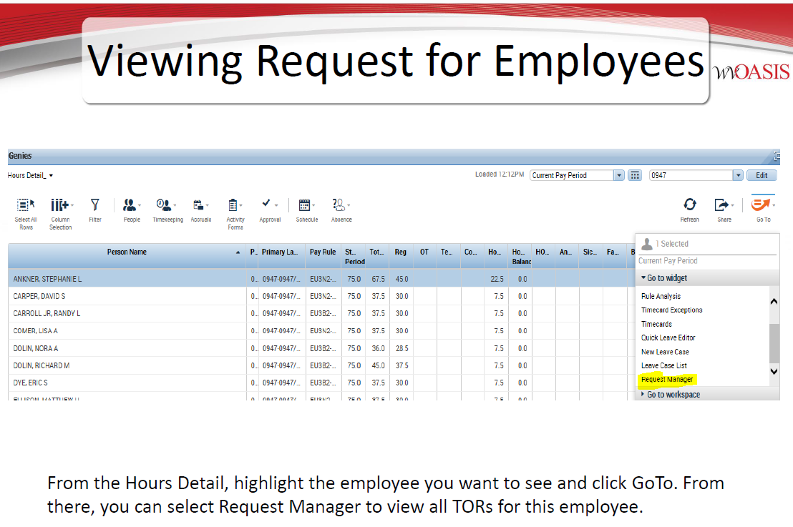
Directions to cancel an approved Time Off Request:

- Select “My Calendar” widget from the right side of your time card.
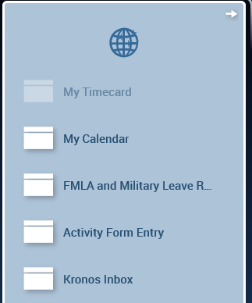

- Move your cursor to the right side of the column until the arrow appears.

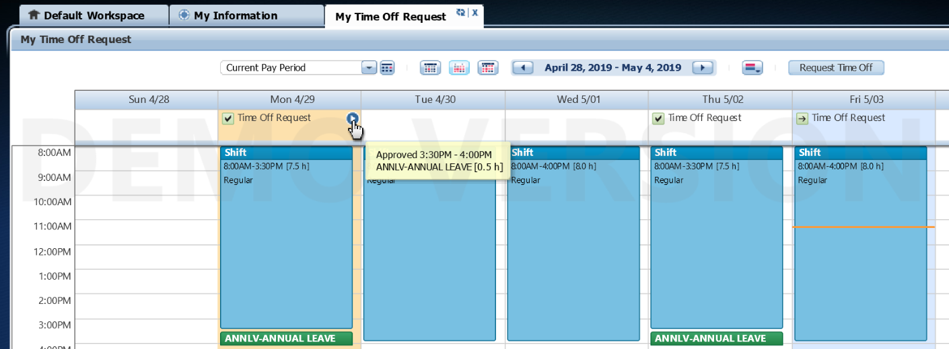
- Click on the arrow and then click on cancel. The cancel request will go to your supervisor for approval.

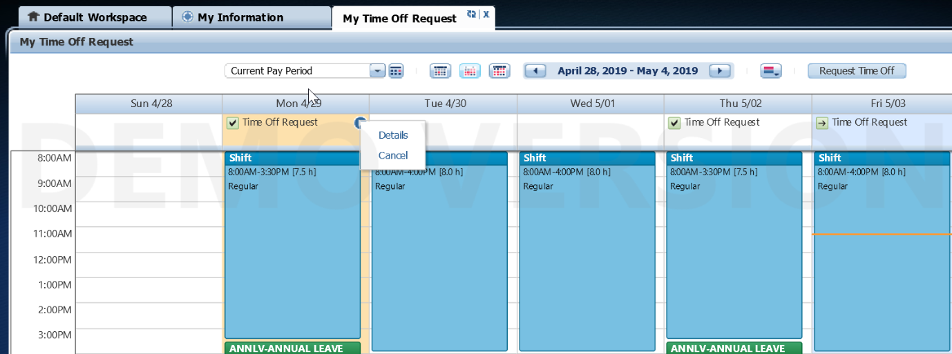
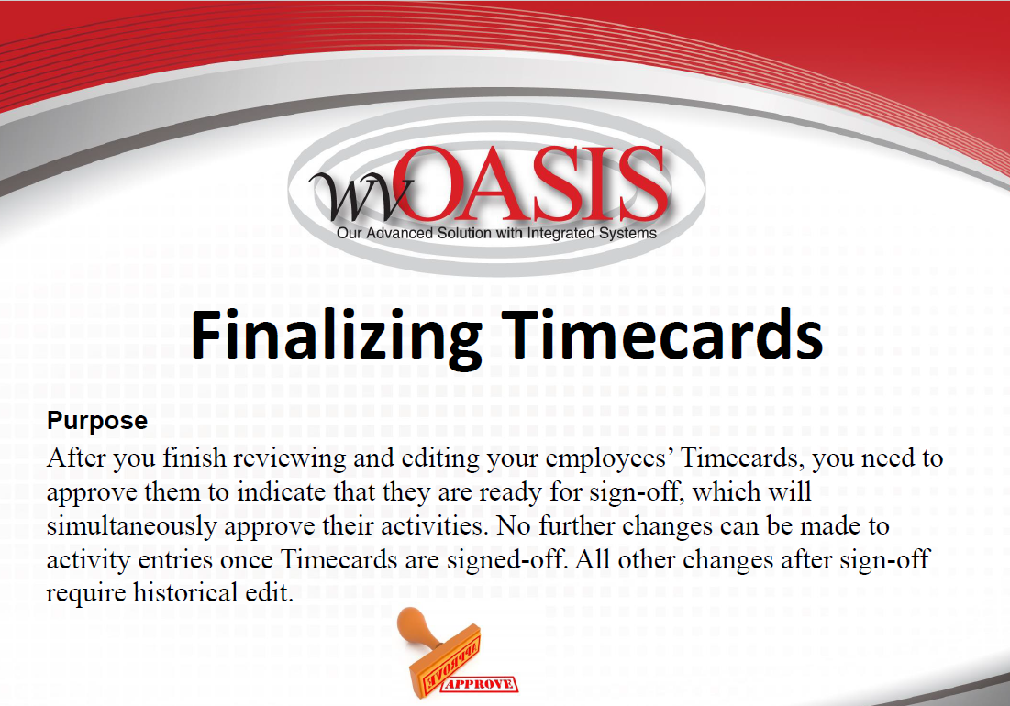

The timecard approval process is performed at the end of day on payday Friday in the current pay period, the latest by noon the following Monday of payroll week by selecting previous pay period. A reminder is sent prior to the approval deadline by the Payroll Department.
The best practice is for the employee to review their timecard and approve. Once the employee’s timecard is approved, then the supervisor/timekeeper will review and approve.
The final step is for the Payroll Department to sign off on the timecards Tuesday morning of payroll week and then no further changes can be made to the entries unless a historical edit is processed.
Any questions regarding the timecard can be directed to the Payroll Department.
***Both employees and supervisors/timekeepers must approve timecards**

