Hiring Managers
User Guide
For
Faculty/Staff Employment

Hiring Process

- Hiring Managers will complete the Faculty & Staff Requisition Request, located on the Human Resources web page (More information below), to start the process of filling a vacancy.
- The HR Generalist/Recruiter is notified via email that a request has been submitted.
- The HR Generalist/Recruiter will review the submission for accuracy and send the most current job description to the Hiring Manager for review/updates (Staff positions only-HR does not house Faculty job descriptions).
- The HR Generalist/Recruiter will create the requisition in NeoEd using the information provided on the Requisition Request
- The requisition will go through the approval process in NeoEd (Please see Updated workflow below).
- Once approvals are completed, the HR/Generalist Recruiter will post the vacant position on NeoEd, Indeed, LinkedIn, WorkForce WV, WLU Connect, and send a notification via email to Faculty/Staff. (Can post to others sites when requested and approved) Positions are posted and can receive applicants for two weeks initially or 10 business days. A request to extend the position may be made to the HR Generalist/Recruiter if a less than satisfactory candidate pool is received.
- The Hiring Manger will be asked to provide the HR Generalist/Recruiter with a list of Search Committee Members and designate who will be serving as Search Committee Chair.
- At this point, all further communication From HR will go to the Search Committee Chair.
- The HR Generalist/Recruiter will email the Search Committee Chair and attach all interview information/best practices, forms needed for hiring, and will offer interview training to those who are new to a Search Committee role or for those who may need a refresher.
- When the requisition starts receiving applicants, the HR Generalist/Recruiter will review closely and send only the qualified candidates through the SME review process in NeoEd. All committee members will receive notification from the NeoEd system that he/she has a candidate(s) to review.
- Once the position closes in NeoEd, the HR Generalist/Recruiter will contact the Search Committee chair to discuss the next steps. Either the posting will be extended or interviewing will begin.
- The Search Committee Chair will need to submit interview questions to the HR Generalist/Recruiter for review/approval.
- The Search Committee Chair will notify the HR Generalist/Recruiter when applicants have been chosen for an interview.
- The Search Committee Chair will schedule interviews with the applicants and provide days, times, and locations to the Search Committee members and HR Generalist/Recruiter. If anything changes from the original schedule, the HR Generalist/Recruiter needs to be notified.
- Once interviews have been conducted, the search committee members will submit his/her Interview Analysis Forms to the HR Generalist/Recruiter via email or hand delivery. The forms will be filed in the job folder. These forms will be completed during every round. (I.E.-If there are two rounds of interviews, the initial round via Zoom and the second round in-person, Interview Analysis forms will need to be completed each round).
- Once the Search Committee selects a candidate, the Hiring Manager will need to complete the Approval for Hire Request and submit it via email or hand delivery to the HR Generalist/Recruiter.(Staff Positions only-Faculty makes their recommendations to the Provost and the Provost submits the Approval for Hire to HR Generalist/Recruiter).
- When approved by the CHRO and President, the HR Generalist/Recruiter will make a verbal offer to the applicant being consider and specify that a formal offer letter will follow upon completion of references and background screening.
- Once the applicant accepts, the HR Generalist will notify the Hiring Manager of the anticipated start date and begin onboarding the new hire. If the start date is altered or something is flagged on the background screening, the Hiring Manager will be notified immediately.

How to Complete the Requisition Form
1. Go to the West Liberty webpage and click on Human Resources. Under employment, click on Requisition and Hiring Information.
2. Click on the following link: Faculty and Staff Employment
3. Section 1: This section lists what information is needed to complete the form
4. Click “Next”
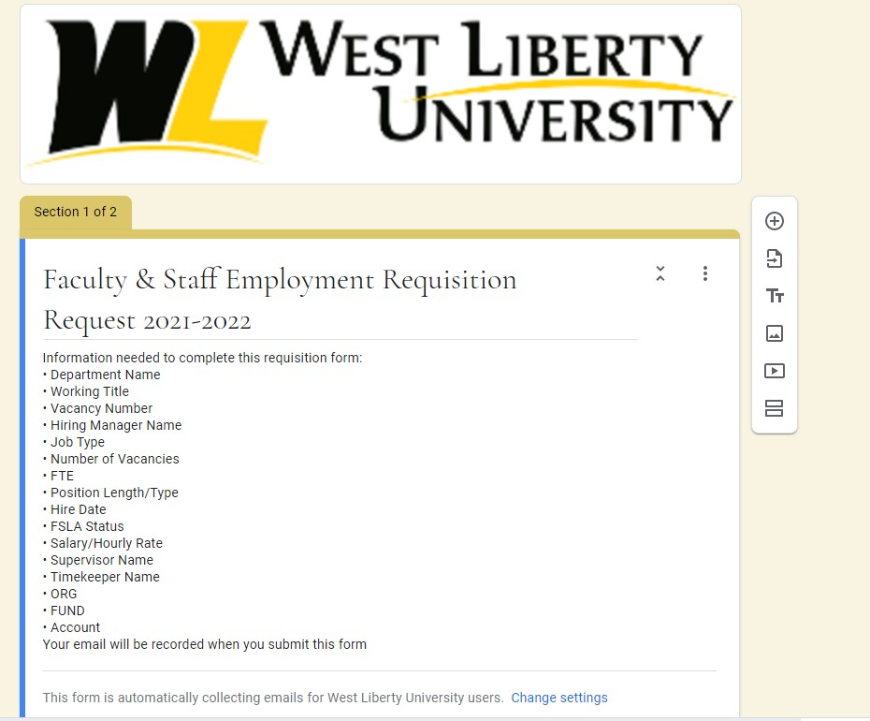

5. Section 2: Answer each question box as applicable and/or required. Answers will be in the form of a short answer, selection from a drop down menu, date, or simply clicking directly on the selection.
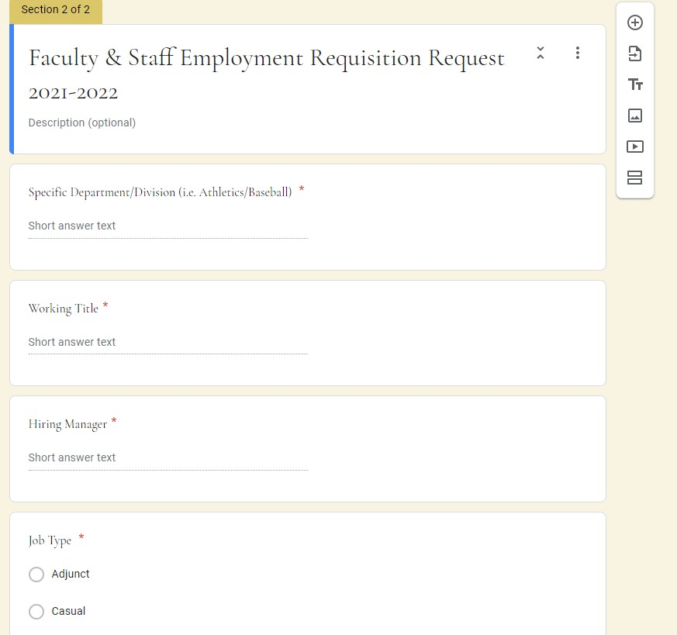
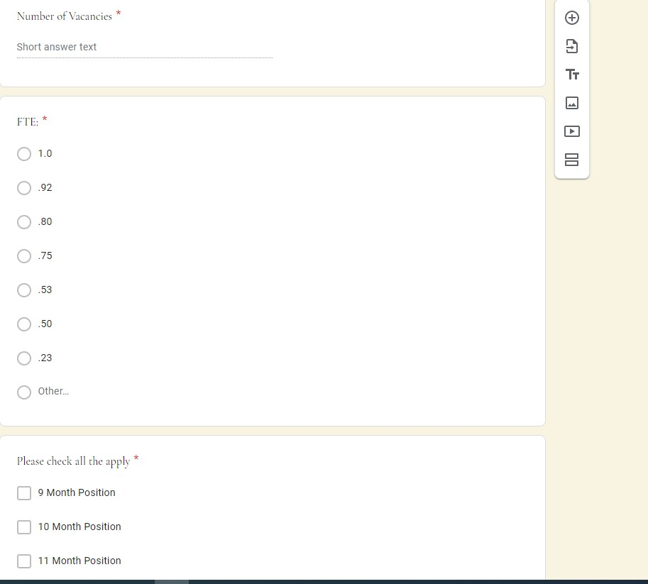
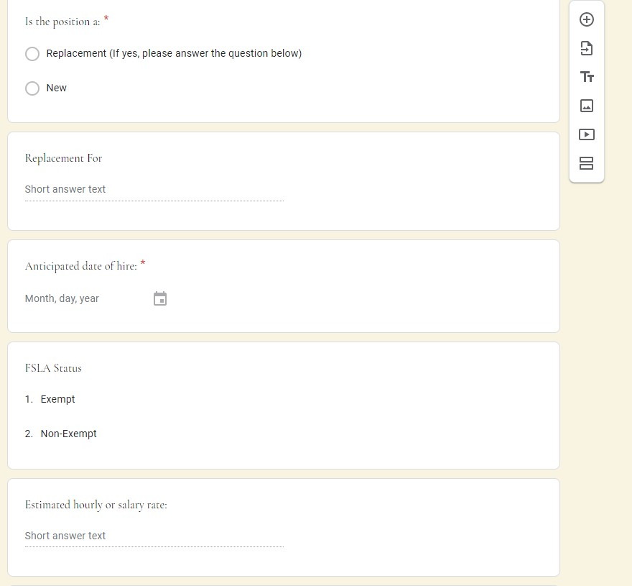
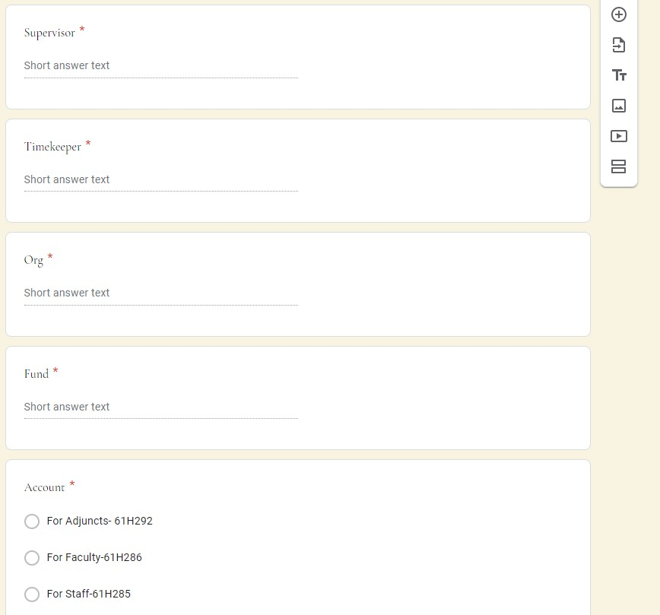

6. Select “Send me a copy of my responses” if you prefer.
7. Click “Submit” when completed.
8. Contact Emily D’Aquila, HR Generalist/Recruiter with any questions. Her contact information is as follows:
Phone: 304-336-8029
Email: Emily.d’aquila@westiberty.edu

Hiring Approval Workflow

