Human Resources

PERFORM Implementation – Manager Guide

Overview
_____________________________________________________________________
This guide details how to navigate the system as a Manager, covering how to add Journal Entries and Rate Direct Report Evaluations.

Journal Entries

Who Should Use This Section

Any user logging and sharing their journals throughout the year. Journal Entries are an easy and effective way to take notes of accomplishments throughout the year for yourself and your direct reports.

Navigating to Journal Entries

There are several ways to log Journal Entries in Perform. They can be created from the Journal Hub, from the Dashboard, and from the Talent Profile.

Adding Journal Entries via the Journal Hub

All managers have access to their Journal Hub. The Journal Hub is a central location where you can find all
Journal Entries that you have created or have access to (those shared with you).

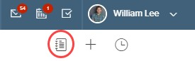
The Journal Hub icon is always accessible to the user, no matter what page they are viewing in Perform.

Select the Journal Hub icon and a fly-out displays the Journal Entries Hub. 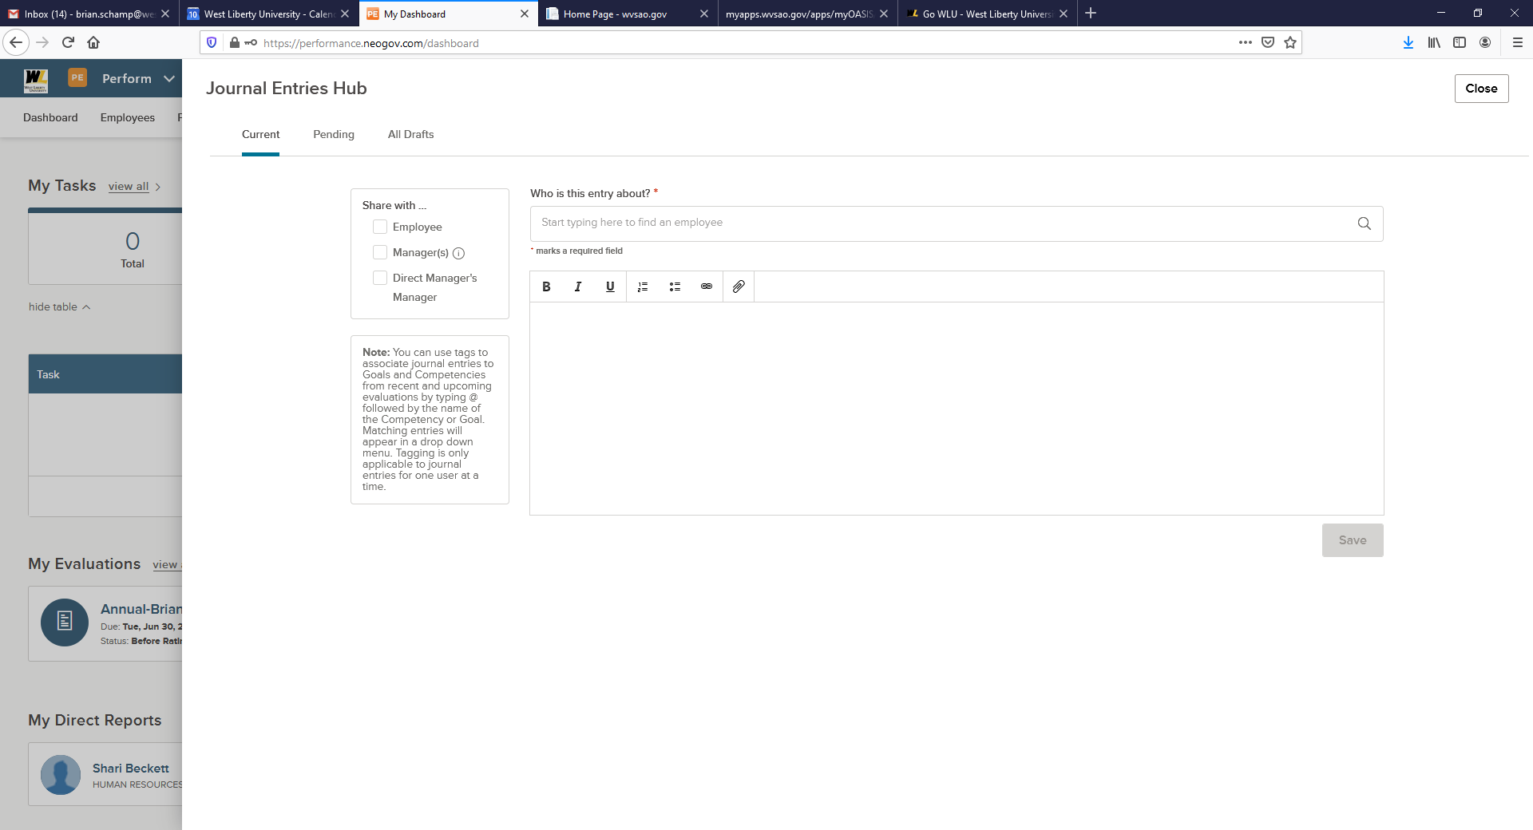

- Current: Journal Entries successfully posted are found in the Current tab
- Pending: Journal Entries unsuccessfully posted can be found and corrected in the Pending tab
a. Once corrected, the Journal Entry is posted to the Current tab
- Who is the entry about? Search for any employee to create a Journal Entry for, including yourself or any direct reports. Once someone is selected, any posted Journal Entries that you have access to displays at the bottom of the hub.
- Share with: this option is used to share visibility to the Journal Entry.
- Body of Journal Entry: Utilize the rich text editor when entering the text of your Journal Entry
a. One attachment can be included (5MB)
- Save: Select Save to post the Journal Entry
- Close: Select Close at any time to close the fly-out and return to the previous page. Any unsaved Journal Entries are lost.
Let’s review what it looks like to log a Journal Entry from the Journal Hub. 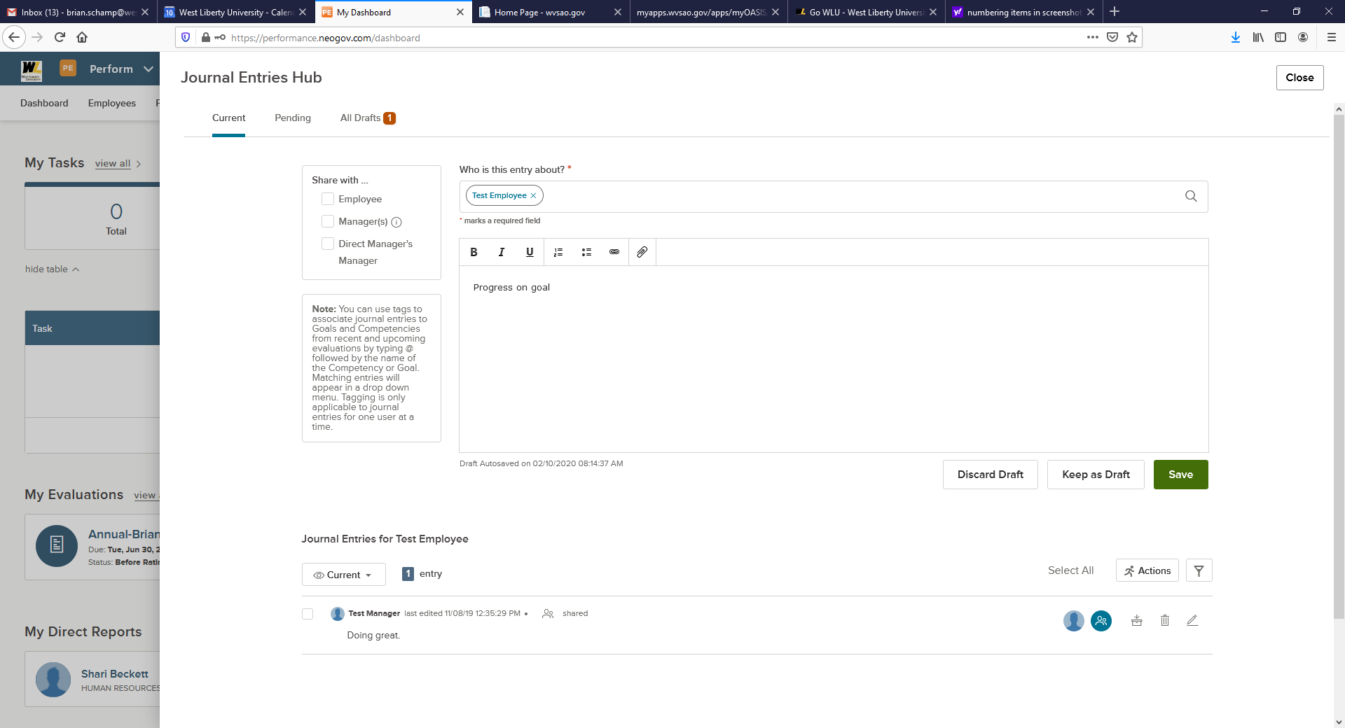
- Enter the name of the employee for whom to create a Journal Entry
a. Any Journal Entries you have access to for that employee displays below
- Use the Text Editor to enter the Journal Entry and style as necessary
a. You can add one (1) attachment to each Journal Entry
b. To tag a Competency, Goal, or Narrative, enter ‘@’ and type the desired competency, goal or narrative. A list of matching items appears. Select the correct item. This assists in searching for this particular Journal Entry when rating
- Use the menu to toggle between Current entries, Archived entries and All Drafts
- You can share, archive, delete and edit your entries

a. To share, select the blue people icon
i. Share Journal Entries created for your Direct Reports with that direct report or your manager
ii. You can share Journal Entries created for yourself with your Manager and your
Manager’s Manager
iii. The default setting allows sharing up to two levels in the organizational hierarchy.
b. Archive a Journal Entry by selecting the archive icon to de-clutter the system, making it easier to search through feedback entries
i. Once archived, the entry moves from your current list to the archived list. The archived entry no longer appears for selection in the rating form
ii. To unarchive, select the unarchive icon
c. To delete any entries you created, select the trash icon d. To edit your entry, select the pencil icon
- Use the Bulk Actions menu to Archive, Delete, Print with Attachments, and/or Print without
Attachments
- Once you have added all comments, attachments, and tagged evaluation items, select Save

Adding Journal Entries via the Dashboard

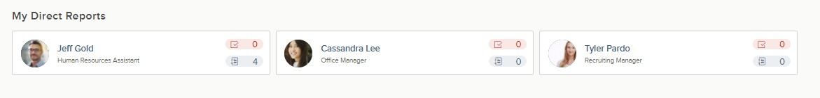
You can create Journal Entries for your direct reports via the My Direct Reports section on your dashboard.

Select the blue journal icon for the direct report you would like to create a Journal Entry for. A
fly-out appears with all Journal Entries you have created for that employee previously, and any that have been shared with you about them.

Adding Journal Entries via the Talent Profile

Navigate to the desired employee’s Talent Profile page by selecting their name on the Employee List.

From your direct report’s Talent Profile, select the Journal Entries button, in the top right corner.

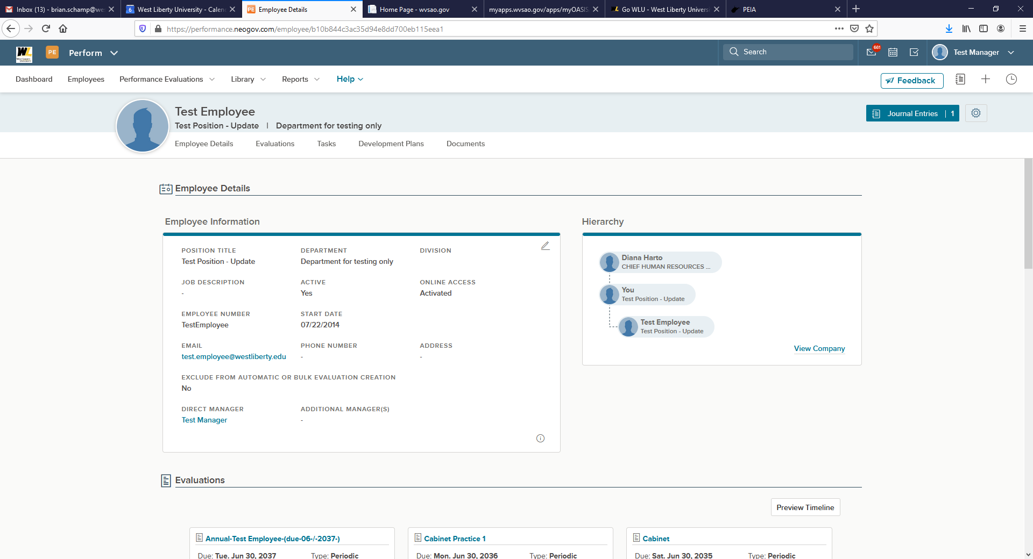

A fly-out appears with all Journal Entries you created for that employee previously. This fly-out will also allow you to enter a new Journal Entry for the employee.

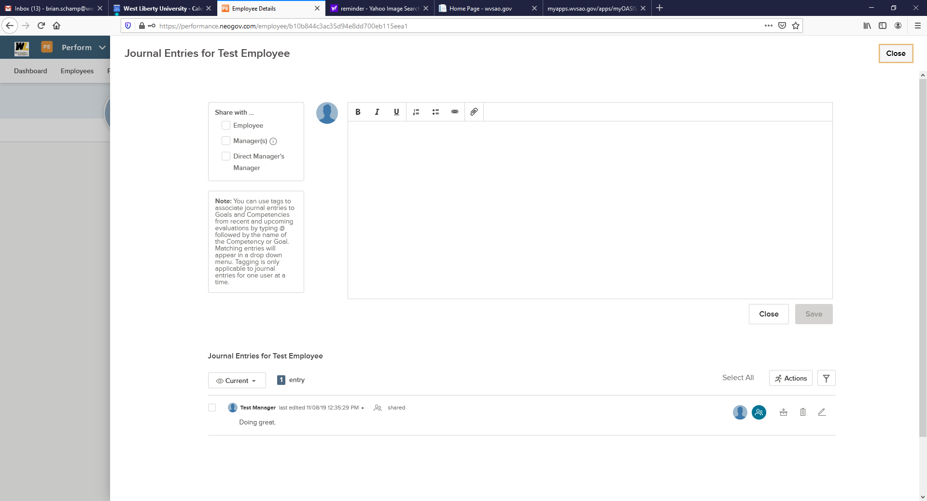
Rating Your Direct Report’s Evaluation

Who Should Use This Section

As a manager, you will be required to complete a rating for your direct reports. This section covers how to rate an evaluation and what useful tools you can use.

Navigating to My Tasks

My Tasks is located on your Dashboard. Upon logging into Perform, you land on your Dashboard. To navigate to your dashboard from any other page in Perform, select NEOGOV in the top left corner. Here, you see a task to complete the Rating.

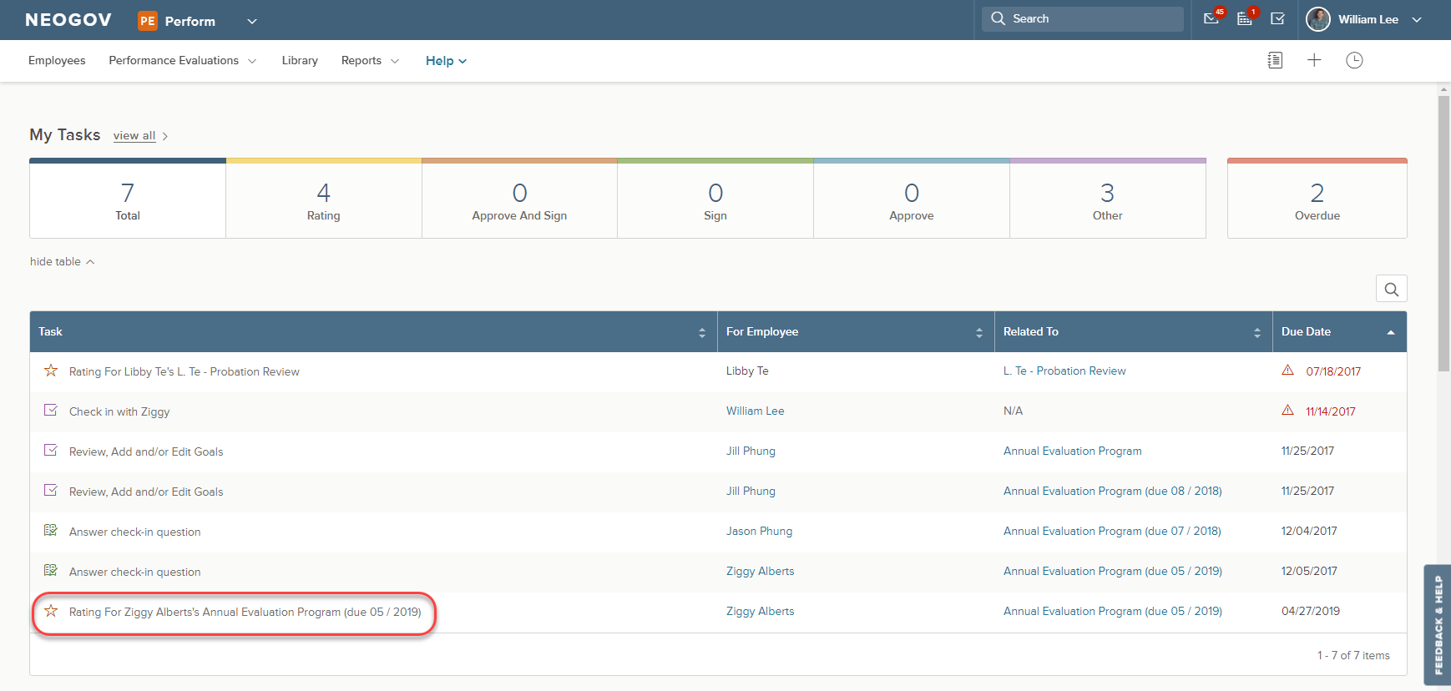
To complete a Rating, click the rating task name on the dashboard.

The link re-directs to the Rating Form.

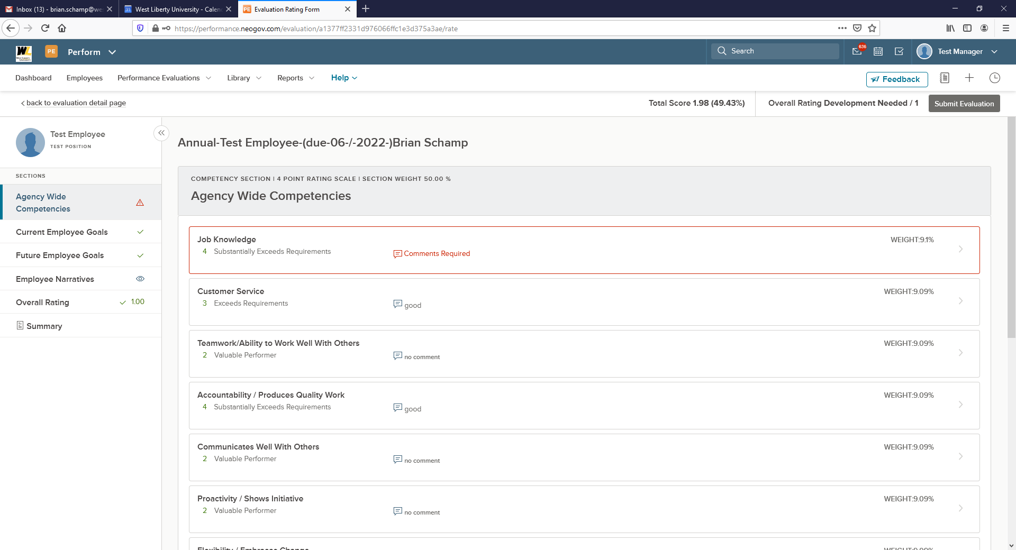

1. To view and rate different items, click the various sections
2. To rate an item, click an item name, e.g. Employee Narrative, within a section, and a fly-out of the
Rating Card appears (see below for further information)
3. To leave the rating card and return back to the evaluation detail page, select back to evaluation detail page

The following legend can be used to identify the different symbols in the evaluation sections:

= Required section, action required
= Read only
= Section completed

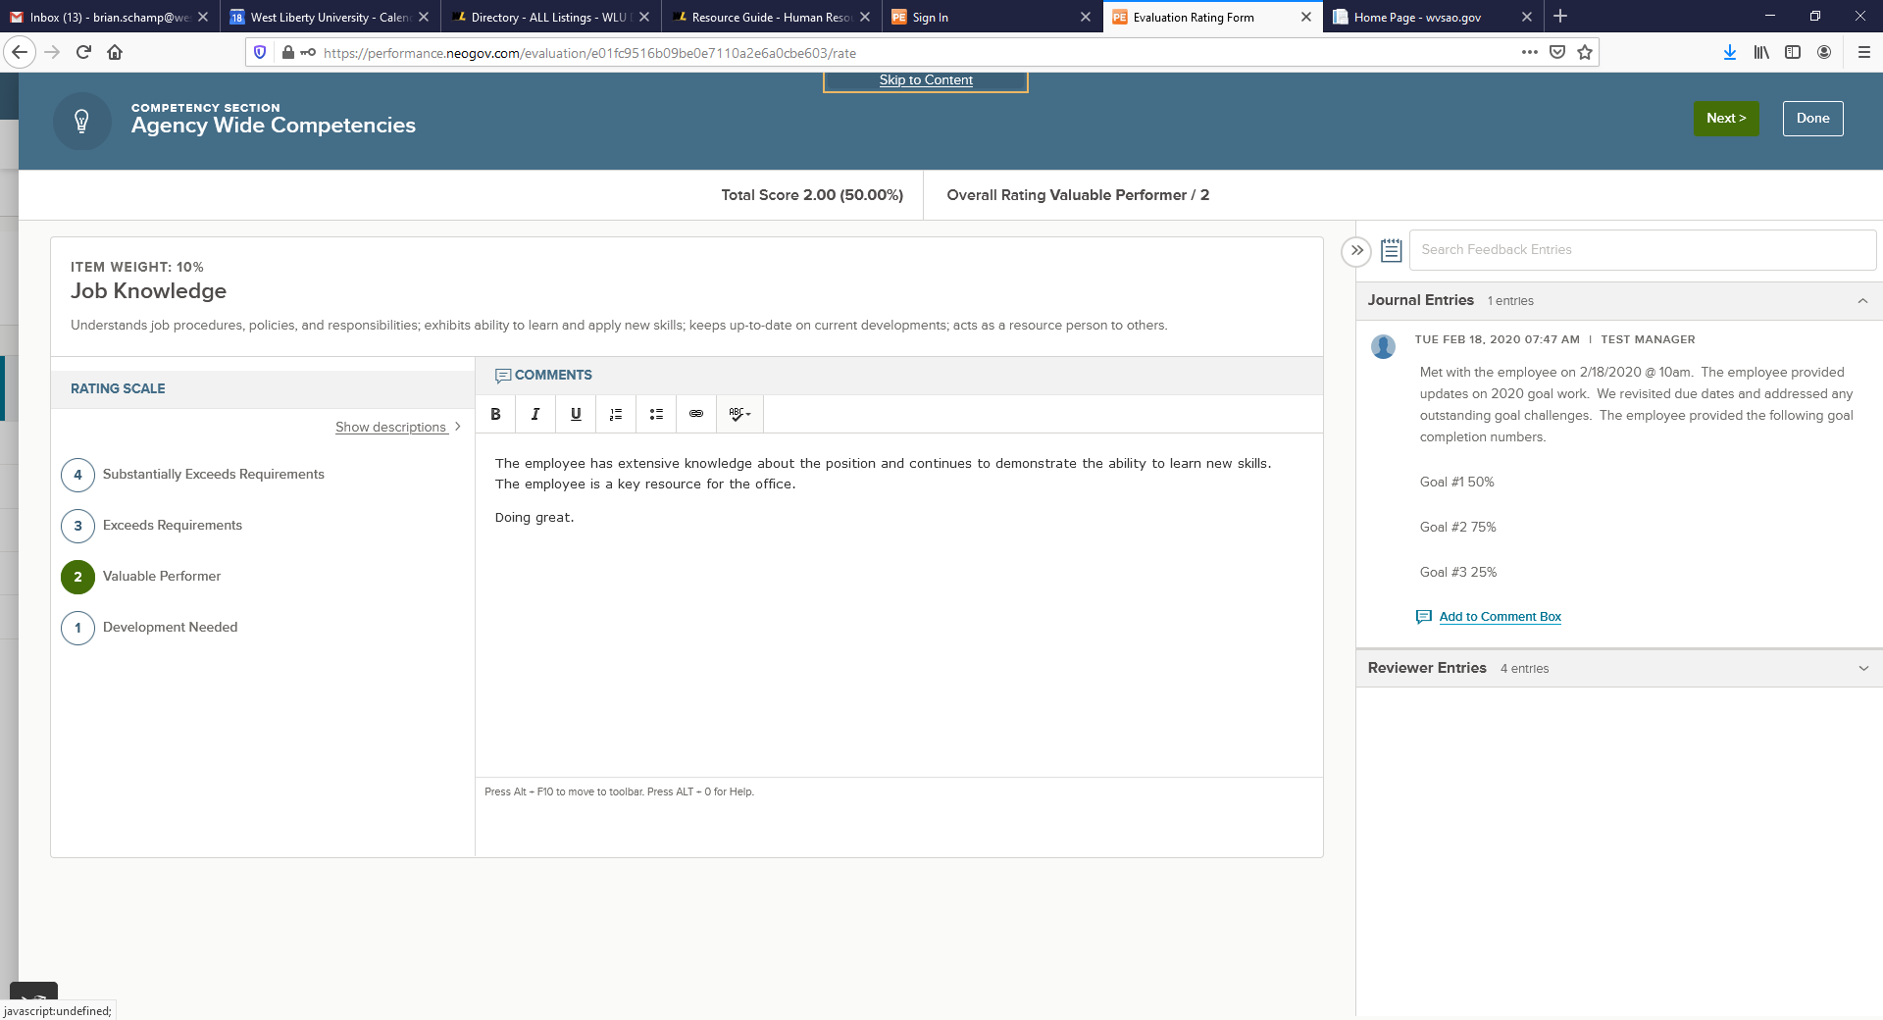

1. Select the Rating Scale Score from the Rating Scale Section
2. Type any text into the Comments box, as needed. Edit text using the text editor provided a. Per HR configuration, if a comment is required the box is highlighted in red
and a comment must be placed in the box.
b. While rating, the system auto saves all progress made
c. If needed, you may exit out of the rating card and resume rating at a later time
3. The Feedback Entries appear on the right side of the rating card.
a. Any Journal Entries created by you or shared by another employee appear here
4. Once you have scored and commented click the Next button to score the next item.
5. Once you have scored the Agency Wide Competencies and Current Employee Goals the system
Will direct you to the Future Employee Goals Section

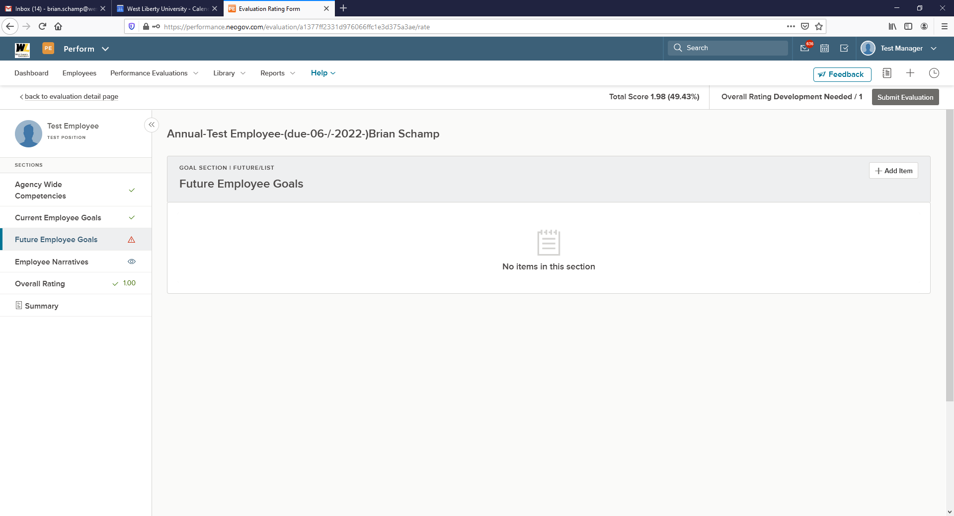

Future Goals are a required part of the evaluation process. Future Goals are goals that the employee will begin working on July 1st.

6. Click the + Add Item button
7. Select New Goal Option
8. Begin adding goal information on the Add Goal screen
9. Click Save

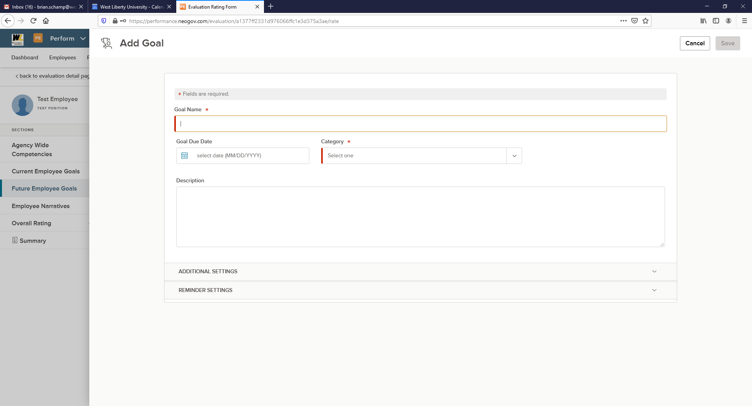

10. Continue adding additional goals as needed.

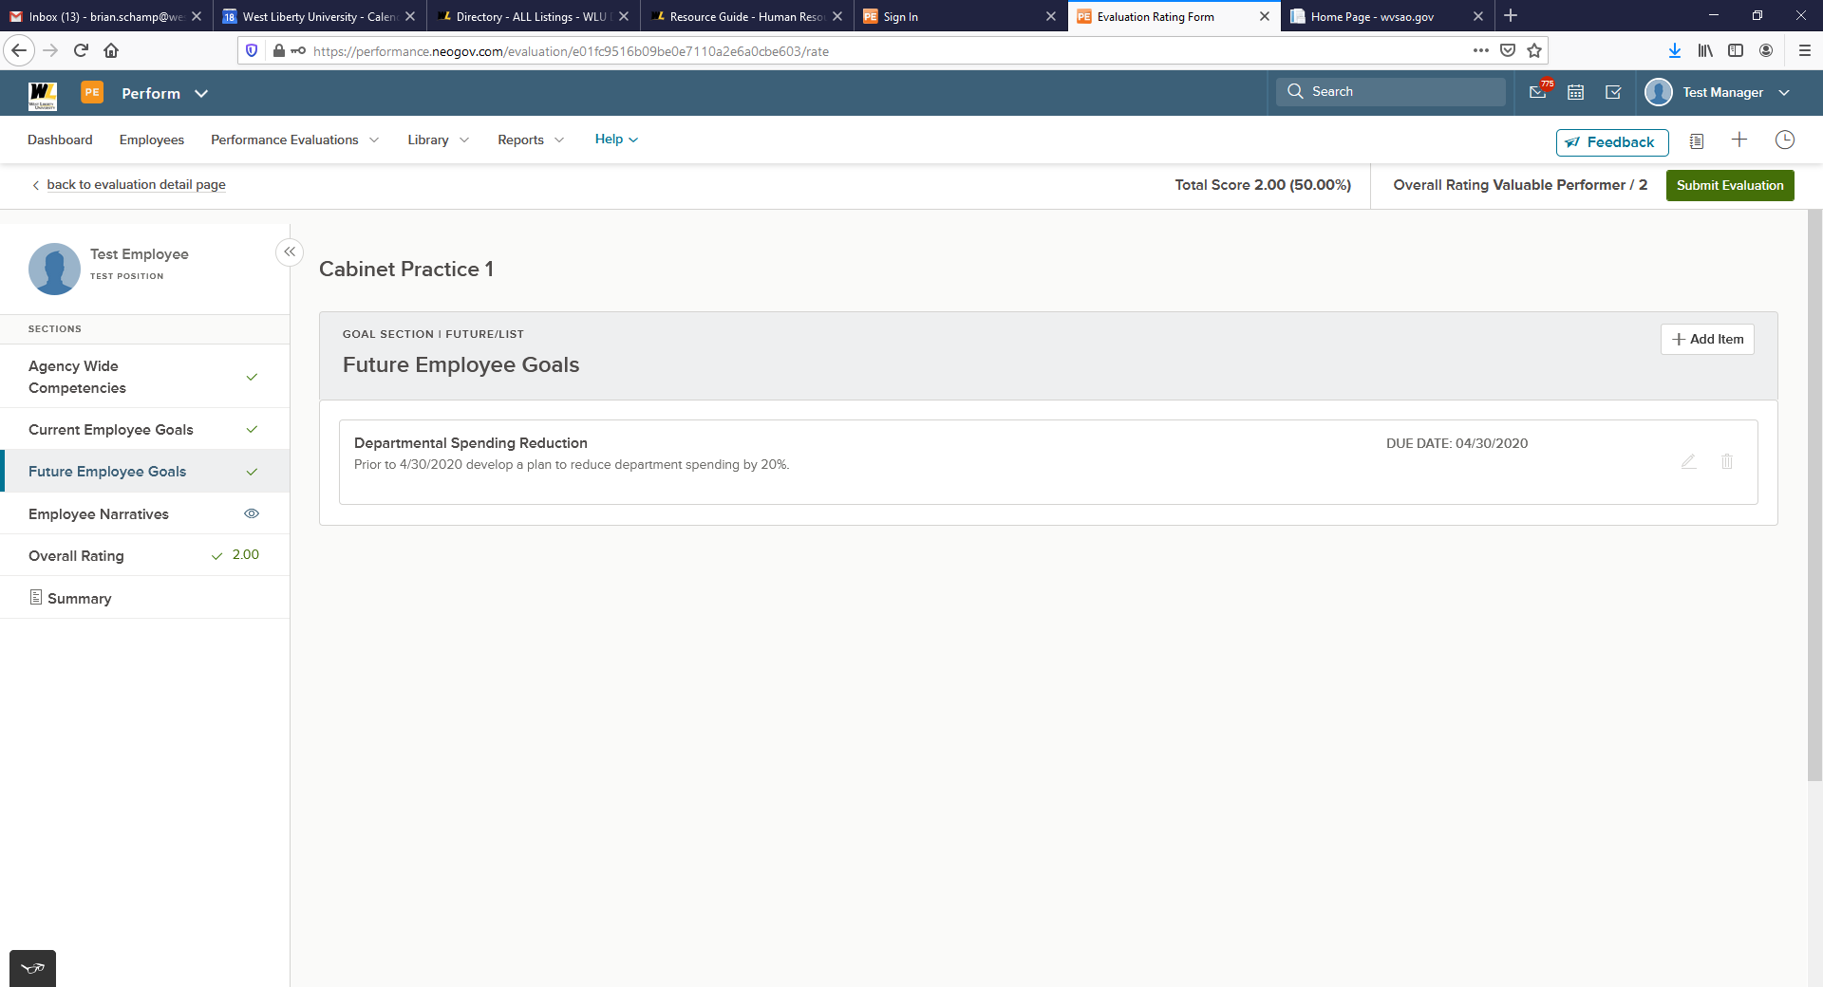
11. Notice the Total Score has now populated at the top of the screen.
12. Click the Summary option on the left side to see a summary of the evaluation.

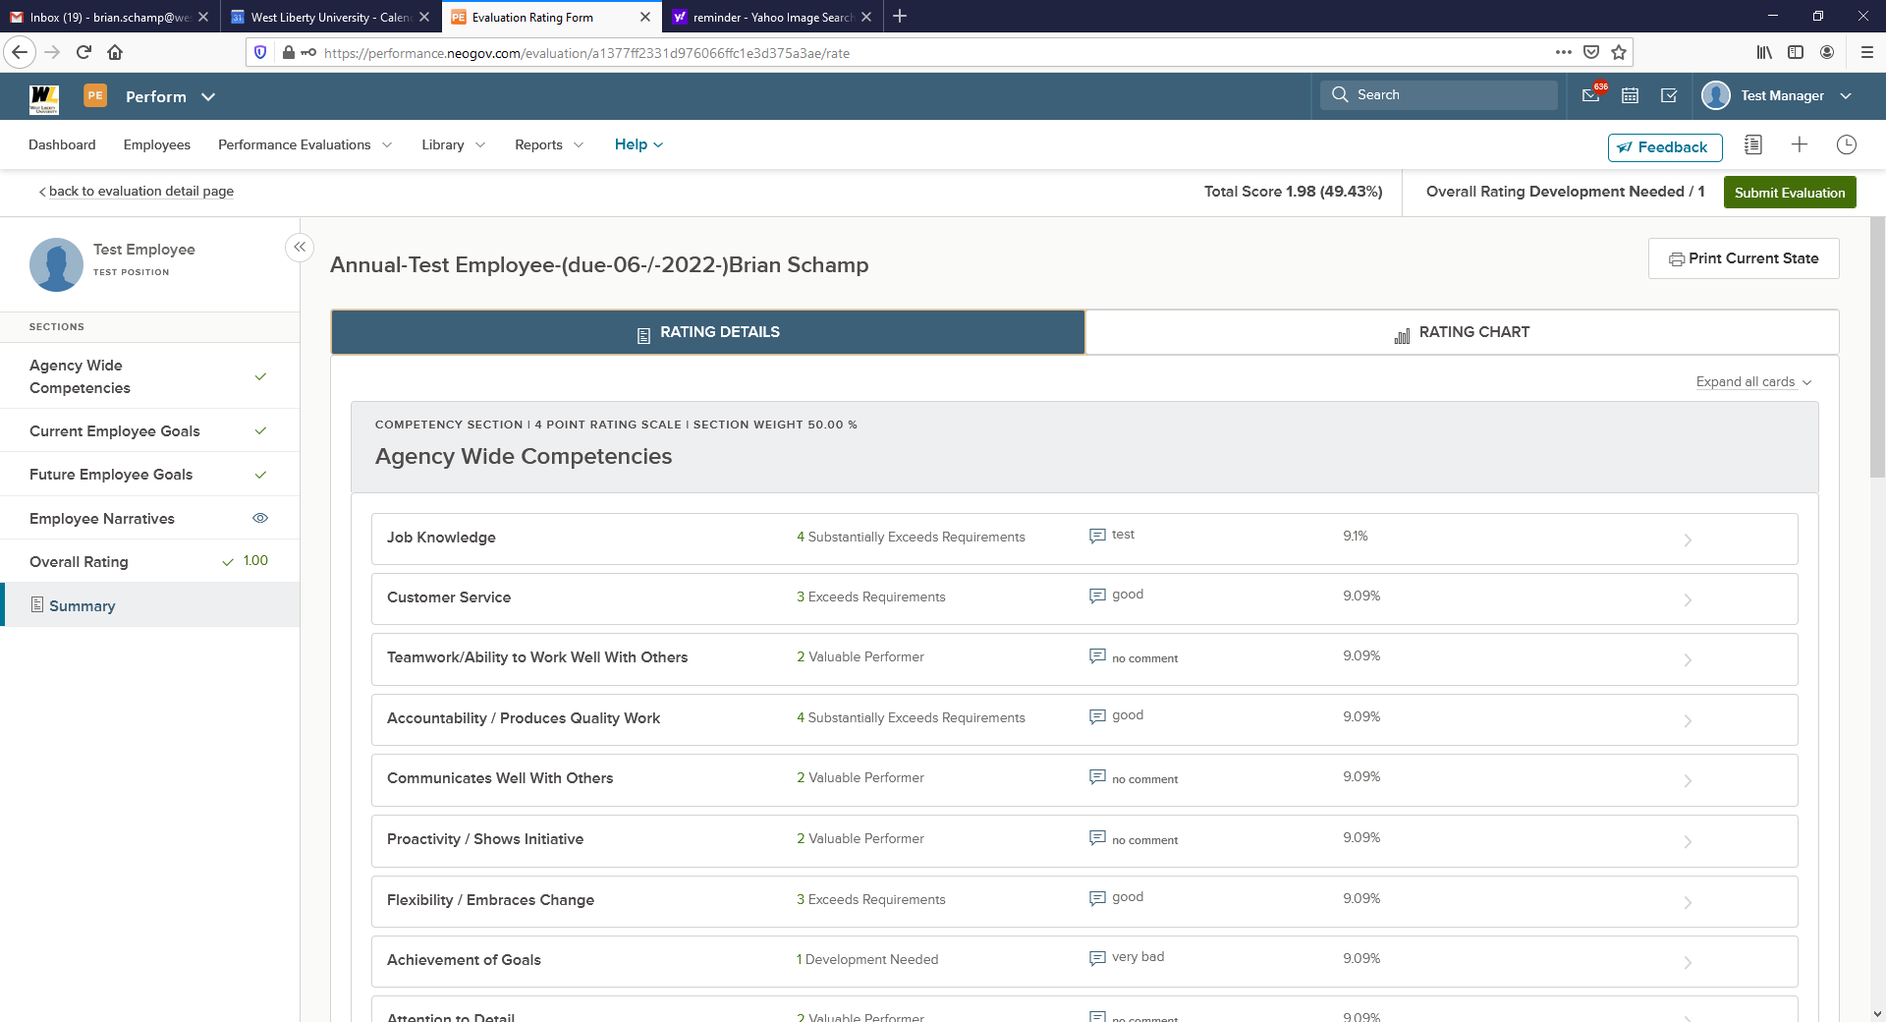

13. Once all required rating and/or comments are complete, select the Submit Evaluation button in
the top right corner.

You will receive a confirmation message. Once the evaluation is submitted changes can no longer be
made without the assistance of HR. If further changes are needed, click Cancel. Otherwise, select Continue.
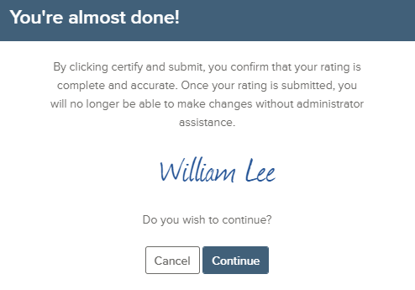

Once your evaluation has been successfully submitted, your Manager is notified.

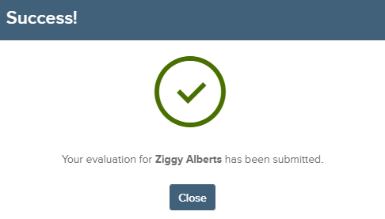

Once you click Close no additional action is needed at this point. The NeoGov system will notify you via email when you need to complete the Approve and Sign Task. You will then proceed to the Approving and Signing Section below.

Approving and Signing an Evaluation

Who Should Use This Section

After all Raters have completed their rating, you will have to Approve and Sign the evaluation before it is released to the employee. You will receive an email notification and the task will appear on your dashboard.

Navigating to My Tasks

My Tasks is located on your Dashboard. Upon logging into Perform, you land on your Dashboard. To navigate to your dashboard from any other page in Perform, select NEOGOV in the top left corner. Here, you see the task to Approve and Sign the completed evaluation.

Click the Approve and Sign task from the task list on your Dashboard. If there are multiple tasks requiring your action, you can use the Approve & Sign filter to limit the tasks displayed on your Dashboard.

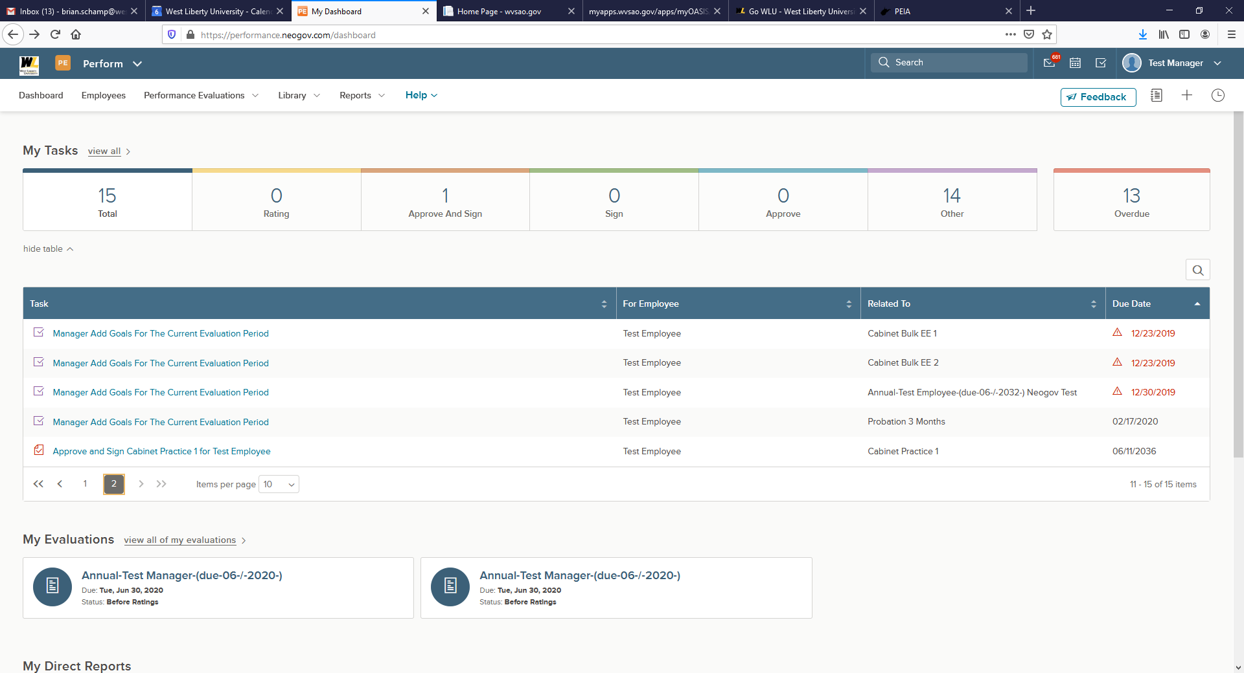

The Approval Form displays.

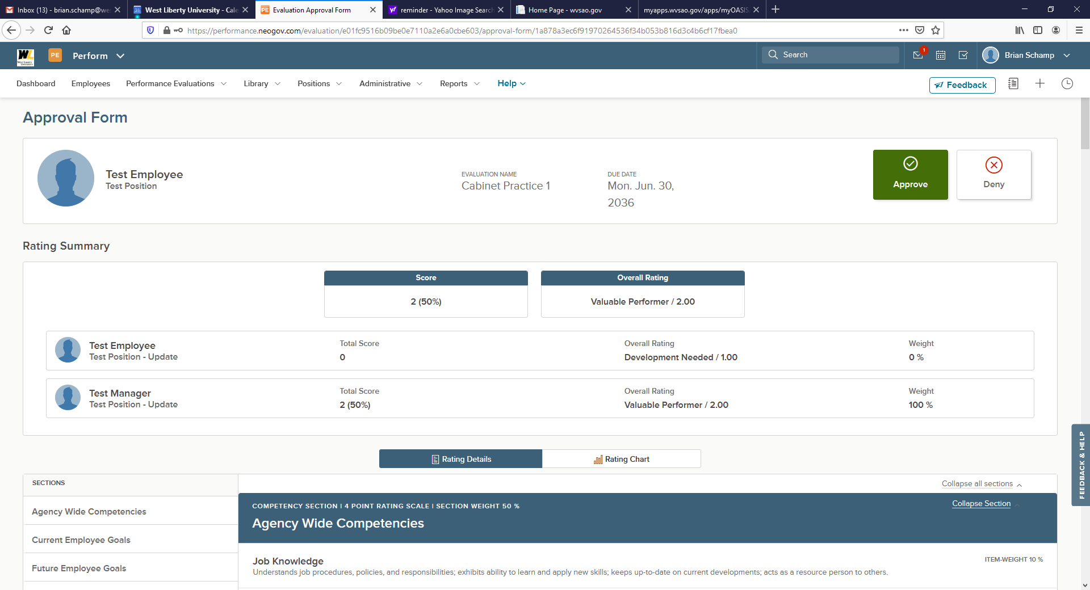

1. Rating Summary: Displays the overall score and all raters with their respective scores
2. Navigate through the various Sections by clicking on the name
a. Scroll through each section to review the ratings and any comments provided
3. Toggle between the Rating Details or the Rating Chart
a. The Rating Chart displays a bar graph of all raters
4. Once you have reviewed the evaluation, select approve & sign, or deny
a. If deny is chosen, based on HR configuration, the system will route the review back to the rater, and you must enter in a comment

Once you have reviewed the evaluation and selected the approve & sign button, a fly-out appears.

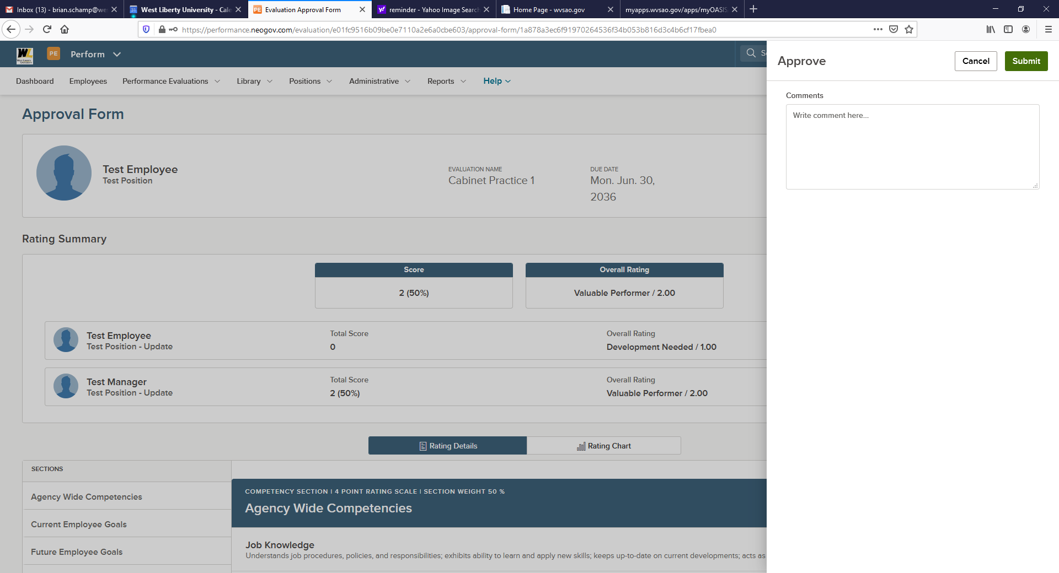

Enter any comments, sign and submit. Once approved, a green success banner appears and you are re- directed to the evaluation page. The evaluation has been successfully approved and signed. An email is generated to the next approver in the process. If you are the last approver/signature in the process, the evaluation status changes to Completed.

