Human Resources

PERFORM Implementation – Employee Guide

Overview
This job aid provides the steps for employees to update goals and narrative in the online performance evaluation product, PERFORM, from NEOGOV.

Before You Use This Guide
Your HR Admin must send you an activation link to activate your account. Once activated, you may log into your Perform account and complete any assigned tasks.

Login
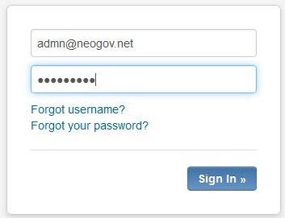
To log into Perform, go to: https://performance.neogov.com/login.

- Enter your username and password then click Sign In:

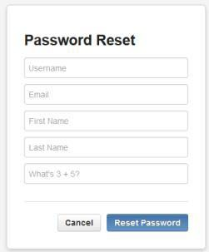

- If a password reset is required, click the “Forgot your password?” link. After entering the required information, an email will be sent to the email address in your profile containing a hyperlink to set a new password.

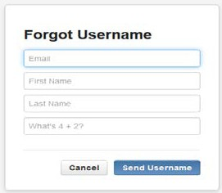

- If the username is forgotten, click the “Forgot username?” link. After entering the required information, a confirmation email will be sent to the email address in your profile with the username.

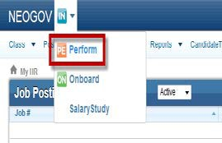

- Employees with access to other NEOGOV products, such as Onboard, may also use the App Menu to toggle over to Perform as the username / password combination is consistent across products.
Start Here
To access NEOGOV PERFORM for employees:
Login
Section 1 - Login
- Click on the hyperlink, System Acknowledgement Task, within the email you received from NEOGOV PERFORM then login into NEOGOV
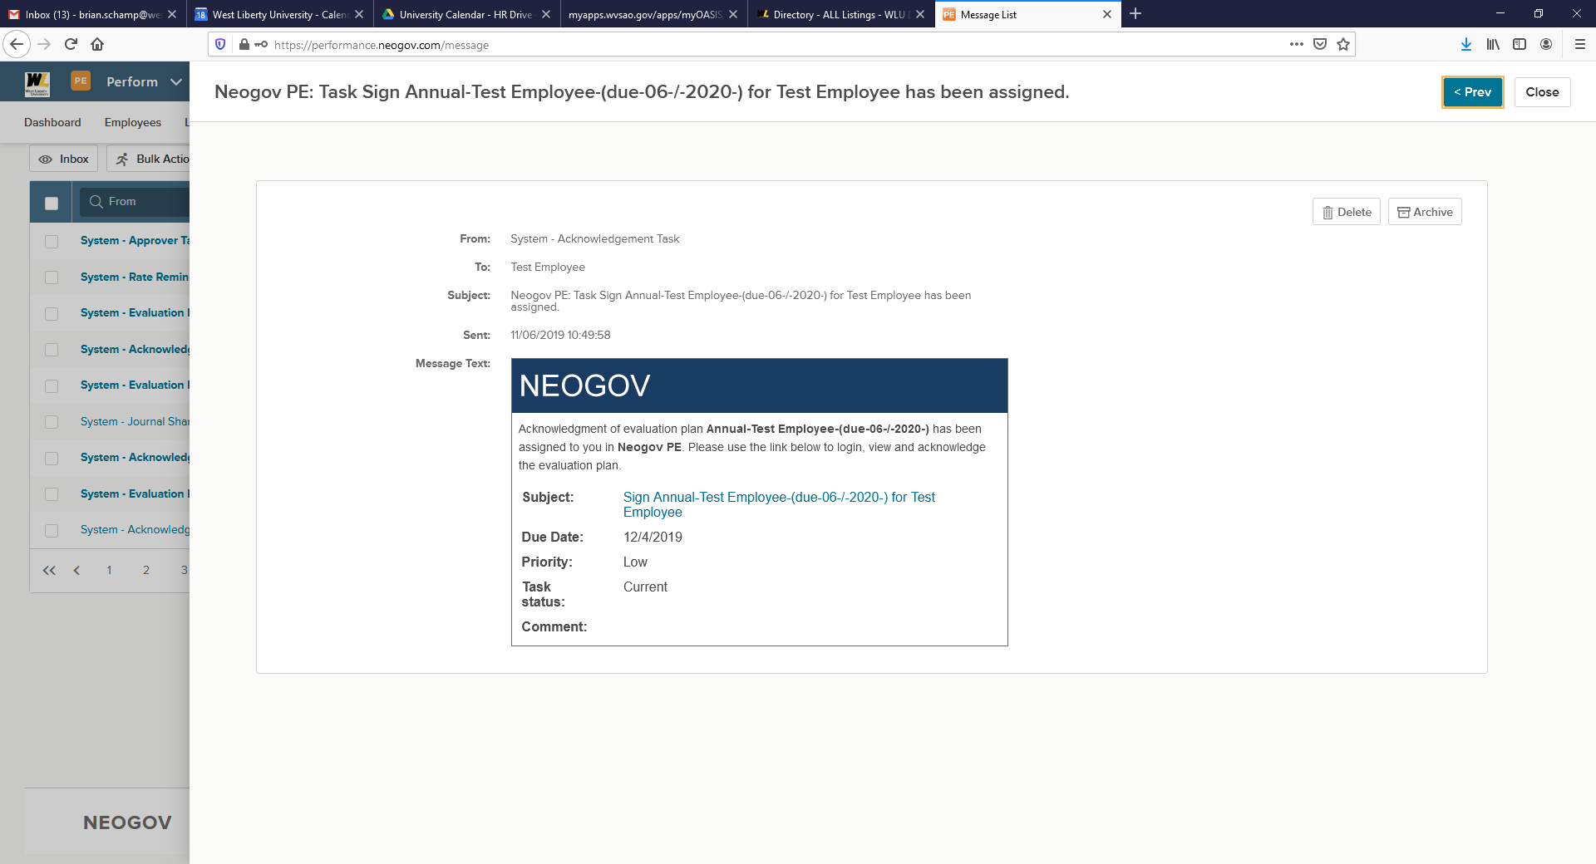

- Or access via the NeoGov website directly at www.NEOGOV.com

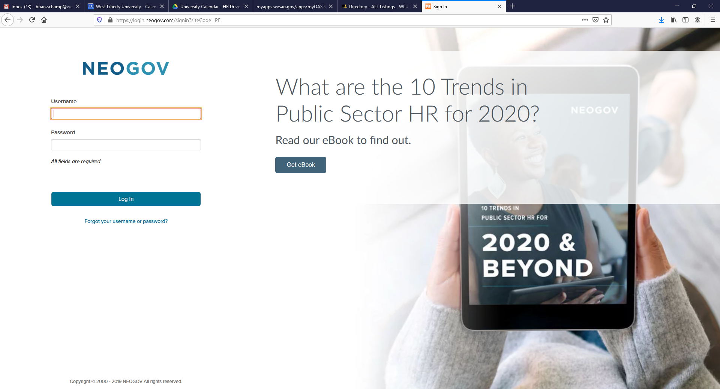

Section 2 – Navigating the Dashboard
Evaluation Dashboard
Upon logging into NeoGov you may need to select Perform from the menu in the upper left hand corner.
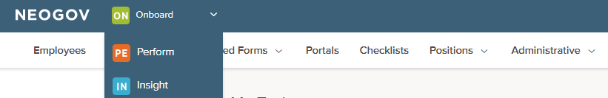

Upon logging into Perform, you will arrive at your Dashboard. The Dashboard is a central location from which all tasks can be completed in the system.

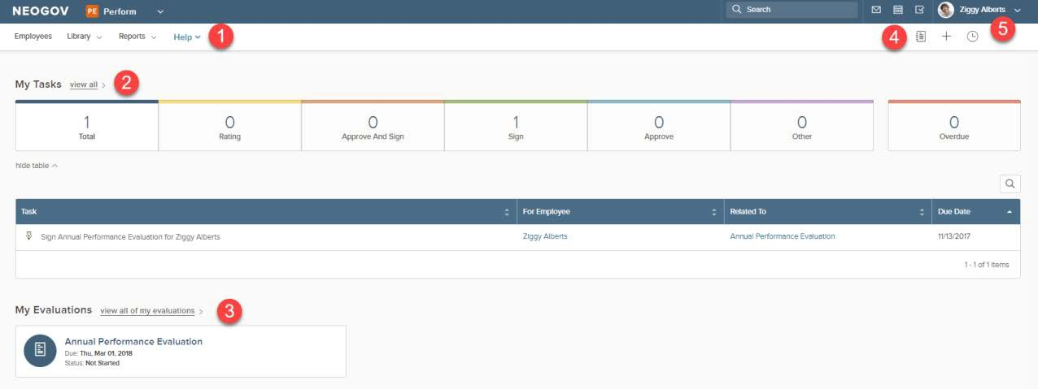

1. Dashboard Menu: Based on HR Configuration you see the following tabs:
• The Employees List
• The Library
• Reports
• Help
2. My Tasks: Contains all tasks currently requiring your action
• Color-coded boxes located within this section can be used to filter the various task types
3. My Evaluations: Displays your three most recent performance evaluations (if applicable)
4. Journal Hub: Contains all Journal Entries that you have created, as well as any pending entries
5. My Profile: Access your Talent profile, update your password, and sign out of Perform.

In-App Help

Both In-App Guidance and Helpful Hints allow users to receive guided assistance directly within Perform.

Using In-App Guidance
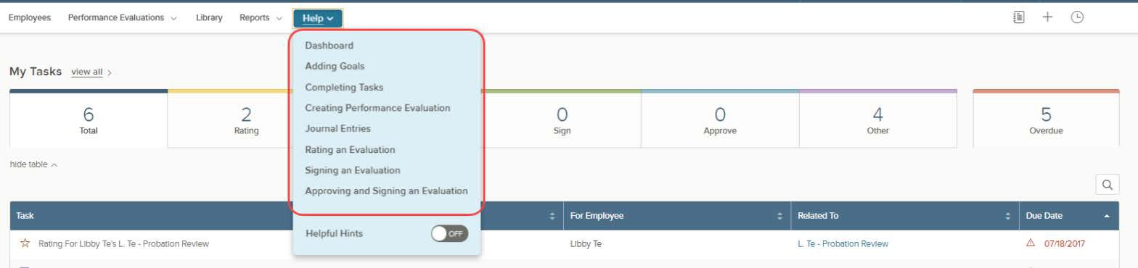
- There is a Help menu accessible to all users. Hover over the Help icon

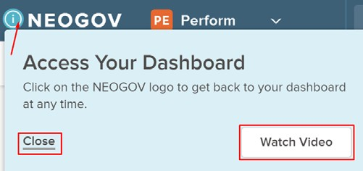
Click on a Helpful Hint icon to receive more information about that specific action. Depending on the Helpful Hint, the system may refer the user to other related hints, or it may offer a description and the corresponding tutorial (if applicable). View the tutorial by selecting Watch Video or close the Helpful Hint description by selecting Close

To turn off the Helpful Hints, hover over the Help icon and disable the Helpful Hints.

My Tasks

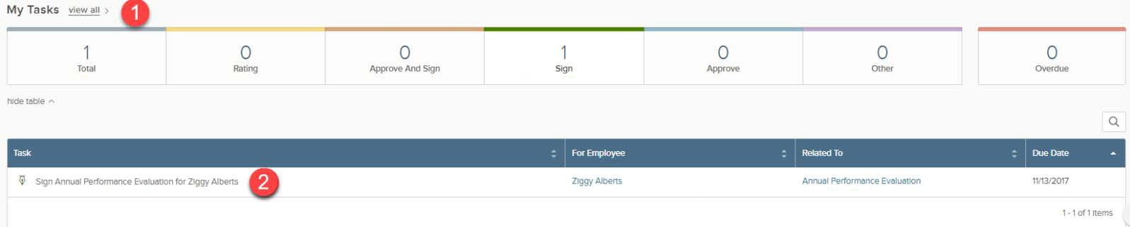
Any current tasks that require your action appear in My Tasks. You can filter on each status by selecting a task type and the list below filters appropriately.

1. View All: Select this to view tasks that are Current, Completed, Canceled, Pending, and Skipped
• Current: Tasks currently requiring action
• Completed: Tasks you’ve already acted on
• Canceled: Tasks no longer required
• Pending: Tasks pending another user’s action, or tasks for Draft evaluations
• Skipped: Tasks that had been assigned to you, but skipped by an HR Admin
2. To complete a task, select the name to be re-directed to the task
• For more information, please refer to Section 4

The task types are designated as follows:
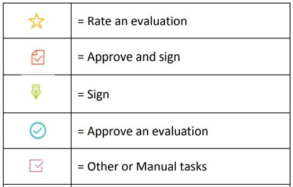
• Total: All tasks currently requiring your action. •
• Rating: Any rating required on an evaluation.
• Approve and Sign: Task to approve & sign the evaluation, after it’s been rated.
• Sign: Task to acknowledge an evaluation before rating can begin, or to sign the evaluation after it’s been rated.
• Approve: Task to approve the evaluation, after it’s been rated.
• Other: Any manual task such as having a meeting with your manager or adding goals to an evaluation.
• Overdue: Any task with a past due date

My Evaluations

Under the tasks section of the Dashboard is the My Evaluations section. Here staff employees will find their three most recent performance evaluations. Select any one of the three evaluations to be redirected to the Evaluation Detail page for the corresponding evaluation.
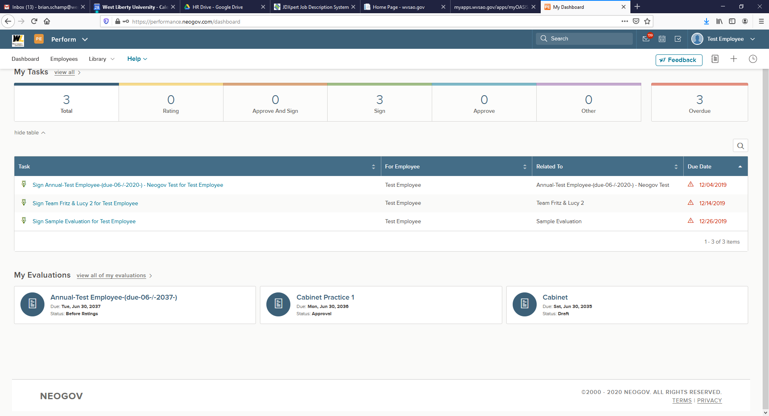

To view all historical evaluations, select view all of my evaluations. To view the evaluation detail page of a specific evaluation, select the title of the evaluation.

My Profile

To access your Profile, hover over your name in the top right corner.

Select My Profile:
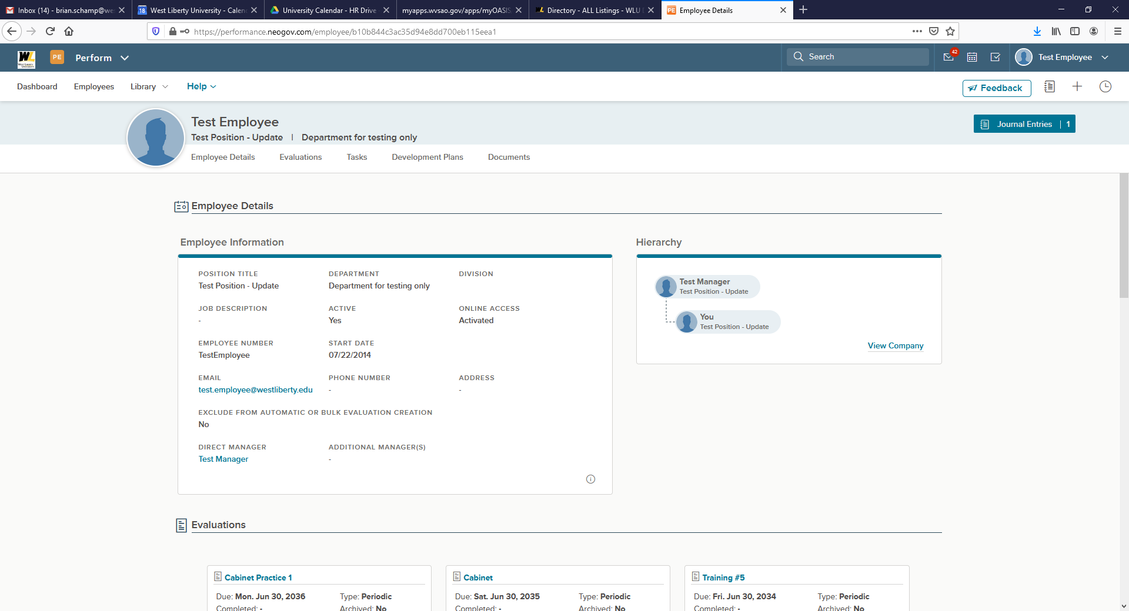

From My Profile, you can see any Performance Evaluations, goals, and all tasks that are associated to you.

TIP: You cannot edit any of your Employee Information, such as position, email address, etc. If you
need to update that information, please contact HR.

Section 3 – Completing a Rating for Employee Task

To complete a task, navigate back to the My Tasks section of your Evaluation Dashboard. To navigate to your dashboard from any other page in Perform, select NEOGOV in the top left corner. Here, you see any current or overdue tasks that require your action. 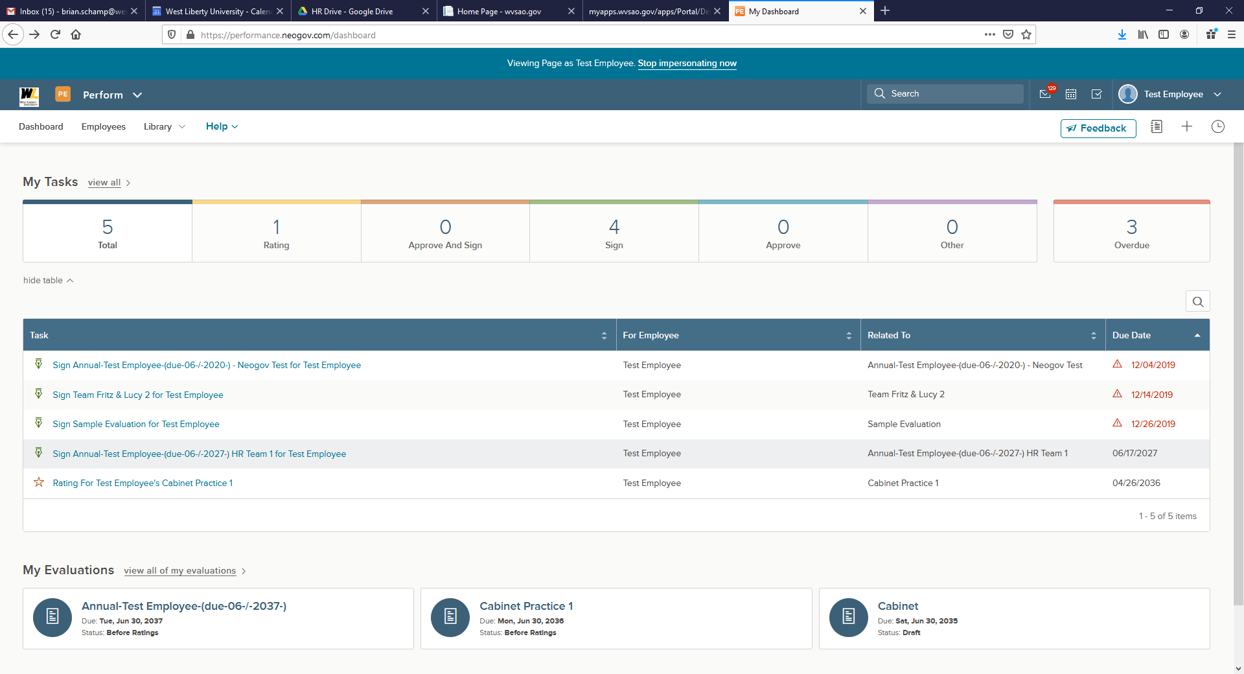

- Click into the corresponding Rating for Employee from the task list.

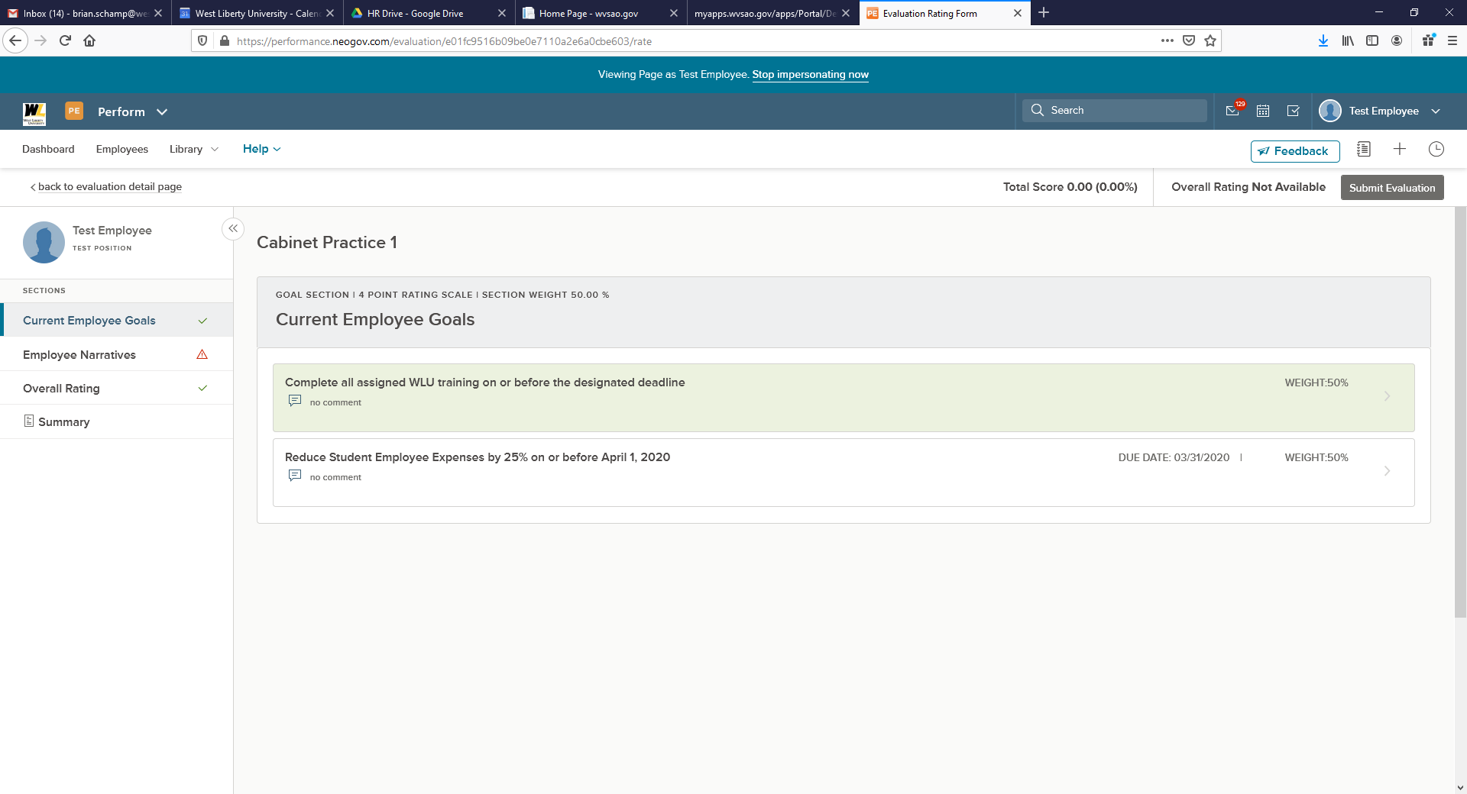
2. Select Current Employee Goals from the left menu.
3. Click on No Comment under each goal.

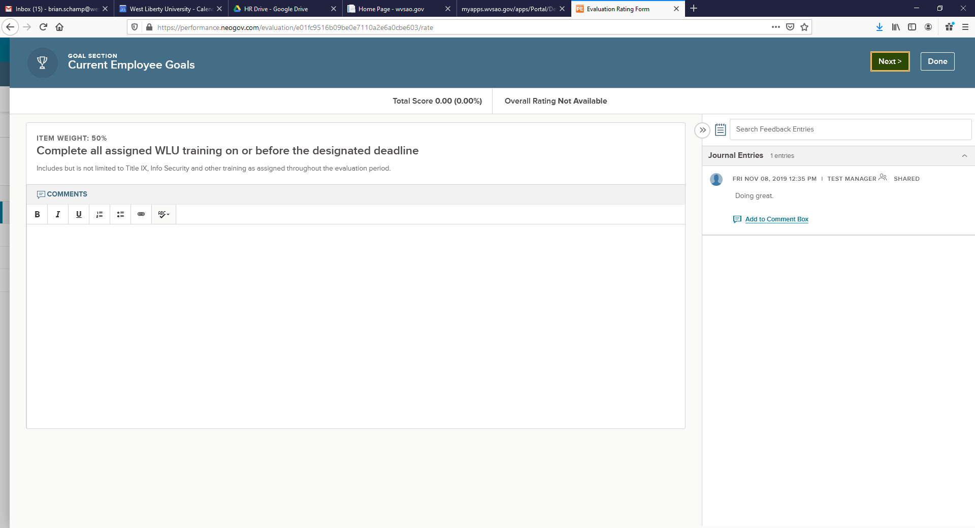

4. Click in the comments section and provide details regarding work you completed on the goal.

5. Click the Next button
- Once all goal updates have been entered the system will transition you into the Narrative section of the update.

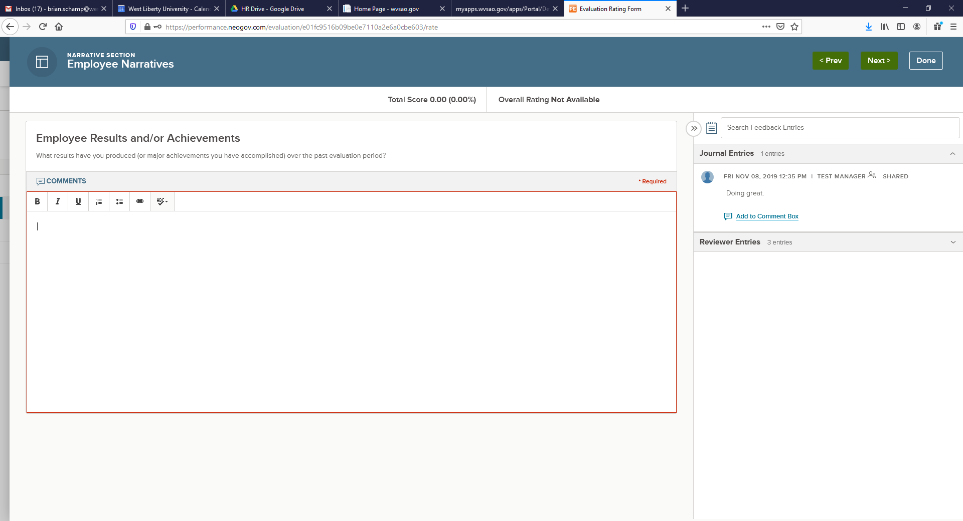
6. Enter comments for the corresponding Narrative questions
- Click Next to move to the next Narrative question
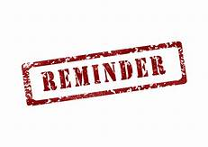Comment boxes outlined in red require comments.
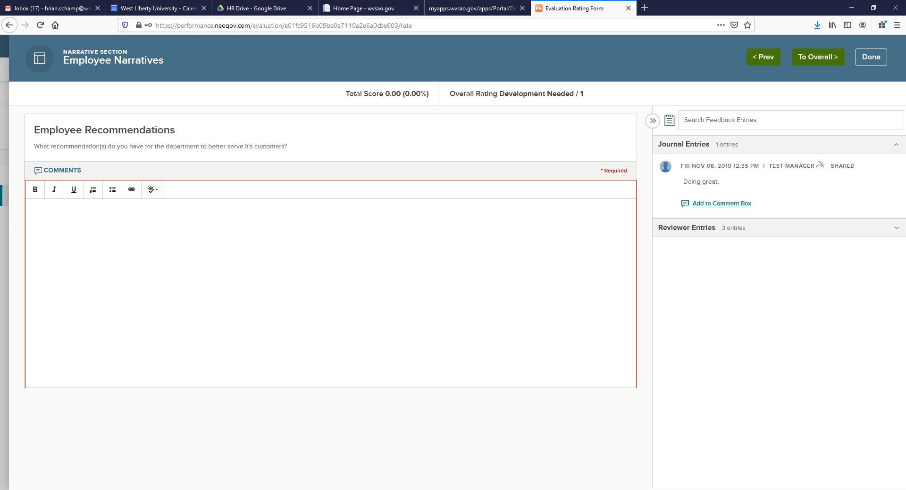
7. Once all Narrative comments have been entered click on the To Overall button.

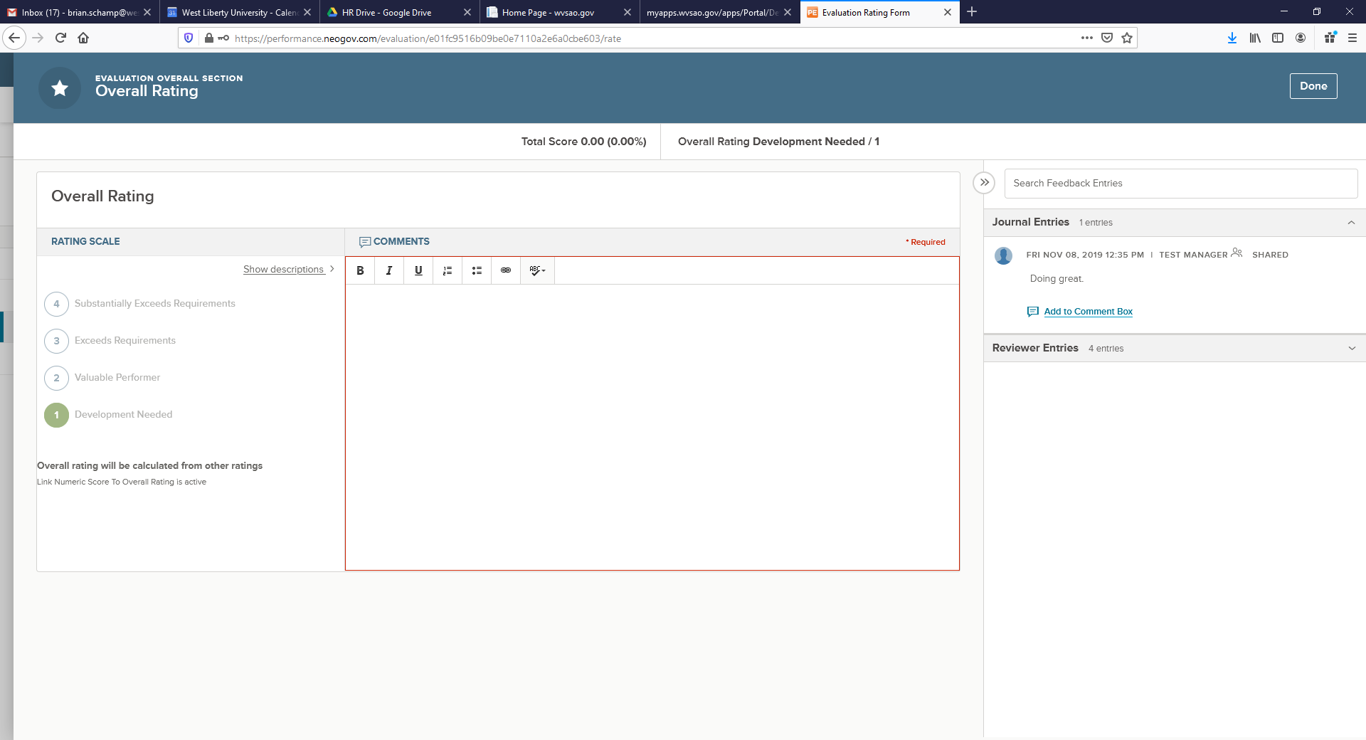
8. Enter the comment “Review Submission” in the comment field. Click on the Done button on the Overall Rating Screen.

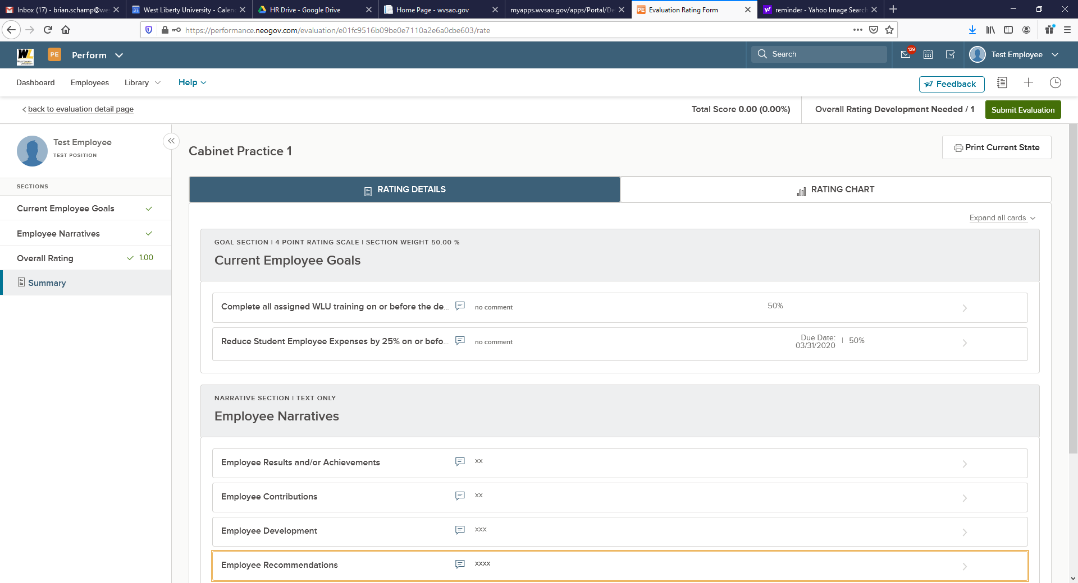

9. Click on the Submit Evaluation button.

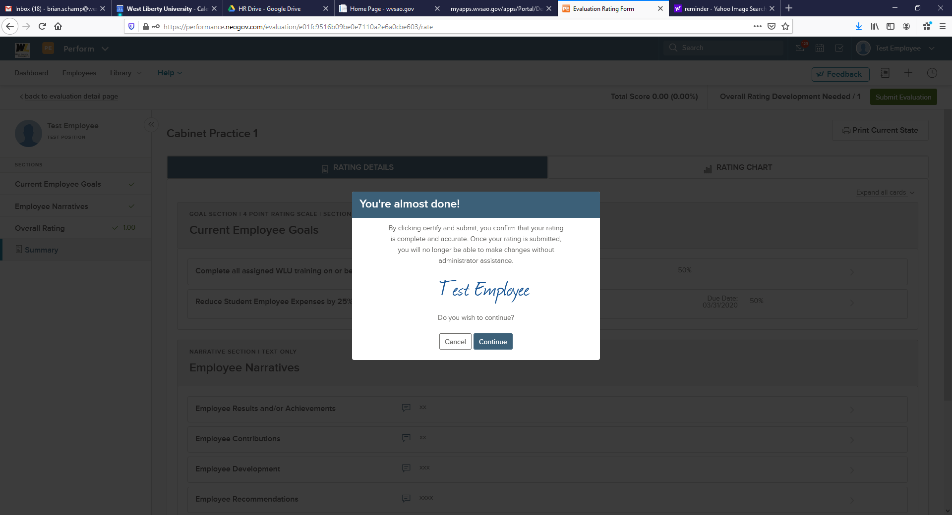

10. Click Continue

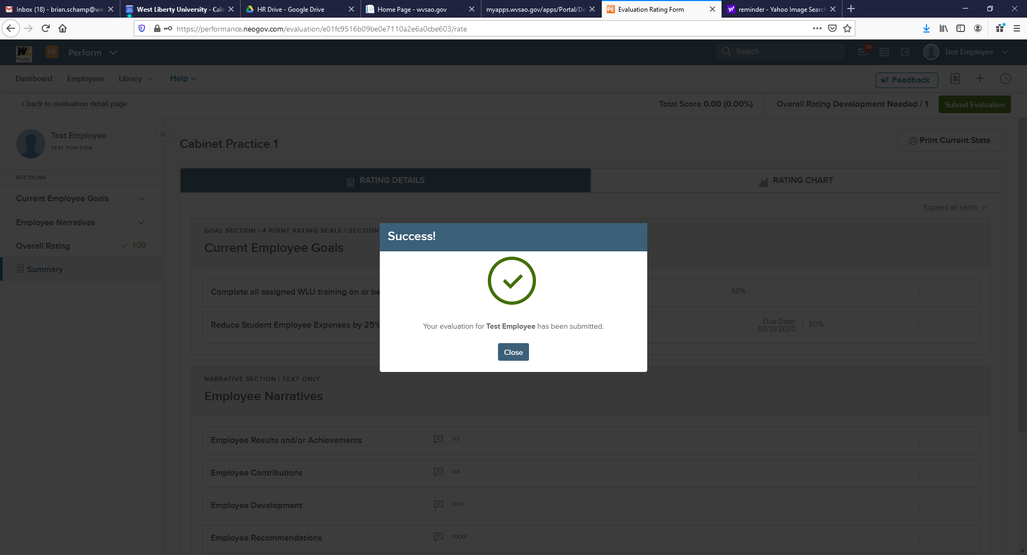

11. Click Close
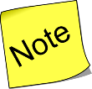Once you click Close no additional action is needed at this point. The NeoGov system will notify you via email when you need to completed the Acknowledgement Task. Once the email is received you will then proceed to Section 4.

Section 4 – Completing Annual Review Acknowledgement Task

To complete the task, navigate back to the My Tasks section of your Evaluation Dashboard. To navigate to your dashboard from any other page in Perform, select NEOGOV in the top left corner. Here, you see any current or overdue tasks that require your action.

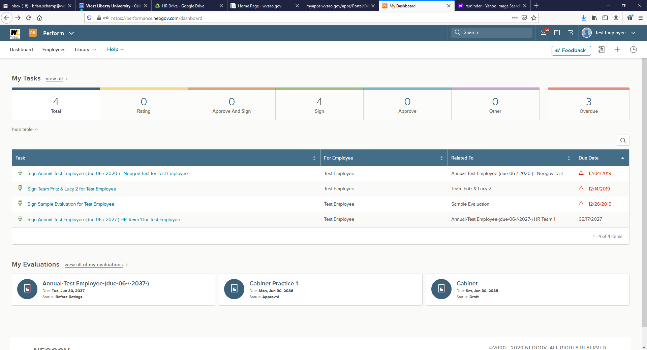

- Click on the Sign Annual Task

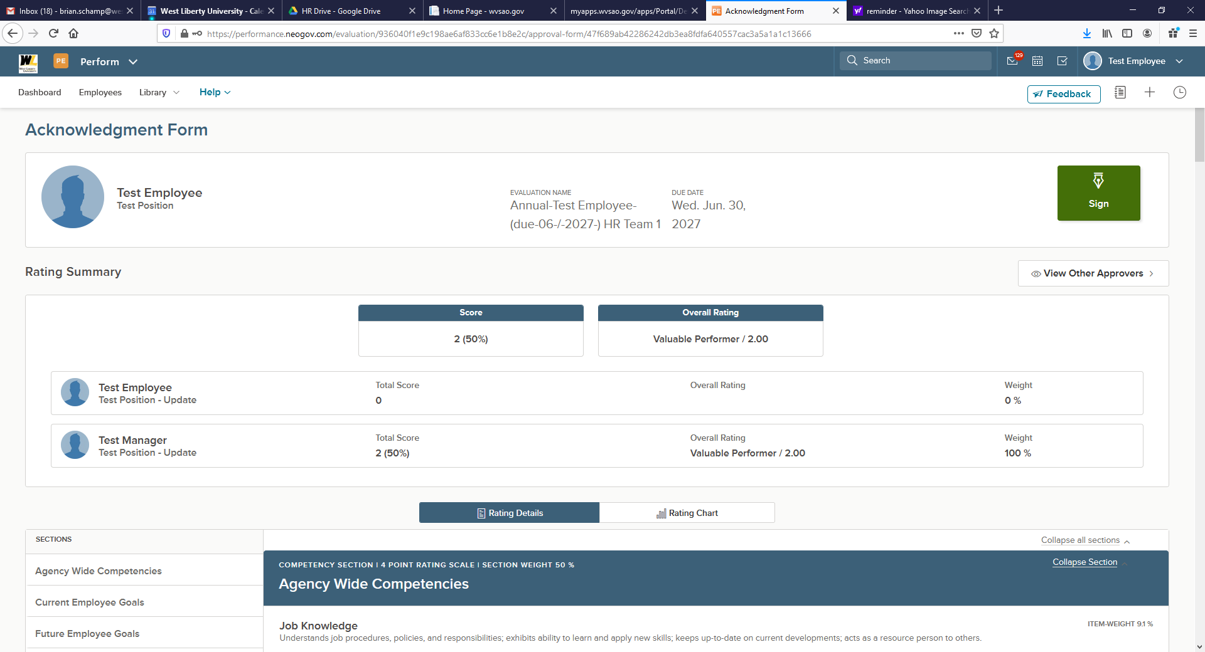

- Click on the Sign button

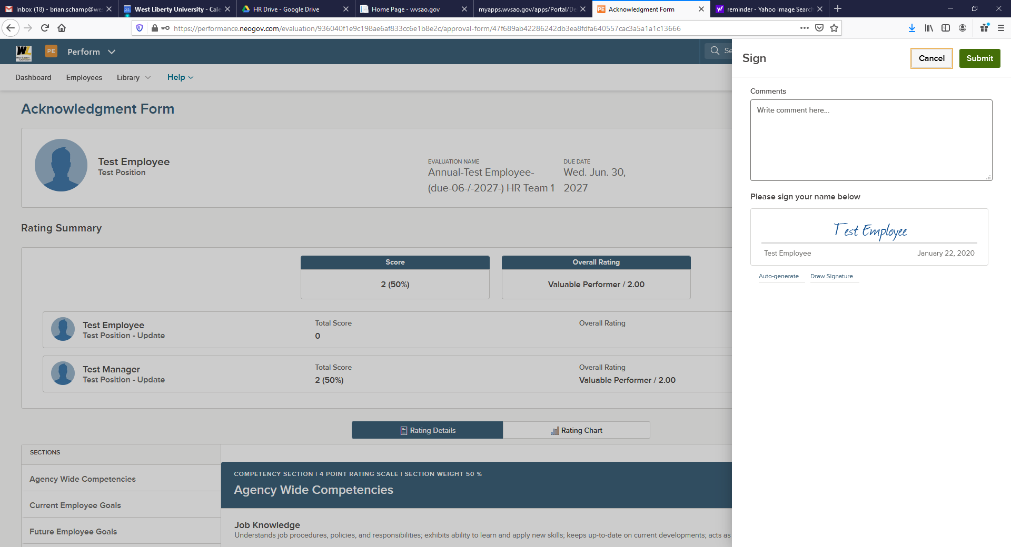

- The fly out menu will appear on the right hand side of the screen.
  - Enter any final comments you have regarding the evaluation
  - In the sign section select to either Draw or Auto-generate signature
  - E-Sign document
  - Click Submit

