http://westliberty.edu/wp-content/themes/wlu-common-april2014/images/wlu-logo-header.png

**Kronos Leave Management System Manual for Employees and Supervisors**

**Revised April 22, 2016**

**Introduction**

**What is Kronos?**

The State of West Virginia has implemented a new Enterprise Resource Planning (ERP) system called wvOASIS. One component of that ERP is Kronos, which is a leave management system and a time keeping system. West Liberty University is required by the State to adopt this system. The Human Resources staff and Payroll staff are committed to making this system work as smoothly as possible for West Liberty University employees.

**Timely Monitoring Required**

The new Kronos leave management and time keeping systemrequires careful monitoring by supervisors. **It is recommended that supervisors develop a habit of checking Kronos every day. The consequences of inaction are severe: Employees will not be paid!**

Leave and time must be submitted by employees and approved by supervisors **within the current pay period.** Pay periods will consist of two-week periods beginning on Saturday and ending on Friday. **If leave is submitted by an employee but not approved by the supervisor within the current pay period then that employee will not be paid for that time even if that employee is on the salaried payroll (i.e., “exception paid”) – as opposed to being on the hourly payroll (i.e., “positive paid”).** If leave and time are not submitted and approved within the current pay period, several steps are required by the supervisor and by the Human Resources staff and Payroll staff to retroactively correct that error.

**myApps Accounts**

In order to use the Kronos leave management system and time keeping system, employees and supervisors must have myApps accounts. You can create a myApps account by going to [www.wvsao.gov](http://www.wvsao.gov) website and clicking on Create Account. Instructions for creating a myApps account can be found on the Employee Benefits page of the Human Resources website.

**Who will use Kronos?**

Kronos will be used by all staff and faculty who accrue leave as well as all hourly employees (including student employees), plus the people who supervise the employees or are considered timekeepers in those categories. Adjunct faculty members and full-time faculty members who do not earn leave or supervise leave-earning or hourly employees will not be using Kronos.

**Changes from Current Leave System to New System**

|  |  |
| --- | --- |
| **Leave** | |
| **With Old Leave System** | **With New Kronos System** |
| * Leave is accrued monthly. * Leave is entered and approved in old system. * Leave is prorated over 12 months. * Leave is reported in hours. | * Leave is accrued bi-weekly. * Leave is entered and approved in Kronos. * Leave is prorated over 26 pay periods. * Leave is reported in hours, not days. * Leave requests must be entered and approved prior to the end of the current pay period. |

Leave will be reported in hours rather than days. Accruals and balances also will be measured in hours, not days. Below is a chart showing the equivalent number of days to hours. (Please remember that lunch hours are *unpaid* time.)

**Annual Leave Monthly Accrual**

1.25 days = 9.375 hours (Less than 5 years of service)

1.50 days = 11.25 hours (5 but less than 10 years of service)

1.75 days = 13.125 hours (10 but less than 15 years of service)

2.00 days = 15.00 hours (15 or more years of service)

**Maximum Annual Leave Accrual Per Year**

30 days = 225 hours (Less than 5 years of service)

36 days = 270 hours (5 but less than 10 years of service)

42 days = 315 hours (10 but less than 15 years of service)

48 days = 360 hours (15 or more years of service)

**Number of Hours Per Work Day** (Use these numbers when submitting leave requests.)

7.5 hours for full-time employees

**Kronos Leave**

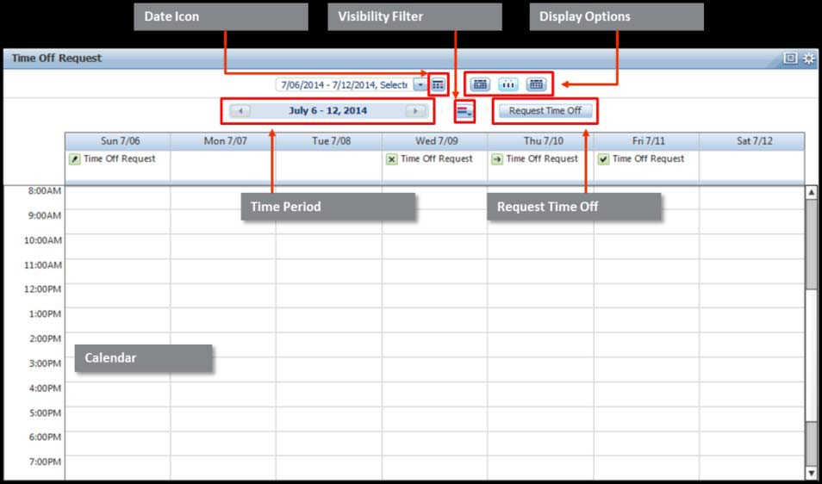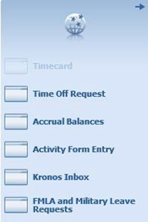

|  |  |
| --- | --- |
| **Leave Request Overview** | |
| **Tool:** | **Definition:** |
| Calendar View | Displays submitted, approved, and rejected requests within the selected time period. |
| Display Options | Enables the calendar to display by day, week, or month. |
| Request Time Off | Displays the Request Time Off form. |
| Time Period | Displays the time period. Click the drop-down to select another time period or select a range of dates. |
| Visibility Filter | Filters the request status within the calendar view. |

**Kronos Accruals Tab**

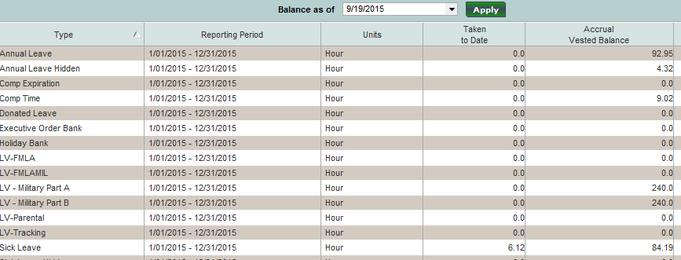

|  |  |
| --- | --- |
| **The accruals reporting tab on the timecard contains employees’ leave balances. Accruals can also be viewed when creating a leave request.** | |
| **Type** | **The code that defines the type of leave. West Liberty University employees are eligible only for Annual or Sick Leave. Other leave types, even if listed, may not be used.** |
| **Reporting Period** | **The accrual reporting period** |
| **Units** | **Defaults to hours** |
| **Taken to Date** | **The amount of leave taken for the reporting period** |
| **Accrual Vested Balance** | **Leave balance based on the “Balance as of date” defined** |

**Creating and Submitting a Leave Request**

|  |  |  |
| --- | --- | --- |
| **1** | **Sign onto MyApps v2**  **https://www.wvsao.gov** | [https://www.wvoasis.gov/img/NEW-myApps-logo.png](https://myapps.wvsao.gov/apps/default.aspx) |
| **2** | **Click on the Kronos Time and Leave icon.**  **Go to Workspaces/My Information and there you will see your name and wvOASIS ID number.**  **If you experience problems with Java or with Banner compatibility, please contact IT Support.** |  |
| **3** | **Click on Time Off Request link in the related items pane on the right side of the screen.**  **The Time Off Request screen opens in a new tab to the current week*.*** |  |
| **4** | **Click on Request Time Off.**  **The Time Off Request box appears.** |  |
| **5** | **Select Type: Time Off Request.** |  |

|  |  |  |  |  |  |
| --- | --- | --- | --- | --- | --- |
| **6** | | **Enter Start Date of leave request.**  **Enter End Date of leave request.**  **To submit more than one leave request, click on the + Add another time-off period. An additional row will be added for a leave request.**  **An additional leave request must be used when submitting leave on continuous days! In other words, each day must have its own leave request.** | | Do :  Don't: | |
| **7** | | **Select Pay Code from the drop down: Annual Leave or Sick Leave. Pay codes are equivalent to leave types in Kronos.**  **You may see other pay codes available but do not use any of them other than Annual Leave or Sick Leave.** | |  | |
| **8** | | **Select Duration from the drop down.**  **All leave requests must be submitted using HOURS. Do not use full days when requesting leave.**  **Be sure that you know the length of your work day. A typical full-time work day should reflect as 7.5 hours in Kronos. Do not include your unpaid lunch break.** | |  | |
| **9** | | **Enter Start Time. Time can be entered using an A for a.m. or a P for p.m.**  **(i.e., 3p = 3:00 p.m., 10a = 10:00 a.m.)** | |  | |
| **10** | | **Enter Length in hours. Leave must be entered in increments of no less than 15 minutes (.25 hours).**  **Leave less than an hour must be entered in decimals:**  **0.25 = 15 minutes**  **0.5 = 30 minutes**  **0.75 = 45 minutes** | |  | |
| **11** | | **Click Submit for supervisor approval.**  **Click Draft if you want to submit the request at a later time.**  **Click Cancel to exit screen without saving or submitting.** |  |
| **12** | | **To exit Kronos, click Sign Out under your name on the top left hand side of the screen.** |  |

**Viewing or Canceling a Leave Request**

|  |  |  |
| --- | --- | --- |
| **1** | **Sign onto MyApps v2**  **https://www.wvsao.gov** | [https://www.wvoasis.gov/img/NEW-myApps-logo.png](https://myapps.wvsao.gov/apps/default.aspx) |
| **2** | **Click on the Kronos time and leave icon.**  **Go to Workspaces/My Information and there you will see your name and wvOASIS ID number.** |  |
| **3** | **Click on Time Off Request in the related items pane on the right side of the screen.**  **The Time Off Request screen opens in a new tab to the current week*.*** |  |
| **4** | **The page will display leave requests for the current week. Use the drop down arrow to change pay periods or click on the calendar button to select dates.**  **The icons to the right will allow you to change the view by day, week or month. Hovering over the icon with your mouse will show the view type.** |  |

|  |  |  |  |  |  |
| --- | --- | --- | --- | --- | --- |
| **5** | | **Time off requests pending will display an arrow.**  **Time off requests approved will display a check mark.**  **Time off requests retracted will display an X.** | |  | |
| **6** | | **To view a leave request, hover over the request on the calendar with your mouse. Click on the circle with an arrow and select Details.**  **The Time off Request details will display, including status history.** | | T:\ERP\Phase 2\Time and Leave\KRONOS Screen Shots\timeoffdetailsretract.PNG | |

|  |
| --- |
| **Retract** is used to withdraw leave requests ***that have not yet been approved by the supervisor***. Retracting a leave request will cause it to be canceled. When this occurs, the leave request status will change to Retracted on the supervisor’s screen. |

|  |  |  |
| --- | --- | --- |
| **7** | **To cancel a submitted leave request, hover over the leave request on the calendar with your mouse. Click on the circle with an arrow and select Retract.**  **The Retract Time Off Request box will appear. Review the details of the request in the pop-up.**  **Click Submit to retract the leave request or else click Cancel to exit the request.**  **The retracted time off request will now display an X.** | T:\ERP\Phase 2\Time and Leave\KRONOS Screen Shots\timeoffdetailsretract.PNG |

If you want to cancel a leave request that already has been approved by your supervisor, you will need to ask your supervisor to cancel it.

|  |  |  |
| --- | --- | --- |
| **8** | **To exit Kronos, click Sign Out under your name on the top left hand side of the screen.** |  |

**Leave Approved on a Timecard**

Before:

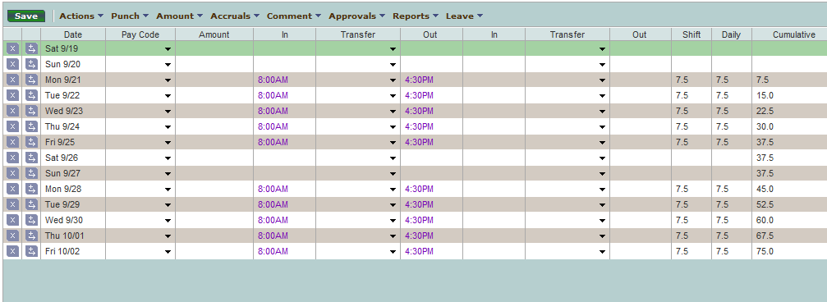

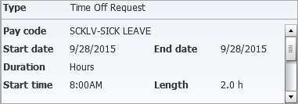

After:

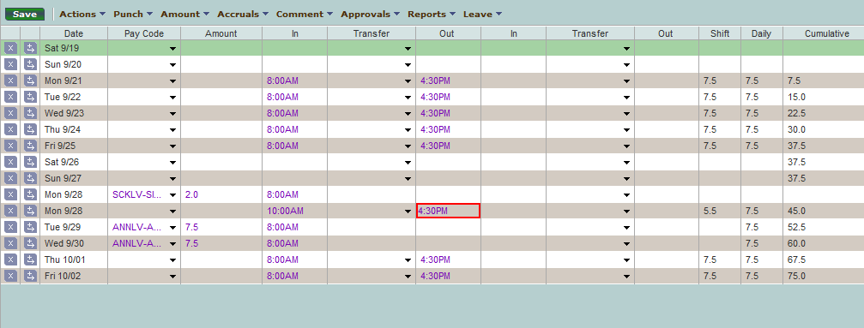

**Kronos Leave Balance Tab**

|  |  |
| --- | --- |
| **The accruals reporting tab on the timecard contains employees’ leave balances. Employees can also be viewed when creating a leave request.** | |
| **Type** | **Employees are eligible for Annual and Sick Leave only. If other types of leave are listed, they must NOT be used.** |
| **Reporting Period** | The accrual reporting period |
| **Units** | Defaults to hours |
| **Taken to Date** | The amount of leave taken for the reporting period |
| **Accrual Vested Balance** | Leave balance based on the “Balance as of” date defined |

HELPFUL HINT

Click on the  above the timecards tabs and drag up to increase or decrease the space for easier viewing.



**Kronos Leave Management System Manual**

**SUPERVISORS’ SECTION**

**Kronos Supervisor Workspace**

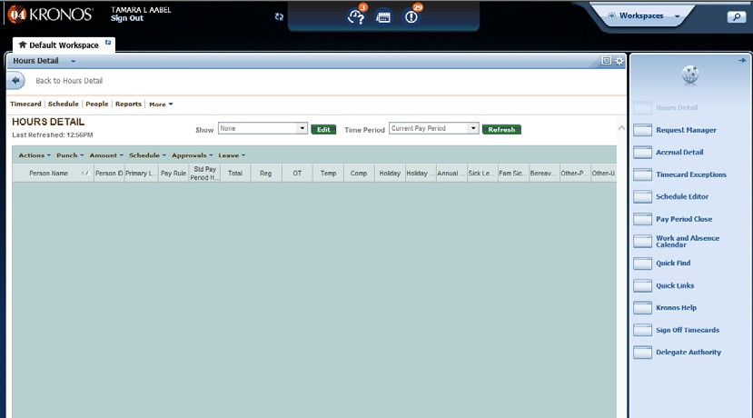

**Request**

**Manager Alert**

**Exceptions**

**Alert**

**Workspace**

**Carousel**

**Related**

**Items Pane**

When employees submit leave requests, email messages are sent to supervisors/timekeepers notifying them of the request. In Kronos, supervisors have the capacity to enter leave for the employees who report to them. This may be necessary in rare circumstances but generally should be avoided since doing so would preclude the record from showing that the employee has requested that leave.

**Kronos Supervisor Managing Leave Requests**

|  |  |  |
| --- | --- | --- |
| 1 | **Sign onto MyApps v2**  **https://www.wvsao.gov** | [https://www.wvoasis.gov/img/NEW-myApps-logo.png](https://myapps.wvsao.gov/apps/default.aspx) |
| 2 | **Click on the Kronos Time and Leave icon.** |  |
| 3 | **Click on Request Manager in the Related Items pane.**  **A new window will appear. The page will default to time-off and include all of the employees that you supervise who have requested time off.** |  |
| 4 | **The page will default to the current pay period. Use the drop down menu to change to a different pay period.**  **Use the All Status drop down to change search criteria.** |  |
| 5 | **Leave will display below for your employees based on the criteria selected.**  **Double click on the request to view.**  **Click Close.** |  |

**Approving a Leave Request**

|  |  |
| --- | --- |
| **Select the leave request and click on Approve.**  **Review the request and click on Approve.** |  |

|  |  |
| --- | --- |
| **Refusing a Leave Request** | |
| Refusing a leave request is used for leave that is still in Submit status and ***has not yet been approved***. This leave request will not appear on the employee’s timecard; however, it will display as “refused” on the employee’s time-off request screen. | |
| **Select the submitted leave request and click on the Refuse button.**  **Review the request and click Refuse.**  **The leave status will change to Refused.** |  |

|  |  |
| --- | --- |
| **Canceling a Leave Request** | |
| Canceling a leave request is used for ***leave that already has been approved***. Once the leave has been canceled, the leave request status will change to Cancel Approved. Only the supervisor can cancel leave after it has been approved by the supervisor. | |
| **Select the leave request and click on Cancel.**  **Review request and click on Submit.**  **The request status will change to Cancel Submitted.**  **Select Cancel Submitted leave and click on Cancel Approved.**  **Click the Approve button. The leave status will change to Cancel Approved.** |  |

**Viewing Your Employees’ Leave**

Supervisors can view their employees’ leave records through the Leave Hours Detail Genie.



From the Related Items pane, select Quick Links > Leave Hours Detail Genie.

Select a group of employees from the Show list.



**Delegate and Accept or Decline**

**Kronos Supervisor Authority**

|  |  |
| --- | --- |
| **Delegate Authority**  As a supervisor, you have the ability to delegate your supervisory functions in Kronos to another supervisor. Delegating authority in Kronos should be used when a supervisor is unavailable, for example, due to travel or long term leave. Once you have delegated authority to another supervisor, they have the access to perform those tasks using their own username and password. The delegation must be to someone with the same security level. | |
| **From the Related Items pane, click on Delegate Authority.** |  |
| **A new tab will display.** |  |
| **Click on Manager Delegation and a window will pop up, which is labeled Existing Delegations.** |  |
| **Enter as Delegate the name of the supervisor to whom you want to delegate your Kronos functions. You must delegate to someone who has a supervisor/timekeeping license.**  **Select the Start Date and End Date showing when you want to delegate your tasks.**  **Select MGR as the Role.**  **Click Save & Close.** |  |

|  |  |
| --- | --- |
| **Accept or Decline Authority:** When another supervisor sends you a request to cover his or her Kronos supervisor role you will receive an alert in the Requests alert icon. You also will receive an email message. You must take action by either accepting or declining the request. | |
| **To view a delegate authority request, click on the Request Manager alert icon and then click Manager Delegation. The Request Manager tab will open to the Manager Delegation page.** |  |
| **Alternatively, you may click on the Request Manager in the Related Items pane.** |  |
| **Once the Request Manager tab opens, select Manager Delegation from the drop down menu.** |  |
| **Double click on the request to view the request details.**  **Select either Accept Delegation or Decline Delegation.**  **Click on Save & Close or click Cancel to exit without taking action.**  **An email notification will be sent to the delegating supervisor.** |  |

|  |  |  |
| --- | --- | --- |
| **Switching to a Delegated Role:**  After you accept a delegate request, the system will automatically provide you access to the delegated role on the start date. A Switch Role link appears as a quick link to access the delegated role. Access to the delegated role will expire the day after the end date and the arrow next to your name will no longer be displayed. | | |
| **Click on the arrow next to your name on the upper left hand side of the screen.**  **Select the supervisor whose tasks you will perform as the delegate.** |  | |
| **Once the page has refreshed, you will see your name and the name of the person who has delegated authority to you.**  **To return to your own role in Kronos, click on the arrow next to your name and select Myself.** |  | |
| **Canceling a Delegated Role:**  Once the end date of the delegation occurs, the system automatically removes the access to that supervisor. If you return prior to the end date you can cancel the delegation. | | |
| **From the Related Items pane, click on Delegate Authority.** | |  |
| **Click on Manager Delegation and select Remove Existing Delegation.**  **Click on Next.** | |  |
| **Select name and click on Delete.** | |  |