West Liberty State College
Board of Governors

Executive Committee
Minutes
April 23, 2008

Executive Committee Members: Lynne Exley, John Moore, John Gompers
WLSC Administrators: Robin Capehart, John McCullough

1. Chair Exley called the meeting to order at 8:00 a.m.

2. Consent Agenda – Chair Exley stated that the consent agenda will still allow for discussion and dialogue among BOG members in addressing important College issues and that it will still provide for specific questions to be asked of President’s Council members at all BOG meetings.

3. Commencement and Contributions – Chair Exley will strongly encourage full BOG representation at the upcoming spring commencement, and she will further encourage full BOG participation in terms of contributions to the WLSC Foundation. Such actions help to build creditability for the BOG regarding their broad level of support for the College and our students.

4. Financial Report – The cash/budget report for April 21, 2008 was distributed along with the FY ’08 third quarter financial statements.

5. President’s Report – President Capehart provided an update/announcement on various on-campus activities including a planned reception for commencement speaker Congressman Mollohan, the WVIAC Golf championships by our men’s and women’s golf teams, a new model for scholarships utilizing some operational dollars, an upcoming economic analysis of marginal cost per student, the spring open house, and the “I Chose West Liberty” student pep rally.

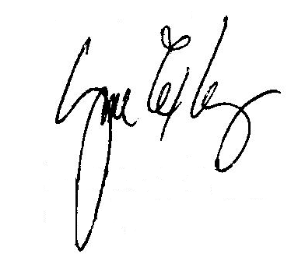
6. Meeting adjourned at 9:10 a.m.

Lynne Exley
Chair

Secretary

