How to Find a Book
By: Anna Cipoletti
- Go to the library’s page on the university’s website
- Under “SEARCH BOOKS”, enter a title, name, or keyword to begin your search
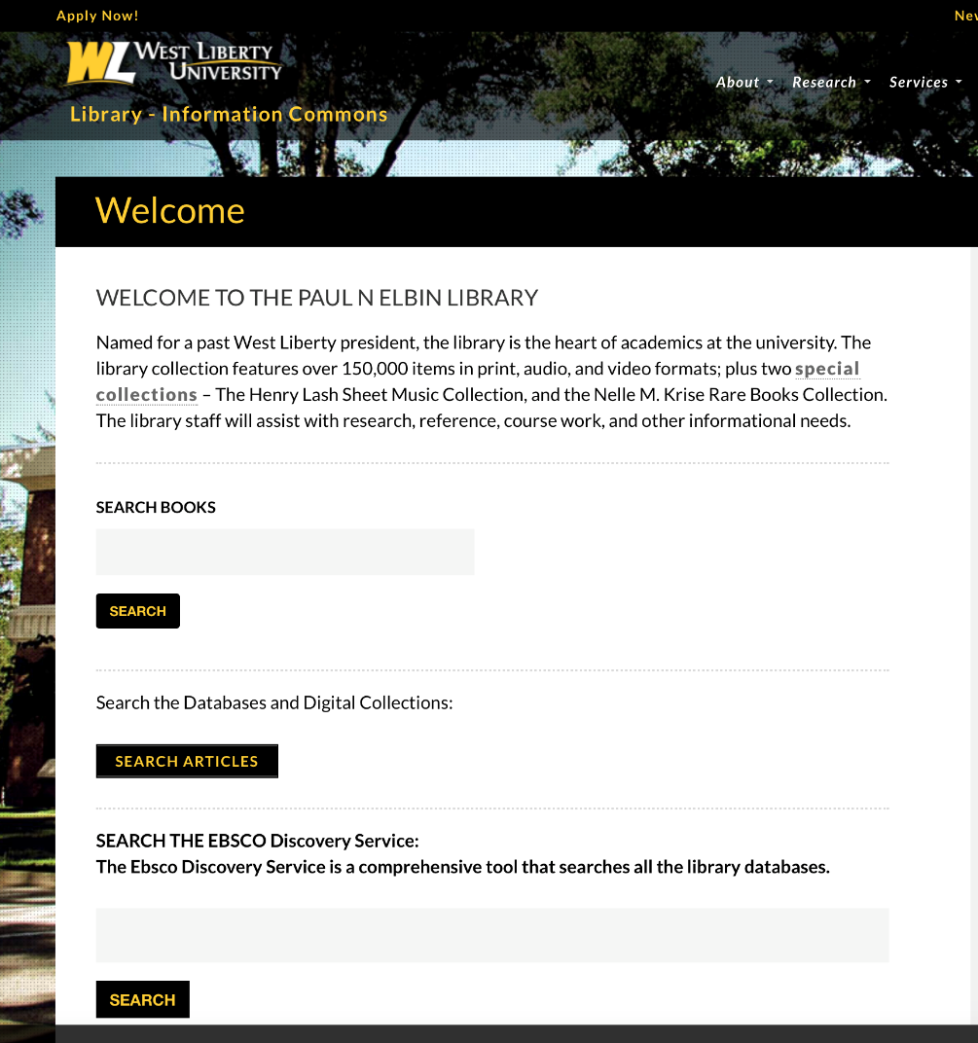
- Once you enter a search, your page will look like this:

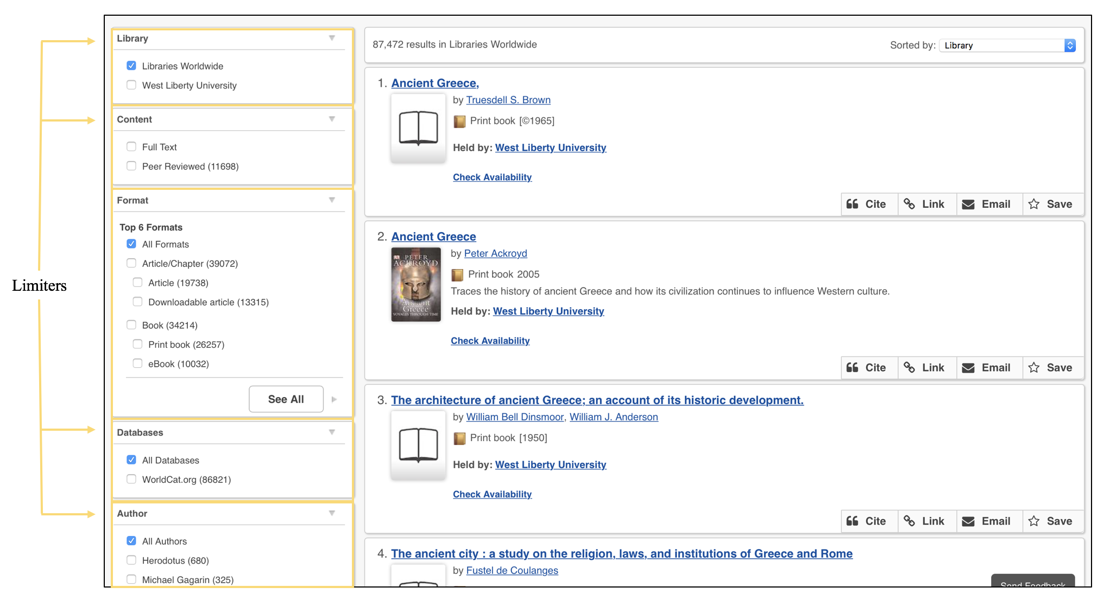
Note: If your results are too broad, try adding some limiters, located on the left side of the page (click here for more information about limiters)
I Found the Item I Want—Now What?
Depending on what type of resource the item is, locating and accessing the item will be a little different. To determine your next step, look at the item’s holding information.
Determining Resource Type
Below is an example of a result from a basic search for “ancient Greece”. In addition to general information about the item, such as title, author, and publication date, this result also displays (1) a summary, (2) whether or not the item is held by the library, (3) whether or not it is available, and (4) other options (cite, link, email, save).
An item’s format type and holding institution can be found the main results page, and availability can be determined by clicking “Check Availability” (see example below).
Use this information to determine an item’s resource type, availability, and holding institution, then follow the corresponding step below to find and access the item.

Print Book in the Library’s Collection: Finding Your Book in the Stacks
- Under the item’s information, select “Check Availability”. This will tell you whether or not the item is available and where it can be found.
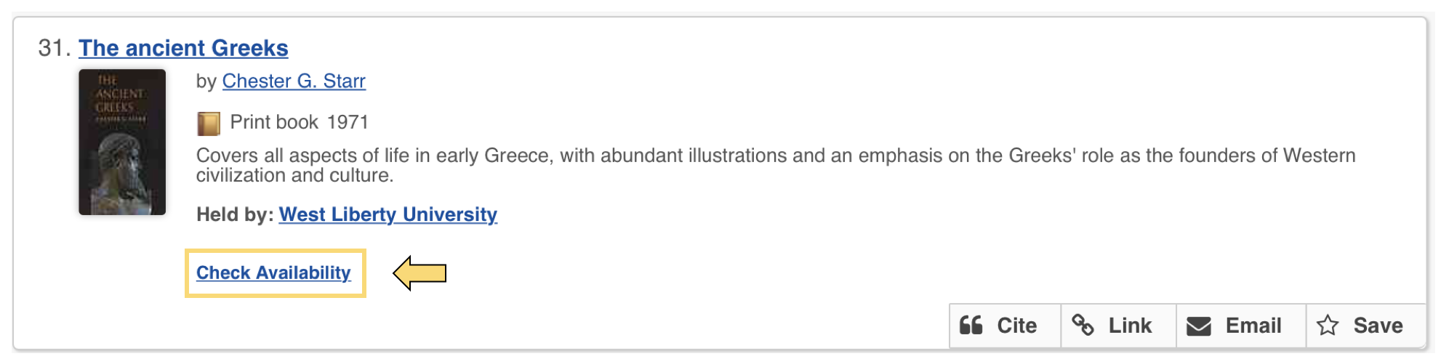

- Once you click “Check Availability”, the hyperlink should change and look like the screenshot below:
Note: If you do not know how to locate a book using a call number, visit our tutorial on the library’s website OR ask a librarian at the reference desk to help you

Print Book NOT in the Library’s Collection: Requesting an Interlibrary Loan
Sometimes, clicking on “Check Availability” will give the following message:
Click on the holding’s title for more information: under the “Availability” ribbon you will see something like the image below:
If the West Liberty library is not listed, please request the item through interlibrary loan. Requests for interlibrary loans can be made by selecting the blue box that says “Request Item through Interlibrary Loan” and filling out the form OR by contacting Alan Ramsey (Interlibrary Lending librarian) directly via phone (304-336-8352) or email (ramseyal@westliberty.edu).
Note: Loans generally take 7-10 business days to reach West Liberty’s library; the library will contact you when your item has arrived. Loans are generally free but the library will contact the lender if a fee is anticipated. For any additional questions please contact Mr. Alan Ramsey.

