Updated January 2017

International Student Guide

How we can help you during your stay at:
International Student Office Location
2nd Floor of College Union
Room S14

International Office Mailing Address
208 University Drive
C.U. Box 200
West Liberty, WV 26074

Contact Information

Mihaela Szabo
Director of International Enrollment Services,
International Student Advisor
Office: 304.336.8270
Fax: 304.336.8635
mszabo@westliberty.edu

Heather Kalb
International Student Recruiter and Adviser
Office: 304.336.8382
Text: 812.461-8965
Fax: 304.336.8635
Heather.kalb@westliberty.edu

International Student Office

You are probably already feeling some kind of culture shock, and we want to assure you that what you are feeling is normal, and most of us experienced disorientation and discomfort associated with initial arrival into a new culture/country. To cope with these feelings, you must give yourself time to adjust, and to accept that certain things you will have to learn again, but after a few months you will grow comfortable in your new environment and you will make your new place your second home. In the International Student Office you will find guidance in how to successfully adjustment to the U.S. culture and the help you need to overcome some of the initial challenges of living in a new environment.
Located on the second floor of the College Union, in room S14, we handle all matters regarding international enrollment, promoting international diversity, and attending to the particular needs that international students on campus face. We call our self the International Student Office because we believe that each international student has particular needs and should be treated as an individual, not as part of a group. We deal with immigration issues, international applications and recruitment, promoting cultural diversity, assisting students with housing, class, personal issues, and the transportation and entertainment needs of our international students.
Mia Szabo, the Director of International Enrollment Services and International Advisor, typically handles issues dealing with international applications and enrollment, visas issues, immigration documents, school and academic registration, and employment programs and issues. Mia can usually be found in the office daily from 8-4 pm. Mia is originally from Romania.

Heather Kalb works on programs and activities that take place once you have arrived on campus, such as travel arrangements, cultural presentations, housing issues, International club and campus tours. With a Ph.D. in biology and many years as a biology professor, she will also be available for advising and assistance in biology courses. Heather is a US citizen but has traveled in Costa Rica, Australia, Mexico, Canada, and parts of Europe. She works part time in our office and part time with high school exchange students and has been a host mom for high school students for the past four years. You will have an opportunity to spend time with her family and host children at their home during the semester.
If one of us is not available when you need us, typically the other is able to provide guidance or assistance. If not, you can contact us through our emails at mszabo@westliberty.edu for Mia and heather.kalb@westliberty.edu for Heather.

Welcome to West Liberty University (WLU)
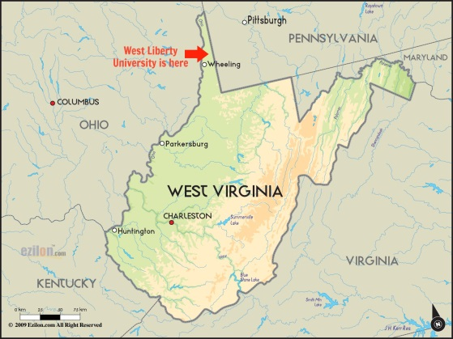
West Liberty University is a small state university located in the hills of West Virginia. It is located in the small rural town of West Liberty and is primarily a residential campus. There are many services available to our students here, such as a tutoring and guidance center, a gym and swimming pool, on-campus restaurants, a bookstore, gaming and lounge centers, and a library. A campus map has been included in your welcome folder.
West Liberty University is a wonderful place for international students to study because it provides constant American interaction. Due to the rural nature of our campus, you will be forced to interact with Americans on a daily basis and by doing so, you will build friendships that can last a lifetime.

Local Cities
Although West Liberty is a rural town, it is in close proximity to other medium and large cities. We are 15 minutes away from Wheeling, WV (once the former capital of West Virginia), two hours away from Columbus, OH, and only an hour away from Pittsburgh, PA. Both Wheeling and Pittsburgh have a rich history in the steel industry as well as with coal and natural gas. Both locations are unique and will show you how different life can be in the U.S. based just on city versus rural living. We, the staff in the International Student office will do our best to show you what these cities, as well as other cities around the area, have to offer through the activities that we plan though out your stay.

Tips for success in a US classroom
In the United States, many teachers follow a learner-centered approach. This means that teachers encourage students to participate in class by asking questions, speaking up in discussions, and doing group activities. While each teacher may differ in their teaching style, student participation and effort is highly valued.
The relationship between professors and students also tend to be less formal than in other cultures. Sometimes, teachers request to be called by their first name instead of their appropriate title and last name. Although they may insist on being informal, they will most likely not be insulted if you continue to address them formally.
It is also important that you maintain eye contact with your professors. In the United States, eye contact shows that you are paying attention to what they are saying and is also a sign of respect. This does not mean that you have to constantly stare at them, but a soft gaze with a break in eye contact every once in a while will suffice. If you are not used to maintaining eye contact, it may take some practice, but we assure you that it will become easier and more natural as time progresses.
This last point can almost be considered the most important. U.S. professors and most U.S. people in general, place high importance on punctuality (being on time). If you are late, you give the impression that you do not care and do not value the other person’s time. Therefore, if you are late for class, the teacher will feel like you do not care about the class or his/her time. When this happens, you are either marked down as late or absent, which can hurt your grade if it happens repeatedly.
If at any point during the school year you feel like you need assistance with your school work or are having trouble coping with the different style of teaching, West Liberty University has tutors and staff available to help you. The office is called the “Learning and Student Development Center”, located in the East Wing of Main Hall. For more information or to contact the councilors, visit http://westliberty.edu/lsdc/.

Your First Days

Initial Walmart Trip
During your initial trip to Walmart, we recommend that you purchase certain items to prepare you for your stay. We have compiled a list below that is comprised of items that many of our past international students have bought when they have first arrived. They are as follows:

- Bedding (pillows, sheets, comforter/blanket). The bed size is a twin
- Towels
- Power strip (do NOT buy an extension cord)
- Hangers
- Laundry detergent & dish soap
- Toiletries (shampoo, conditioner, soap, toothpaste & brush, etc.)
- Shower flip-flops
- Toilet paper
- Trash can
- Notebook, pencils, and folders
- Book bag/ backpack
- Laundry hamper/basket/bag
- Bedside lamp
- A shower caddy/basket
- If you arrive before school starts, you will want some food to cook/eat in the dorm.

Once you have completed your initial shopping trip at Walmart, you will be assigned a room, receive your room keys, and possibly (depending on your arrival time and date) obtain your student ID card. During the following days or weeks before school starts, we will assist you in registering for classes, give you a tour of the campus, help you set up cell phone plans and bank accounts, and provide you with fun activities to show you what our campus and region has to offer. We encourage you to participate in these initial trips as they are either essential for your stay or will provide you with a fun and new experience.

Bank Accounts
When opening a bank account, you will need your passport and your immigration documents (Forms I-94, I-20 or DS2019). There will be weekly trips to the highlands shopping area where you can visit the bank.
Wesbanco bank has an office near Walmart at the Highlands. They may tell you that you have to call in the next day to activate your debit card, but we can usually find someone to help us over the phone. We will need to set you up with “fake” social security numbers based of your passport number to get you online banking.
Be sure to close your bank account before you return home.

Cell Phones and Skype
We will provide you many opportunities to set up a cell phone account so that you can communicate with friends here at West Liberty University and family back home. The only two cell phone services that work at West Liberty are Verizon and AT&T. When we bring you to their stores, you will be able to take a look at the available plans and be able to make a decision that best suits your needs. We do recommend that you purchase a cell phone with which we can contact you while you are in the U.S. It is very important that we have a quick way to get ahold of you in case of an emergency. You will NOT be able to participate in off campus club activities if you do not have a phone.
We also encourage that you use Skype to contact your family back home, as it is often cheaper and more gratifying than using cell phones. As discussed earlier, we have Skype in the Spice Room and you can also use it on your personal computer or phone. With Skype it is currently $0.08/minute to call a landline from your computer or cell phone.

Topper Card
Every student at West Liberty University is given a school Identification card that is called a “Topper card.” It works for opening the main doors of their respective dorms, using laundry services, getting meal plans, buying foods and beverages from different dinning service providers on campus, and identifying yourself at campus events.
The Topper card can be presented at the Sodexo restaurants to pay for food using your “Sodexo” dollars which you get with your meal plan. In addition, to Sodexo dollars, students can also add money to their Topper account and use the Topper card as a debit card in the campus bookstore, restaurants (including Subway), and the laundry facilities on campus. To use on campus laundry services students must have topper dollars in their accounts. Students swipe their Topper card to activate any washing machine or dryer in the laundry rooms.
Depositing money in Topper Card (Topper Dollars)
- Go to the home page of WLU website www.westliberty.edu and click on the Go button on top right of the page.
- Once you click on the Go button, it will take you to another page with different image buttons which are windows to different other pages. Now click on the eAccounts button.
- Now click on the +Add Money option in Topper Account button on center left side of the page.
- Now add as much money as you want and it would deposit equal amount of Topper Dollars in your Topper account as Topper Dollars.

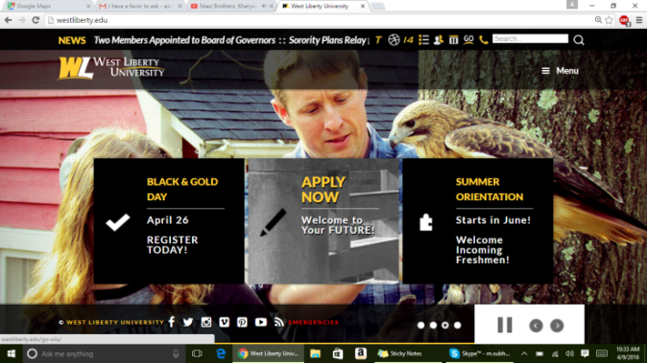
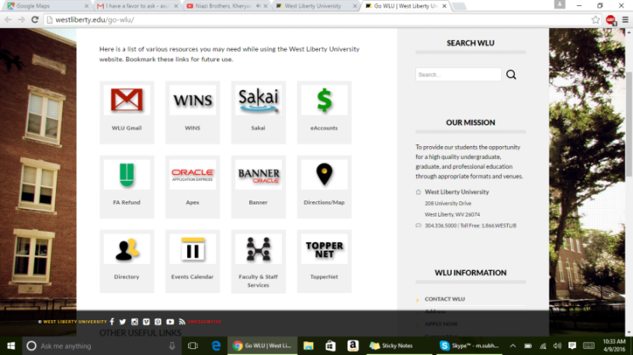
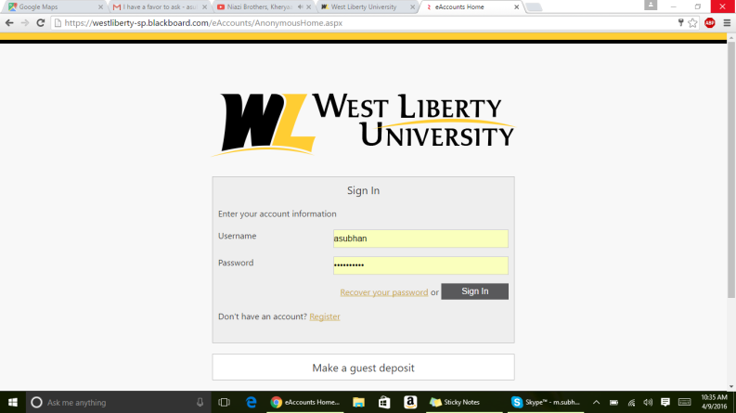

Life on Campus

Campus housing
West Liberty University residential community includes seven residence halls, two apartment complexes, and campus houses. Upon enrollment, new students are assigned to a building and can request or be assigned a roommate. First year students are housed in Curtis Hall, Beta Hall, Boyd Hall, and the honors floors in Krise Hall. Upper-class students are able to select specific buildings and roommates during an annual housing assignment process. Returning students and transfer students are housed in Krise Hall, Beta Hall, Hughes Hall and Bonar Hall. University Place and the Commons Apartments are reserved for returning students who meet a selection of criteria. Student Houses are reserved for special groups and students who again meet given criteria. All residence halls are smoke and alcohol free facilities.
The University supplies to each resident:

- Twin bed and mattress
- Desk and chair
- Dresser
- Comcast Cable and High Speed Internet
- Phone jack

The University supplies to each residence hall:
- Laundry facilities (machines are operated by Topper Cards)
- Lounge area with cable television and recreational equipment (one of the following: pool table, ping pong table, foosball table)
- Vending machines for drinks and snacks
- Kitchenette (it may or may not have a refrigerator)
- Smoke detectors

Rules and guidelines for student housing can be found in the residence life handbook (http://www.westliberty.edu/residence-life/hrlhandbook/). Please read through these rules. A few items to point out now include

“3.20 Use of non-approved appliances in a residence hall room, including but not limited to deep fat fryers, electric crepe makers, electric fry pans, electric griddles, electric hamburger cookers (George Foreman’s), electric space heaters, electric waffle irons, electric woks, hot oil popcorn poppers, hot plates, coffee makers with a warmer, indoor grills or broilers, and slow cooker/grill convertibles are prohibited. Questions of approval should be made to the Director of Housing and Residence Life.

3.22 Cooking in the residence halls, using either the residence hall microwave, personal microwave, or residence hall oven/stove is not to be left unattended at any time. Any unattended cooking will be considered a fire safety risk to the residence hall.”

For help with housing questions, please visit the housing office in the main lobby of Rogers Hall. Their primary work hours are Monday-Friday 8am – 4 pm. Telephone: (304)336-8345. E-mail: residencelife@westliberty.edu You can also visit www.westliberty.edu/residence-life or www.westliberty.edu/student-life.

Mail and Packages
When sending letters, you can purchase envelopes and stamps at the campus bookstore located in the College Union. If you are sending packages, we recommend that you use the United States Postal Service at www.usps.com. You can get mailing and shipping supplies online, print and pay for your shipping label, and have your package picked up on campus. Their website is very user friendly, but if you need assistance with their website, we will be more than happy to help.
When you are sending mail or if you intend on receiving mail (like bank statements, Social Security card), or are asked for your address, you will need to follow the reference shown below. Failure to do so could result in delayed processing of your mail or packages. The more information that is on the envelope or package, the faster you may receive your mail. It is also important that you check your campus mailbox at least once a week because important information is sometimes distributed through the mailroom and you may not receive the information on time if you do not check your mail.
Your Name
(Your campus mail box number) College Union Office
208 University Drive
West, Liberty, WV 26074

*It is important that you do not put the word “box” on a package that is coming UPS, FedEx, or DHL. If the word “box” appears, the company will assume that you are trying to send the package to a P.O. Box number and they will reject the address telling you it is undeliverable.

To find your unique campus mail box number, log into your WINS account from www.westliberty.edu

Eating on Campus

There are four Sodexo operated cafeterias in West Liberty University that offer meal plan options. The main dining area, known as the Market Place, is located in Rogers Hall. It serves three meals a day during the week and two (brunch and dinner) on the weekends. In addition, there is a Taco Bell, Pizza Hut, and the Sky Ranch Grill which offers a variety of delicious sandwiches and pizza. If you are interested in a coffee or snack, the place to visit is Jazzman’s. For more information and for up to date information on hours please visit http://westliberty.edu/dining/.
When you sign up for the on campus dinning services, you can chose one of the different meal plans that come with a combination of number of meals per week and 100-300 “Sodexo” Dollars (depending on the plan you chose). The Sodexo dollars are automatically added to your Topper card (see next section) and can be used to pay for food at any of the Sodexo locations. There are three different meal plan options that all cost the same amount.
12 meals/wk and $300 Sodexo $/semester
14 meals/wk and $200 Sodexo $/semester
19 meals/wk and $100 Sodexo $/semester
You were automatically placed in the 19 meals/week plan. You can change their meal plan until September 2, online at www.westliberty.edu/residence-life/mealplan, or in the Housing Office in Rogers Hall.

Students may use their meal plan for breakfast in The Grill and Jazzman’s Café through 11am. There has also been an addition of a fourth meal option for a late night meal from 8:00 p.m. – 10:00 p.m. in The Grill and Jazzman’s Café. Students will still only be able to utilize three meals in one day, but will be able to select those three meals from the four different time options (breakfast, lunch, dinner, and late night).

If you arrive late to campus and have not had a chance to get your ID card, you may enter the Marketplace by giving them your name. Please get your ID card at your earliest opportunity.

Meal plan options (unless stated differently it is Mon-Fri)

Marketplace:
Breakfast: 7am – 10:30am
Continental Breakfast: 10:30am – 11am
Lunch: 11am – 2pm
Brunch: 10am – 4pm (Sat & Sun)
Dinner: 4pm – 7pm (Mon - Thur),
4pm – 6:30pm (Fri, Sat, & Sun)

Taco Bell/Pizza Hut
Monday – Thursday: 11:00am – 8pm
Friday: 11:00am – 2pm

The Grill at West Liberty
Monday – Thursday: 8am – 10pm
Friday: 8am – 2pm
Sunday: 4pm – 10pm

Jazzman’s Café & Bakery
Monday – Thursday: 7:30am – 11pm
Friday: 7:30am – 7pm
Sunday: 4pm – 10pm

Until the campus officially reopens on Monday, Jan 17th for lunch you will have limited meal options on campus. Jazzman's Monday - Friday from 8 am to 10 am and The Grille from 8 am to 2 pm.
SUBWAY is located in the basement of the student union. It does NOT accept meal plan credit, but you can use your topper dollars. It is not open on the weekends.

Getting Ready for Classes

Class Registration
Please see Mia for assistance with registering when you first arrive. The sooner you get this done, the better class options you will have.
Please note that students in the Irex programs are expected to have classes a minimum of four days per week.

School Books
Once you are registered for classes, you will be able to locate a book list that describes which books you will need to purchase for your classes via your WINS account.

Campus book store: All books that are required for your classes can be found at the campus book store in the basement of the College Union. Depending on the book, you are given the option of renting or purchasing it. Some professors will put a copy of the text book in the library or on hold for class use at the front library desk. At the end of the school year, if you are renting a book, it must be returned. If you have purchased a book, you can sell it back to the book store at a pre-determined value or sell it to a classmate.

Online purchases: We have comprised a list of different websites where you can purchase or rent books. This list changes regularly if there is a site that is no longer working or is not recommended please let us know and we will remove it from our list. This is the cheapest method of obtaining books, but you need to make sure that you will have the book by the time you need it in your class.

- www.amazon.com
- www.betterworldbooks.com
- www.textbooks.com
- www.half.com
- www.cheaptextbooks.com
- www.cheapbools.com
- www.chegg.com
- www.affordabook.com
- www.ebay.com

Learning and Student Development Center
This is located on the first floor of Main Hall in the east wing. They offer a number of student services for free. You can access tutoring services, accessibility to disability accommodations, career services to help you chose the right career for you, testing for college credit, parent services etc. For more information you can contact Liz Richter at earichter@westliberty.edu or visit http://westliberty.edu/lsdc/

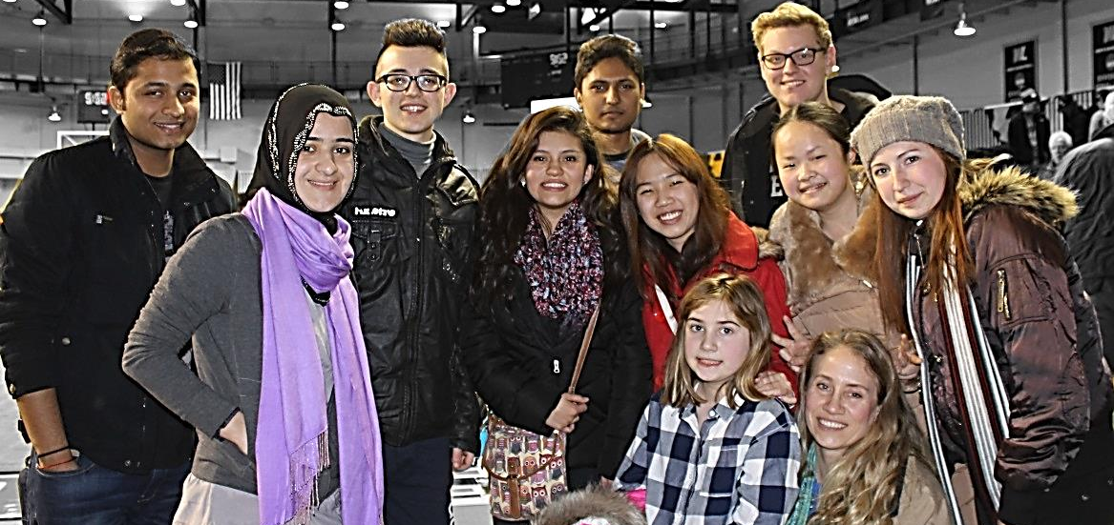

Health

Physical Health
Christy Bennington, RN BSN, Director of Health Services, (304)336-8049
Nurse Available: Monday through Friday from 7 a.m. to 3 p.m. when school is in session in the back of Shaw Hall.
Physician Available on campus: Monday through Friday7 a.m. to 8 a.m. (schedule subject to change)

To visit the campus nurse you MUST have submitted the appropriate health forms in advance.
A student unable to see the physician at the Health Service for injuries or illness may go to Doctors Urgent Care. If visiting Doctors Urgent Care for treatment, the student should take a student ID card and health insurance information. There may be a fee for some services.

Doctors Urgent Care:

24 Homestead Ave (at the bottom of Route 88 before Sheetz on the right hand side)

304-232-1020

8 am to 4 pm Monday through Friday
- 8 am to 12 pm Saturday and Sunday
- Closed on holidays

Mental Health

Personal problems may arise that interfere with a student’s adjustment and ability to fully benefit from the college experience. These problems can include

Academic Concerns Alcohol Abuse Suicidal Thoughts or Gestures
Anxiety Depression Stress
Drug Abuse Eating Disorders Self-injurious Behavior
Grieving Homesickness Sleep Difficulty
Identity Issues Relationship Issues Sexual/Physical Assault

Free and confidential counseling appointments are available with LisaWitzberger. Her office is located next to the Learning and Student Development center in Main Hall. Seeking help or advice is not an admission of weakness, but a demonstration of a student’s determination to help themselves during a challenging or critical period of adjustment.

To schedule an appointment:
- Sign into your WINS account
Click Student Services

Click Request a Counseling Session
- Email lwitzberger@westliberty.edu
- Phone 304-336-8215
- Referral box beside office door
- Walk – In

Get Involved

Once school has begun, you will have met your roommate and hopefully have familiarized yourself with the campus. Like your school back home, there are many clubs you can join and lots of campus activities. We at the International Student Office also provide activities specifically for international students on the weekends, as many of the local students go home on the weekends. There are many fun ways to stay busy on campus and we will now discuss them further.

International Office Activities
We want you to be able to enjoy everything that our community has to offer. That is why the International Student Office plans events and activities to entertain and educate you and to provide you with fun, new experiences. As soon as the first international students arrive on campus for the new school year, we are hard at work making sure that you will have activities to attend and participate in. Once the school in is session, there are weekly trips to the local shopping centers, grocery stores, banks, and sometimes a weekend activity.

In order to see what international office activities are planned, please visit http://www.westliberty.edu/admissions/international-students/programs-and-activities/. If you click on an event, it will show you details of the event and allow you to sign-up for it. Make sure to check the calendar often as events and activities are regularlycan be canceled or have the time and date changed. We also post upcoming activities and events on the International Club Facebook page. Trips with fewer than four people will be cancelled. These trips are first open only to international students,.

In return for our planning events for you we ask the following…

1. Stand by your commitment! We must make plans in advance to get drivers and to reserve the van. Please pay us the respect due by honoring your commitment or notifying us at least 2 days in advance should you decide to cancel. Should you sign up and then fail to show up, your rights to attend more office activities for the following 4 weeks will be terminated.
If there are available seats in a van for an upcoming trip, they will be offered to US families, and friendship and host family members two days before the event. Should you show up without signing up, there is no guarantee that there will be seats available to you.

2. Be on time!! The van will leave at the time stated. The ONLY person the van will wait for is the driver or chaperone. Trips depart from the Union steps. Please plan on being there ten minutes early and go to the bathroom, so that you are not the one left behind and we don’t have to make multiple bathroom stops.

Clubs and Organizations
There are many clubs on campus that will allow you to make friends with American students and provide you with fun ways to get involved with our campus. We encourage that you join one of these clubs as this will help you create lasting friendships as well as improve your English speaking skills. Please visit http://www.westliberty.edu/student-life/files/2009/12/Clubs-Organization-List.pdf to see the most recent list of clubs and organizations on campus.

The International Club
The West Liberty International Club is a West Liberty University student organization that promotes cultural awareness and diversity among the West Liberty community. In addition, the International Club supports the welfare of international students and facilitates interaction between American students and international students at West Liberty University. The club provides an atmosphere where students interested in other cultures can meet people from other countries, make lifetime friendships and share their cultural experiences with the university and the local community.
Throughout the year, the club working with the International Office has different cultural events to educate the community and bring students closer together. Some of the biggest events that are offered include the International Food Festival (spring), Culture Fair (fall) Country Presentations (on campus and at local schools), International Tea Time

The International Club also takes trips to share and learn about American Culture. It is a great place for both international and US students to interact and expand their knowledge. Weekly trips sponsored by the international office will be announced during club meetings. These trips are open to all members regularly attending the club meetings. The club members go to movies, go bowling, have game nights, have dance nights, go to Pittsburgh, and occasionally take an overnight trip. The international office strongly encourages all exchange students to get involved in the club and to attend regularly. The club meets every Friday @ 4pm in the Alumni Room in the College Union.

The Spice Room
As an international student, you are given access to a room that is specifically tailored to your needs. We call this room the “Spice Room.” It is also the headquarters of the International Club. In this room, you will be able to easily make friends and meet other international students as well as American students. Besides facilitating interactions and networking, the Spice Room is a good location to relax and nap between classes, read, play Xbox, watch TV on our flat screen “smart” TV, Skype with your family and friends, socialize with your international and American friends here on campus, do homework, and so much more. This room is here to provide you with entertainment, privacy, or a meeting place without you having to leave campus. We just ask that you keep it clean, be respectful of others in and around it, and follow the general rules while in the room.
The closet in the Spice Room is called the “Exchange Closet.” In this closet, you can find used clothing or items in clean, good condition that were left by previous students. While you are here, we encourage you to periodically check the closet if you want free, gently used clothes, TV’s, notebooks, books, etc. This Exchange Closet program not only saves you money and time, it encourages recycling and waste reduction. So have fun and check it out. When your time at WLU is over, please consider donating CLEAN, gently used items back to the closet for future students to use.

Travel

There is no routine transportation available between Wheeling and West Liberty, WV. Making friends with US students will give you more options for local travel. Mia and Heather may be able to drop you off in town if you are leaving campus at the end of their work day and IF you ask in advance. Do not assume we will be able to transport you without asking.
If you wish to travel within the US and do NOT have a car, you will most likely use the following methods of transportation. The Pittsburgh airport is the closest airport. In Pittsburgh you can also find the Megabus which has direct routes to cities like New York. The Greyhound bus system picks up in Wheeling and has a large station in Pittsburgh.
The international student office will supply limited transportation to the Pittsburgh airport and Mega bus station on holiday weekends that are of at least three days duration. The trips available will be posted on our activity page. Please check regularly and read the details of those trips. You must sign up to use the transportation. If you fail to show up for a trip that you are signed up for, you rights to attend international office activities for the following month will be terminated.
Please also note that due to liability, during the time that school is cancelled or delayed due to bad weather we will not be supplying transportation. This may leave you stranded or requiring you to hire your own transportation if you chose to still travel. You are responsible for any financial expenses that you might incur if bad weather delays our trip.

If our hours of availability are not convenient for your schedule you may use the local taxi services
- Airport Limousine Service (Wheeling, WV), 304-232-0920, info@wheelinglimo.com
  - They operate 24/7/365 and are a door-to-door service.

- Yellow Cab Company (Pittsburgh, PA), 412-321-8100

- Grey hound bus departs Wheeling for Pittsburgh at 7:15 am, 1:40 pm and 6:00 pm daily. It is usually less than 22$ for a one way ticket to Pittsburgh. https://www.greyhound.com/

Friendship Families

A friendship family is a family in the local area that will welcome you into their home throughout the semester to give you an idea of what home life is like in the US. I ask the families to try and get together with you once a month. These families have very busy lives but have volunteered to spend time with you and are not reimbursed in any way by the school. A host family is absolutely not to be used for transportation requests to Pittsburgh or Wal-Mart runs.
Every friendship family relationship is different. Some may be what you dreamed of, others may not be. Your relationship will depend on your chemistry, abilities to get together and the effort you and your family put in to it. I hope everyone has a great relationship with their friendship family. I will do my best to match you with a family that has similar interests to you. Many of our families have indoor dogs and cats. If you do not want have a family with a dog, I will be much more limited in the families I can find for you.

To request a friendship family you must meet the following criteria.
- You will be on campus at a minimum of two weekends every month during your stay at WLU.
- You will prioritize visits with your family over partying on campus with other students.
- You will not cancel planned visits with your families because another event sounds like more fun.
- You will pay your own way to events or activities that the families invite you to. If your family offers to pay for you, you may accept their hospitality, but not all families have the financial ability to cover your expenses. Please be respectful of your family.

Community Service

Some international exchange programs require students to do community service or unpaid internships. There are many opportunities in the Ohio Valley to do this, like with the local YMCA, Salvation Army, and school sponsored community service trips. The international student office can give you some assistance with this, but most programs want you to research your own community service activities. Please remember that the international student office may not be able to guarantee you transportation off campus.

Community Service Name | Phone Number | Category | Contact Person | Duties
West Liberty Elementary School (WLES) | (517) 917-1310 | Children | Missy Swartz | Missy is president of the parent teacher organization at the local elementary school. She is also a lecturer on campus. She may be able to facilitate some volunteer opportunities.
After school care for WLES students |  |  |  | This is done at the local church above the WLU campus in town.
Ohio County Public Library  52 16th St,  Wheeling, WV 26003 | (304)-232-0244 | Children | LeighAnn Cleary | Reading books with children and sharing their culture
Salvation Army  140 16th St  Wheeling, WV | (304) 233-4400 | Poverty | Janine Pietras  Major Dianne Levins | Fold and sort clothes and items  Clean up store  Ring bell to collect funds (Nov – Dec)
Mercy Ministry |  | Misc. | Fred MacAfee | Assist church with various community service opportunities
Gabriel Project  1154 National Rd.  Wheeling, WV 26003 | (304)-639-5039 | Women & Children | Faith Hicks | Assist families/women with application and meetings  Put together care packages
House of the Carpenter*  200 S Front St,  Wheeling, WV 26003 | mlucarelli@houseofthecarpenter.com  304-233-4640 | Poverty | Michelle Lucarelli | Sort food and clothing for the food pantry and thrift store  Clean store
Youth Services  P.O. Box 6041, 87 15th St.  Wheeling, WV 26003 |  | Women |  | Tutoring, mentoring, crafts, etc.  Help during special events and fundraising  Food drives, maintaining clothes closet
YWCA  1100 Chapline St, Wheeling, WV 26003 | (304) 232-0511 | Women | Rhonda Hayes | Help during special events and fundraising  Administrative tasks  Clean and maintain storefront
St. Vincent de Paul  225 McColloch Street  Wheeling, WV 26003 | (304)-233-2992 | Poverty | Janice | Sort clothing and items  Clean store
West Liberty Fire Dept.  PO Box 49  West Liberty, WV | (304)-639-4335/(304)-336-7500 | Misc. | Bill Cox | Washing Emergency Vehicles
Interfaith Chapel  208 University Drive  West Liberty, WV 26074 | (304)-280-9218 | Misc. | Pastor Debra Dague | Assist church with various community service opportunities
Wheeling Soup Kitchen  1610 Eoff St.  Wheeling, WV ‎ | (304)-233-2992 | Hungry & Homeless | Becky Shilling-Rodocker, | Serving food to the homeless & poor  Clean the kitchen  Prepare the food
The Seeing Hand  750 Main Street  Wheeling, WV 26003 | 304-232-4810 | Disabilities | Karen Haught | Help out office work  Help the blind read

Working in the U.S.

International students in valid F-1 status desiring to work while studying at West Liberty University can apply for jobs on campus without seeking DSO authorization. Students in valid F-1 status cannot be employed off-campus without meeting eligibility requirements and obtaining prior written authorization. Off-campus employment is any type of internship, practicum, and other types of off-campus experiences, whether or not you are receiving college credit for it. Working off-campus without the appropriate authorization is considered illegal employment according to federal immigration law and it could result in deportation. SEVIS regulations require that all unauthorized employment be reported.

Working on-Campus
According to your F-1 visa responsibilities, work is restricted to 20 hours per week during the academic year and 40 hours per week during vacations and holiday breaks. It does not matter how many jobs you hold on campus, as long as you abide by these hour restrictions in the total amount of work you do. In order to obtain employment, international students must first get a social security card or ITIN number.

Working off-Campus
International students can work off-campus under the CPT Program (Curricular Practical Training) or OPT (Optional Practical Training). These programs are explained on our website and we can explain them to you if you are visiting the International Student Office.
Please note that the USCIS defines “employment” as any type of service for which a benefit, including academic credit, is received. Therefore, even if you will not be getting paid for your internship, you should obtain CPT authorization.

Social Security Card
International students who want a social security number must first have employment. In order to apply for a social security number at the local Social Security Administration office, you will need a letter of employment from your employing department including your start date, a letter from the International Student Office verifying your attendance to WLU, your I-20 and I-94, and passport.
If you do not qualify for a social security number, you can apply for an individual taxpayer identification number (ITIN) using a Form W-7. This form can be down loaded from the IRS website, www.irs.gov
The International Student Office will assist students with the SSN application process and will facilitate trips to the local Social Security Administration Office in Wheeling, during the first months of the fall and spring semesters or when needed.

NOTE: As soon as you receive your card in the mail (usually 10 days from the day of application), please bring it to the International Student Office to update your records (notify your employer and your bank etc.)

Immigration or Administrative Concerns

F-1 Visa

What does it mean to be in F-1 student status? You entered the U.S. with an F-1 visa means that your primary purpose for being in the United States is to study.

To maintain your F-1 status, you must comply with ALL of the following requirements:
- Keep your passport valid at all times.
While you are in the U.S., you must always have a valid passport. In addition, you may be required to have six months’ validity remaining on your passport for re-entry to the U.S.
- Attend the school you are authorized to attend. This means that you must report to the school whose I-20 you used to enter the U.S. or to which your last school transfer was authorized.
- Remain a full-time student and make normal progress toward your degree. Undergraduate students must register for 12 credit hours each semester (except during summer vacations) and Graduate students must register for 9 credit hours each semester.
- Have a valid and accurate I-20. Check section 5 of your I-20. The date of expected completion of studies must not have passed. If the expiration date is approaching and you have not finished your program, you must apply for an “Extension of Stay” before the expiration date.
To re-enter the U.S., you must get a travel signature on page 3 of your I-20 every year.
Exception: Students on OPT must get a new signature on page 3 of their I-20 every six months.
Note: Only Designated School Officials (DSO’s) are eligible to sign your I-20.
- Not work without proper employment authorization
- Notify the International Student Office of a change of address within 10 days of your move. If you are on OPT, you must report your change of address.
Failure to comply with these requirements is a violation of your F-1 status, which may result in serious consequences, including your termination in SEVIS (Student and Exchange Visitors Information System), inability to reenter the U.S., and arrest, detention and deportation from the U.S. Please direct all questions regarding your F-1 student status to Mia Szabo at mszabo@westliberty.edu.

Wheeling WV area To Do Activity List

Here are some things that you can do in Wheeling and the surrounding area. For more information do a google search. Many of the activities are seasonally available – summer and winter activities are very different!

Wheeling and surrounding areas
- The highlands is our closest shopping complex which includes a Walmart, movie theatre, a Cabelas outdoor and hunting store, and many other stores.
- Oglebay Park is a lovely outdoor park with outdoor pool, gardens, walking trails, nature center, Good zoo, golfing, miniature golf, picnic areas, tennis courts, paddle boats, sledding (winter), and beginner skiing slope (winter)
- Wheeling Park has an outdoor pool, year round tennis courts, golf, ice skating (winter), playground, picnic areas, summer outdoor swimming pool, and paddle boats.
- Wesbanco arena in downtown Wheeling is home to the Wheeling Nailers (hockey) and houses many concerts and various other shows throughout the year.
- Capitol Music Hall in downtown Wheeling is a lovely recently renovated facility that houses the Wheeling Symphony, musicals, concerts and various other shows throughout the year.
- The Wheeling Waterfront area is busiest during the summer months hosting outdoor movie nights, concerts, fireworks, Italian festival, Greek festival, multicultural and arts festival, etc.
- The Wheeling heritage bike trail runs along the Ohio river and up into the Washington Ave part of town. It can be accessed at various locations. http://www.traillink.com/trail/wheeling-heritage-trails.aspx
- Prabhupada’s Palace of Gold is a local Krishna temple and palace build for their spiritual leader. The Palace features lovely gardens, the annual Color of Festival, a vegetarian restaurant, and a peaceful environment.

Pittsburgh
- Carnegie Museum of Natural History and Art. The local area also has various ethnic restaurants and groceries.
- Carnegie Science Center
- Cathedral of Learning
- Pittsburgh Zoo
- Phipps Conservatory
- National Aviary
- Strip District is home to Salem’s halal market and grill, various Asian and Middle Eastern groceries and a fun collection of ethnic and sporting stores. The area has a great collection of restaurants.
- Cultural district with ballets, plays and operas
- Tangiers shopping outlet, The MALL at Robinson Township, and many others
- Take the Duquesne Incline to Mount Washington to look out over the golden triangle of downtown Pittsburgh.
- During the winter visit the PPG complex to see an amazing collection of gingerbread houses, the Christmas village and outdoor ice skating around a large Christmas tree.
- Pittsburgh is home to the Pittsburgh Pirates (baseball), the Penguins (ice hockey), and the Steelers (American football)

Ohio
- St. Clairsville, Ohio Valley Mall is a typical indoor mall and houses Carmike movie theatre.
- The Wilds – Animal conservation outside facility

